# Chapter 1

# FROM FRANCE TO CANADA

## Louis Hebert/Marie Rollet

The 16th century was a period of tremendous world expansion and it is here that the story of Andy Bannister's ancestors begins.

Adventurers from Spain, Portugal, England and France set out from the Old World of Europe to discover the New World of the Americas, in the name of "God, gold and glory."[1] Spain had the New World to itself until the middle of the century while the French and English were fighting among themselves. England was in the midst of religious uncertainty; King Henry VIII took England out of the Roman Catholic Church and, under his son, the country became more Protestant. Challenging Spain under Elizabeth I, the English fleet defeated the Spanish Armada in 1588, ending Spain's monopoly of the rich trade with the New World. By 1606, King James I granted charters to two companies to create colonies in America; in 1607 John Smith founded Jamestown in Virginia. The Pilgrims founded Plymouth, Mass. in 1620.

**1604: Acadia**

1606: Port Royal

1607: Jamestown

**1608: Quebec**

1620: Plymouth

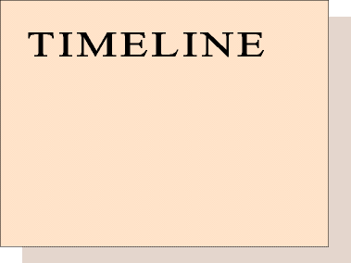

France, meanwhile, was torn by a vicious civil war, partly over whether to remain Catholic or Protestant. The civil war finally ended in 1589. Based on Jacques Cartier's voyages to America in 1533 and 1541, France laid claims to the St. Lawrence River region. Unlike the Spanish, who had exploited the Americas searching for gold and silver, France was interested in the fur trade and in finding a northwest passage leading to the Orient.

In 1603, Henry IV of France persuaded Samuel de Champlain to join an exploring and colonizing expedition to North America. It was the first of 12 visits Champlain would make to the New World.[2] **Louis Hebert** sailed with Champlain on several of those trips, traveling the coast of New England as far south as Cape Cod as Champlain searched for a suitable site for a colony.

**LOUIS HEBERT2**; (**NICOLAS1**) b. 1575, Paris, France; first trip to New World 1604 to Acadia, then Port Royal, established residence with family in Quebec in 1617; first officer of justice in New France; first Canadian settler to support himself from the soil[3]; m. Marie Rollet bf 1600 in France; d. 25 Jan 1627, Quebec; buried Recollet cemetery, later moved to vault at Recollet chapel.

MARIE ROLLET; (parents unknown) b. ab. 1584[4] traveled from Paris to Quebec with her husband in 1617, aided him in caring for the sick and shared his interest in natives; d. 1649 at Quebec[5].

Their children:

1. Anne Hebert; b. c 1601, France; m. 1618, Joseph-Marie Etienne Jonquet, the first marriage solemnized in Canada by the Catholic church[6]; d. 1619.

2. **GUILLEMETTE HEBERT3**, b. 1606, Paris or Dieppe, France; m. Guillaume Couillard 26 Aug 1621; d. 1684, Quebec.

3. Guillaume Hebert; m. bf 1661, Helen Desportes; d. 1639[7].

Louis Hebert's father, Nicolas, was an apothecary in the court of Catherine de Medici, Queen Mother of France[8]. Louis was born in the Mortier d'Or, a house near the Louvre. He followed his father's choice of profession. As a boy, Louis was exposed to court life, which may have influenced him. "The royal chambers buzzed continuously with talk of the great country across the Atlantic. The boy grew up with a deep desire to keep far away from royal courts and to have a personal share in the settling of Canada."[9]

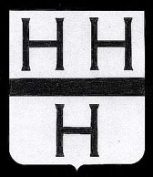

A description (according to author Azarie Couillard Despres) of the French coat of arms of Louis Hebert: “Of money, with the sand fasce, and three H of the same, posed two as a head, the other at a peak.” The coat of arms was found on a Web page devoted to the descendants of Guillaume Couillard and Louis Hebert.

Hebert has been called the first Canadian settler.[10] He sailed first with Jean de Biencourt de Poutrincourt (a nobleman who was the husband of his mother's niece[11]) and Champlain when Poutrincourt spoke of needing an apothecary in the company he was organizing for Ile de Saint Croix. Ile de Saint Croix was located in a region known as Acadia in what is now Maine.

Champlain had been sent to the New World to establish forts that would be safe from Indian attack and to open trading posts to purchase deer hides and furs from friendly Indians. While some tribes were absolute enemies of the French, others, like the Algonquins northwest of the St. Lawrence, became friendly and cooperative because of the fur trade. Other friendly tribes included the Micmacs and Malecites of Acadia, the Montagnais of the lower St. Lawrence, and the Chippewa, or Ojibwa, of lakes Huron and Superior. The Hurons occupied the northern part of lakes Erie, Huron and Ontario. They held a traditional feud with the Iroquois, fierce warriors who terrorized the region.[12]

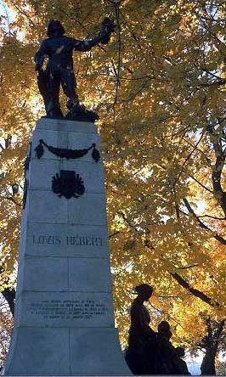

A monument to Louis Hebert in Quebec was erected in 1917. (Source: Monuments commemoratifs de la ville de Quebec Web site)

The Indians of Canada had no effective political organization and were mainly nomadic hunters who set up teepees. To the south, however, where tribes had begun agriculture, a more advanced organization developed in villages that gave them a stable operating base for both hunting and warfare. Five Iroquois tribes — the Mohawk, Seneca, Oneida, Cayuga and Onondaga tribes — formed the Five Nations, a league for common action.[13]

Champlain's Acadian site proved unsatisfactory and, after a harsh winter, he abandoned it. In 1605, the colony moved across the Bay of Fundy to Port Royal. Marc Lescarbot, the lawyer who wrote "The Theatre of Neptune," came there in 1606. He spoke of Louis Hebert with respect for his skill in healing and his pleasure in cultivating the soil. On his map of that region, Lescarbot indicates an island and a river named for Hebert. The island, located in the harbor of Port Royal, is now known as Bear Island.[14]

In the summer of 1606, Hebert sailed with Champlain and Poutrincourt along the coast to the southwest, seeking other suitable sites for a settlement. Poutrincourt and Hebert were so attracted by what is now Gloucester, Mass., that they planted a clearing there to test the soil's fertility.

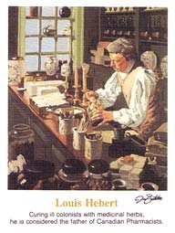

Louis Hebert is depicted as Canada’s first apothecary who cured the ills of Quebec residents in an envelope produced in 1985 by the Canadian government. Canada also produced a stamp of Hebert.

On this journey, Hebert showed he could be counted on for quick and courageous action in an emergency. With Champlain, Poutrincourt and several others, he leaped from the ship into a small boat, unclothed, in the middle of the night, in response to frantic cries from some foolhardy men who, having defied orders and remained on shore, were being attacked by Indians.[15]

The company was recalled to France in 1607 and Hebert returned to his family and his shop in Paris. In 1610, Poutrincourt again established Port Royal. Louis Hebert returned in 1611 on the Grace-de-Dieu, a light ship of 50 or 60 tons. The journey took four months; Hebert arrived May 21 or 22.[16]

A monument in Quebec honors Louis Hebert, foreground, and Guillaume Couillard. The photo was found in a tourism information book about Quebec City.

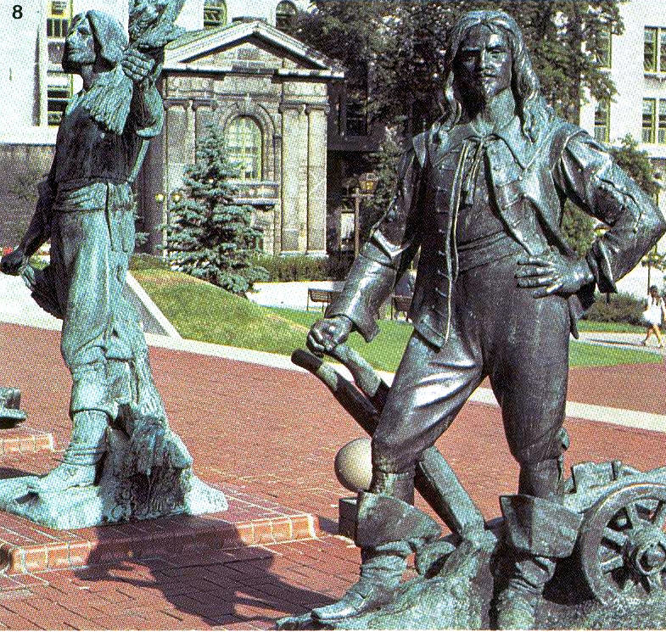

In Port Royal, Louis Hebert acted as apothecary, treating both French and Indian patients. He treated and prepared meals for chief Membertou in his last illness. The English destroyed Port Royal in November 1613 and Hebert and the other colonists were driven into the woods.[17] He was forced to return again to France.

In the winter of 1616-17, Hebert renewed his acquaintance with Champlain, who was in Paris seeking support for Quebec. Champlain had founded Quebec, the first permanent French colony in North America, in 1608. (The name "Quebec" is of Algonquin origin and refers to the narrowing of the St. Lawrence River at this point, or kebek.[18]) Quebec, having survived for nine years, probably seemed to Hebert a safer place than Acadia or Port Royal.

Champlain obtained for Hebert a contract from the fur-trading company in control of the St. Lawrence region. Relying on the promises — 200 crowns a year for his service as apothecary, and food and shelter for his family while getting land cleared — Hebert sold his house and garden in Paris and took his wife, Marie, and three children, Anne, Guillemette and Guillaume, to Honfleur ready to embark. There he found that the company had no intention of honoring the contract; the company claimed Champlain had negotiated without authority. The best Hebert could do was half the salary and half the land grant. The new two-year contract stipulated that his family and his servant should be at the company's service without pay. Without alternatives, Hebert accepted the terms and the family sailed for Quebec on 11 Mar 1617.[19]

The family landed on a summer's day in Tadoussac, the gateway to New France. Large ships could pass the narrowing of the St. Lawrence only at a risk, and Tadoussac harbor (about 100 miles north of Quebec) became a busy port of call. Upon landing, a Recollet father said mass in a flimsy structure made out of the branches of trees. (The Recollets, an offshoot of the Franciscans, whom Champlain had brought to Quebec two years earlier, wore the pointed capuche and depended on charity for their food.)

This map, originally drawn by Jean Boisseau in 1643, depicts villages that grew up along the St. Lawrence. The map was found in “Canadian Frontiers of Settlement.”

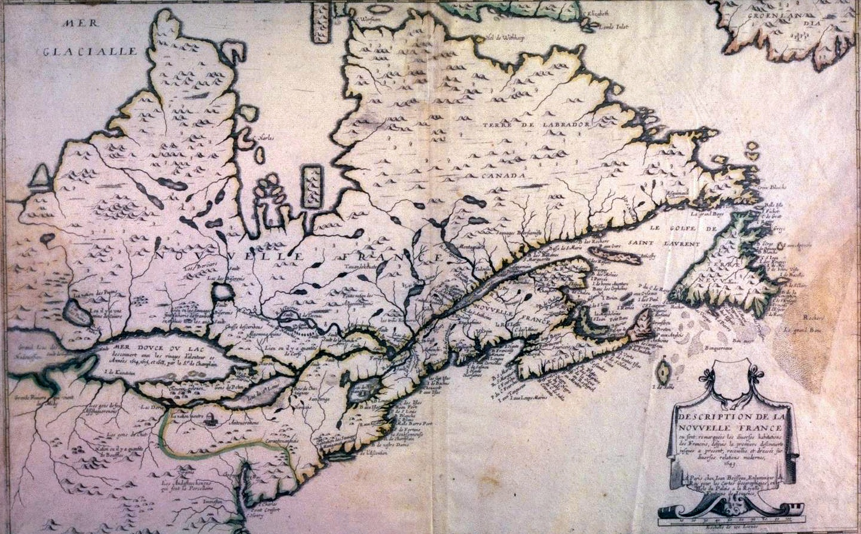

Quebec, farther south, was perched on a promontory at the entrance to the narrowing in the river. Despite the demands set upon him by the company, Hebert set to work quickly, clearing the 10 arpents (one square arpent was roughly 5/6 of an acre) allotted to him. A permanent house, a substantial structure of stone, soon replaced the temporary house he set up on the top of the cliff. The one-story house was 31 feet long and 19 feet wide.[20]

For many years, Hebert was the only colonist besides Champlain who took any interest in cultivating land. "The vegetables they [the Heberts] grew on their fertile acres soon supported all of the less fortunate families on the riverbanks; and for this under the terms of the unfair agreement, they received no pay. At the same time the head of the family acted as physician and dispenser to the whole colony."[21]

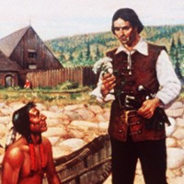

Louis Hebert discusses a medicinal plant with a Micmac Indian in this painting by Robert Thomas.

In 1620, Champlain returned from a trip to France with full authority over the colony. He appointed Hebert king's attorney, giving him responsibility for the administration of justice in the colony. (It was in this capacity that Hebert signed a colony petition to the king in 1621.) Hebert also enjoyed the confidence of the Indians. Unlike many of his contemporaries, he considered the Indians intelligent, lacking only education. Many instances bear witness to their affection and respect for him.

From the beginning, land in Canada was divided by fiefs under the feudal system recognized in France, first by the French king or his deputies, and later by those who were granted a charter by the king. Holders of a fief were considered seigneurs, lords or nobles, which gave them rank in the social hierarchy. He or she (many land-holders in the mid-1600s were women) could collect taxes or rent from settlers; hand down punishment for crimes, even the death sentence; or impose mandatory work to develop the seigneur's land.

In 1622, Louis Hebert petitioned the king's viceroy for a title to his land. Title was granted on 4 Feb 1623, guaranteeing him possession. The land was known later as the fief Sault-au-Matelot. The title was ratified on 28 Feb 1626 and some acres along the St. Charles River were added. The land was known as the fief Saint-Joseph and later as the fief de Lespinay, both to be enjoyed "en fief noble." The meadows along the St. Charles gave him pasture for cattle; on the higher ground he had grain fields, vegetable gardens and an orchard planted with apple trees brought from Normandy. The land was worked with hand tools only; plows and oxen were not yet brought to Quebec.[22]

The winter of 1626 Hebert had a fall on the ice, which proved fatal. He died 25 Jan 1627 and was buried in the Recollet cemetery. In 1678 his bones, still in a cedar coffin, were transferred to the vault of the Recollet chapel and with those of a Catholic priest were the first to rest there.[23]

When **Marie Rollet** came to Canada with her three children in 1617, she found starvation, sickness and threats of Indian attacks. A year after their arrival, their eldest daughter, Anne, married Etienne Jonquet. It was the first marriage solemnized in Canada with rites of the church. Anne died in childbirth the following year.

A monument honoring Marie Rollet and her work with Indian children is located in Quebec. (Source: Monuments commemoratifs de la ville de Quebec)

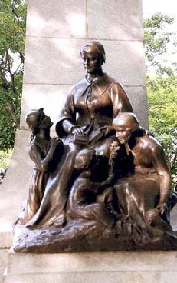

Marie Rollet aided her husband in caring for the sick and shared his interest in the Indians, especially with the education of the children. In 1627, at the baptism of Chomina's son, Naneogauchit, which the priests were striving to make an impressive occasion, she fed a crowd of visiting Indians out of a big brewing kettle. Her name appears often as godmother at the baptism of converted Indians.

Two years after Louis Hebert died in 1627, she married Guillaume Hubou.

When the British besieged Quebec in 1629, Champlain — as governor of Quebec since 1626 — was forced to surrender. After seeking his advice, Marie Rollet and her family — her second husband; her 15-year-old son, Guillaume; her daughter, Guillemette, and son-in-law, Guillaume Couillard — remained in Quebec during the English occupation, keeping alive the memory of French friendship with the Indians. After the return of the French in 1632, her house became the home of Indian girls given to the priests for training.

Marie Rollet died in 1649. She was buried at Quebec on 27 May 1649.[24]

A plaque on a monument to Louis Hebert at the Place de l'Hotel de Ville in Quebec lists 94 "first colonists of Quebec." Of those 94, the family of Andy Bannister has ties to these colonists:

**HUSBAND** **WIFE**

Louis Hebert Marie Rollet

Guillaume Couillard Marie-Guillemette Hebert

Etienne Jonquet Anne Hebert

Oliver Le Tardif Louise Couillard

Jean Nicolet Marguerite Couillard

Zacharie Cloutier Xaintes Dupont

Marin Boucher Perrine Mallet

Robert Drouin Anne Cloutier

Antoine Brasard Francoise Mery

1. Joseph R. Conlin, *A History of the United States, Our Land, Our Times*, (San Diego, Calif: Coronado Publishers, 1995) p. 28
2. Unknown, Family Encyclopedia of American History (Pleasantville, New York: th e Reader’s Digest Association, 1975) p. 195
3. W. Stewart Wallace, Dictionary of Canadian Biography (New York, NY: Macmillan Co. 1945) Vol. 1 pps. 367-8
4. Tanguay Dictionary, Que 3, Vol. 1, p. 301
5. W. Stewart Wallace, Dictionary of Canadian Biography (New York, NY: Macmillan Co. 1945) Vol. 1 pps. 367-8
6. Ibid
7. Ibid
8. W. Stewart Wallace, Dictionary of Canadian Biography (New York, NY: Macmillan Co. 1945) Vol. 1 pps. 367-8
9. Thomas B. Costain, *The White and the Gold -- The French Regime in Canada* (Garden City, NY: Doubleday & Company, 1954) pps. 89-92
10. Ibid
11. W. Stewart Wallace, Dictionary of Canadian Biography (New York, NY: Macmillan Co. 1945) Vol. 1 pps. 367-8
12. Edgar McInnis, Canada: A Political and Social History (Toronto: Holt, Rinehart and Winston, 1969) pps. 10-15
13. Unknown, Family Encyclopedia of American History (Pleasantville, NY: The Reader’s Digest Association, Inc., 1975) p. 411
14. Ed: Reuben Gold Thwaites, *Jesuit Relations and Allied Documents* (Cleveland, Ohio: The Burrows Brothers Company, 1896) Vol. 2, p 308
15. W. Stewart Wallace, Dictionary of Canadian Biography (New York, NY: Macmillan Co., 1945) Vol. 1, pps. 367-8
16. Marcel Trudel, The Beginnings of New France, 1524-1663 (Toronto, Ont., Canada: McClelland and Stewart Ltd., 1975) p. 111
17. *Acadia and the Acadians*, Collier’s Encyclopedia, Vol. 1, 1962 ed.; p. 58-6-, Collier’s Encyclopedia (The Crowell-Collier Publishing Company, 1962) Vol. 19, p. 574
18. W. Stewart Wallace, Dictionary of Canadian Biography (New York, NY.; Macmillan Co., 1945) Vol. 1
19. Thomas B. Costain, *The White and the Gold -- The French Regime in Canada* (Garden City, NY: Doubleday & Company, 1954) pps. 89-92
20. Ibid
21. W. Stewart Wallace, Dictionary of Canadian Biography (New York, NY.; Macmillan Co., 1945) Vol. 1
22. Ibid
23. Ibid
24. *Your Ancient Canadian Ties*, Burton Historical Collection, Detroit Public Library, Detroit, Mich.