Chapter 4

MOVING SOUTH

# Joseph Guyon/Genevieve Cloutier

By 1640, 32 years after it had been founded, Quebec had grown little; its population was a mere 200 habitants.[1] Settlers there still clustered about the military and administrative center of the town, mainly for protection from Indian attack. But sights had already been set to the south.

Champlain had believed settlements could survive in two other locations — Trois Rivieres, about 60 miles sough of Quebec, and Montreal Island, about 140 miles to the south. The island lay at the juncture of the St. Lawrence, the Richelieu and the Ottawa rivers. The year before he died in 1635, Champlain established a post at Trois Rivières. Missionaries founded a settlement at Montreal in 1642.

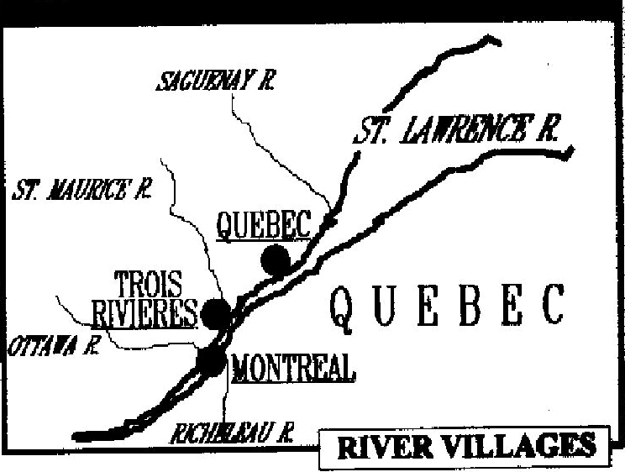

Trois Rivières lie at the mouth of the St. Maurice River, which tapped a wider fur area than Tadoussac and the Saguenay River in the north. Champlain saw a fort at Trois Rivières as an advance post against the mighty Iroquois. He felt it would encourage Indian traders from Lake Huron and the Upper Ottawa to come by the St. Maurice.

At the rivers’ juncture, Montreal Island was a natural meeting place. But its location also made easy access for the Iroquois. The settlement there was founded for religious reasons at the same time chronic Indian warfare intensified in a struggle for control of the St. Lawrence trade route.

By 1650, the colony of New France was in a virtual state of siege. Iroquois raids had wiped out or scattered the French allies, the Hurons and the Algonquins. The Huron country north of lakes Erie and Ontario no longer existed. The Iroquois controlled the supply of furs and concentrated all their attacks against the French colony. The settlers were harassed by continuous warfare, carried on by surprises and ambushes; those who left the stockades risked their lives.[2]

Appeals to the government for soldiers from France brought little assistance. The inhabitants were their own defense, working their fields with vigilance and a musket at hand.[3]

It was into this era that **Joseph Guyon** was born on 10 Sept 1649.

**JOSEPH GUYON Du BUISSON5**; (JEAN and **ELIZABETH COUILLARD4**); b. 10 Sept 1649, baptized the next day in Quebec); m. Genevieve Cloutier 29 Jan 1674 at Chateau Richer; d. 8 Sept 1712 at Grondines, buried the next day.

**GENEVIEVE CLOUTIER**; (ZACHARY and MAGDELENE BARBARA AYMARD); b. 22 Jan 1655 at Quebec; d. 19 Feb 1725 at Varennes, St. Anne de Varennes, which opened in 1693.

Children of this marriage were:

1. Madeleine Guyon; b. 15 Dec 1674 at Chateau Richer; m. 19 Feb 1692 to Antoine Goulet at L’Ange Gardien; m. 12 Apr 1712 to Jacques Roussin; d. 12 May 1758.

2. **ANGELIQUE GUYON6**; b. about 1677; m. 8 Feb 1694 to Jacques Letourneau at St. Anne de la Perade.

3. Ignace Guyon; b. 13 Feb 1680 at L’Ange Gardien; m. 12 Jan 1705 to Marie-Louise Guillet

4. Joseph Guyon; b. 27 Apr 1682 at L’Ange Gardien, m. 3 mar 1710 to Elisabeth Guillet

5. Jean-Baptiste Guyon; b. 21 Oct 1684, L’Ange Gardien; m. 25 Aug 1718 to Marie-Jeanne Guillet at Batiscan.

6. Charles Guyon; b. 18 Mar 1686 at L’Ange Gardien.

7. Noel Guyon; b. 5 Sept 1688 at L’Ange Gardien; buried there 5 Feb 1692.

8. Ambroise Guyon; b. 5 Jan 1690, L’Ange Gardien, buried there 4 Feb 1692.

9. Marie-Madeleine Guyon; b. LaPerade, baptized 20 Feb 1693 Batiscan; d. 10 Feb 1714.

10.Genevieve Guyon; b. 23 May 1694 or 1696 at Grondines, baptized the next day at La Perade.

**Joseph Guyon** was the first son of Jean Guyon DuBuisson and Elizabeth Couillard. From his father he inherited the title of sieur (sir) DuBuisson.

In *A History of Canada*, Gustave Lanctot describes what living conditions would have been like at the time:

“Large game such as moose and elk abounded, as did wild birds good for eating, particularly wild pigeons, which were shot down by the hundreds; but eels proved the real manna from heaven. In August the colony enjoyed large salmon catches, which were shortly followed by the sturgeon catches and in September innumerable shoals of eels came downstream from Lake Ontario. All along the St. Lawrence, fishermen were after them constantly for two months. The eels kept very well, either cured over a fire or salted, and tasted much better than the eels caught in French waters. Finally, freedom to barter in furs enabled the habitant to acquire a few luxuries for himself, such as a bit of strong spirits, a glass of Quebec beer or even French wine. Most slaked their thirst with the so-called bouillon made from fermented dough and spiced water.”[4]

The typical Kebeker, Lanctot wrote, “usually lived in a wooden rather than in a stone house, and his home had a quaint, high-peaked cap of a board roof. Little square-cut windows were covered with heavy linen or oiled paper as there was no glass. The furniture included a table, beds, linen-chests and a few rustic chairs. A huge chimney dominated the kitchen, which was the main room, and over the fire pots wither stood on tripods or hung from chimney hooks. Candles supplied the only artificial light; consequently the people went to bed early and arose at daybreak. Mass was sometimes sung at four o’clock, and weddings celebrated at five o’clock in the morning.”[5]

Although he grew up in Quebec, Joseph’s family apparently moved a few miles to the north to Chateau Richer between 1662 and 1665, when he was in his early teens. Chateau Richer was one of two villages — the other was St. Anne — in the neighboring seigneury of Beaupre.

By the mid to late 1600s, Quebec began to take on an urban shape. The lower town was established between the St. Charles River and Cape Diamond. Seven streets were laid out, with about 90 residences. The upper town was reached by a steep, winding road. Quebec had three churches, seven chapels, a college, a convent for girls, a hospital and nine mills. In the surrounding countryside, there were five or six forts, including two in the Sillery seigneury.

Meanwhile, the Trois Rivieres region had three forts, a church and two outside chapels, a hospital and two mills. Montreal had only two streets, one fort, a hospital, two mills and a school for girls.

Joseph married Genevieve Cloutier on 29 Jan 1674 at Chateau Richer. They had 10 children. Three sons, Ignace, Joseph and Jean-Baptiste, married three sisters, Marie-Louise, Elisabeth and Marie-Jeanne Guillet, the daughters of Louis Guillet and Marie Trotier. Ignace and Jean-Baptiste served in the military.

The family apparently moved to the south when the children were young. By 1694-1696, the 10th and last child, Genevieve, was born in Grondines, about 30 miles south of Quebec.

Joseph died on 8 Sept 1712 and was buried the next day at Grondines, at St. Charles de Roches de Grondines.

**Genevieve Cloutier** was the granddaughter of Zacharie Cloutier and Xainte Dupont and the daughter of Zachary Cloutier and Magdelene Barbara Aymard (also known in some records as Madeleine Emard). She was born 22 Jan 1655 at Quebec. She had seven brothers and sisters: Barbe-Delphine, Rene, Sainte, Marie-Madeleine, Marie, Charles and Pierre.

Genevieve grew up in a large extended family that included both parents, both paternal grandparents and five aunts and uncles in New France. The family lived in Quebec until they moved apparently to Chateau Richer when that parish was founded in 1661 seven or eight miles north of Quebec. Brothers Charles and Pierre were born in Chateau Richer, in 1662 and 1666.

Both of her parents died in 1708. Her father, who was born 16 Aug 1617 in Sainte Jean Baptiste de Mortagne in Perche, France, died at 81 on 3 Feb 1708 at Chateau Richer. He was a carpenter who was clerk of the Communaute des Habitants of Quebec in 1648. (The society was founded 6 mar 1645 for trade with the Indians; members could also carry on trade of their own.[6]) Her mother, whose birth date in France is unknown, died on 28 May 1708 at Chateau Richer. Genevieve’s maternal grandparents, Jean Emard and Marie Bineau, were from St. Andre, ville de Niort, France.

Her paternal grandfather, Zacharie, who was born about 1590[7]7 in France, probably in Mortagne, died 17 Sept 1677 at Chateau Richer. Her paternal grandmother, Xainte or Sainte, who was born about 1596 in Mortagne, died at Chateau Richer at the age of 97[8]8 on 13 July 1680 and was buried in the cemetery there the next day. The couple had been married since 18 July 1616. They were married in St. Jean, a village in Mortagne, in the diocese of Sees, Perche.

Genevieve would have known both sets of great-grandparents only through stories told by her grandparents. Her grandfather’s parents, Denis Cloutier and Renee Briere, both died in France. Denis died after 2 Mar 1633. Renee was buried 1 May 1608 at St. Jean. The names of Genevieve’s grandmother’s parents are unknown.

Genevieve’s grandfather, Zacharie Cloutier, a master carpenter, left France from the port of La Rochelle to settle in the seigneury of Beauport. He entered into a contract with Robert Giffard, the seigneur of Beauport, on 14 Mar 1634. The agreement called for him to come to Canada that year with fellow countryman Jean Guyon DuBuisson, senior, the man who ultimately would become Genevieve’s grandfather-in-law. Both Guyon and Cloutier were to receive the grant of an arriere-fief, or backlands, at Beauport and the title of lord. The two settlers took formal possession of their lands on 3 Feb 1637. The previous year, if not before, their families had joined them in Canada.[9]9 *Your Ancient Canadian Ties* by Robert Drouin, which is part of the Burton Historical Collection in the Detroit Public Library, claims Cloutier and his wife Xainte brought their five children with them to Canada.

Genevieve’s grandfather began constructing a home for Giffard at Beauport on 22 July 1634. He also worked on the construction of the church and Fort St. Louis.[10]10 In January 1647, he gave the Jesuit fathers an ebony staff for the Beadle, a parish official, as a New Year’s gift.[11]11

Zacharie Cloutier’s holdings, the fief of La Cloutiere (or La Cloutiererie) brought him into conflict with his neighbor Guyon and with Giffard, his seigneur. He sold the land to Nicolas Dupont de Neuville on 20 Dec 1670 in order to settle at Chateau Richer, where he had already received a land grant from Gov. Jean De Lauson on 15 July 1652. (Your Ancient Canadian Ties said he went to live with one of his sons.)

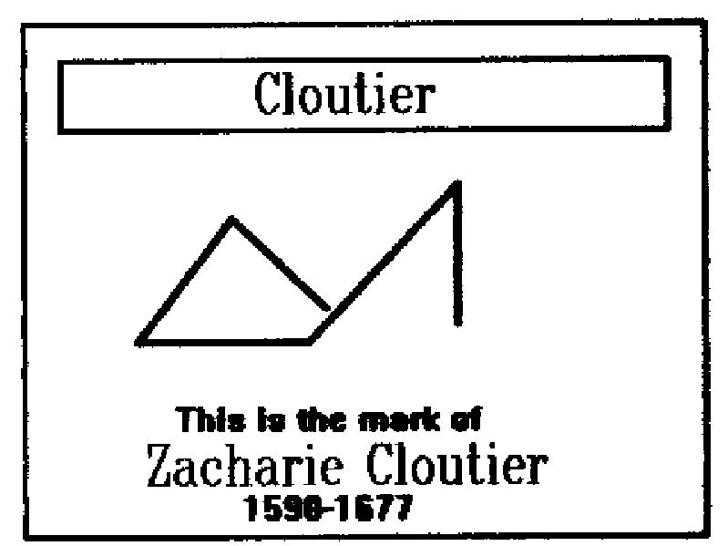

Genevieve’s grandfather had a very original mark that took the place of his signature. It was an axe, or hammer, the emblem of his trade.[12]12

Married in 1674, Genevieve and Joseph apparently moved from Chateau Richer to L’Ange Gardien at least by 1680, when their son Ignace was born. L’Ange Gardien is about five miles north of Quebec, up the St. Lawrence. By the time daughter Marie-Madeleine was born in 1693, they had moved to La Perade, about 40 miles south of Quebec. The last child, a daughter named Genevieve, was born in Grondines, north of La Perade but still about 30 miles south of Quebec.

Genevieve died and was buried on 19 Feb 1725 in Varennes, just north of Montreal Island, on the south shore of the St. Lawrence. While no records can be found, she may have traveled that far south with her sons. Of Ignace’s 12 children, six were either born or baptized at Varennes. Jean-Baptiste had several children born there and the last five of Joseph’s 10 children (dit Lemoine) were born in Vercheres, about eight miles north of Varennes.

1. Edgar McInnis, *Canada: A Political and Social History*, 3rd ed. (C. 1947, 1959; Toronto: Holt, Rinehart and Winston, 1969) P. 38.
2. Marcel Trudel, *New France*, *1524-1713,* Dictionary of Canadian Biography*,* Vol. 1, 1996 ed.: P. 32.
3. Edgar McInnis, *Canada: A Political and Social History,* 3rd ed. (C. 1947, 1959; Toronto: Holt, Rinehart and Winston, 1969) P. 39.
4. Gustave Lanctot, *A History of Canada,* vol. 1 (Cambridge, Mass.: Harvard University Press, 1963) P. 311.
5. Ibid.
6. George W. Brown, Dictionary of Canadian Biography*,* (Toronto, Ontario, University of Toronto Press, 1966) Vol. 1, P. 330.
7. Ed: Eusebe Senecal, *Genealogique des Familles Canadiennes,* l’Abbe Cyprien Tanguay, Premier Volume, Province de Quebec Montreal, 1871.
8. Official record, Archives de L’Etat Civil, Palais De Justice, Quebec
9. George W. Brown, Dictionary of Canadian Biography, (Toronto, Ontario, University of Toronto Press, 1966) Vol. 1, P. 232.
10. Robert Drouin, *Your Ancient Canadian Ties*, Burton Historical Collection, Detroit Public Library.
11. Ed: Reuben Gold Thwaites, *The Jesuit Relations and Allied Documents* (Cleveland, Ohio; Burrows Brothers Co. 1896) Vol. 27, P. 312.
12. Ibid.