Chapter 10

MICHIGANDERS and VOYAGEURS

Clareta Thibault/Toussaint Moore

**Toussaint Moore** was the first person in this genealogical history to be born in Michigan – although it was the Michigan Territory when he was born 1 Nov 1807 at the Clinton River region north of Detroit.

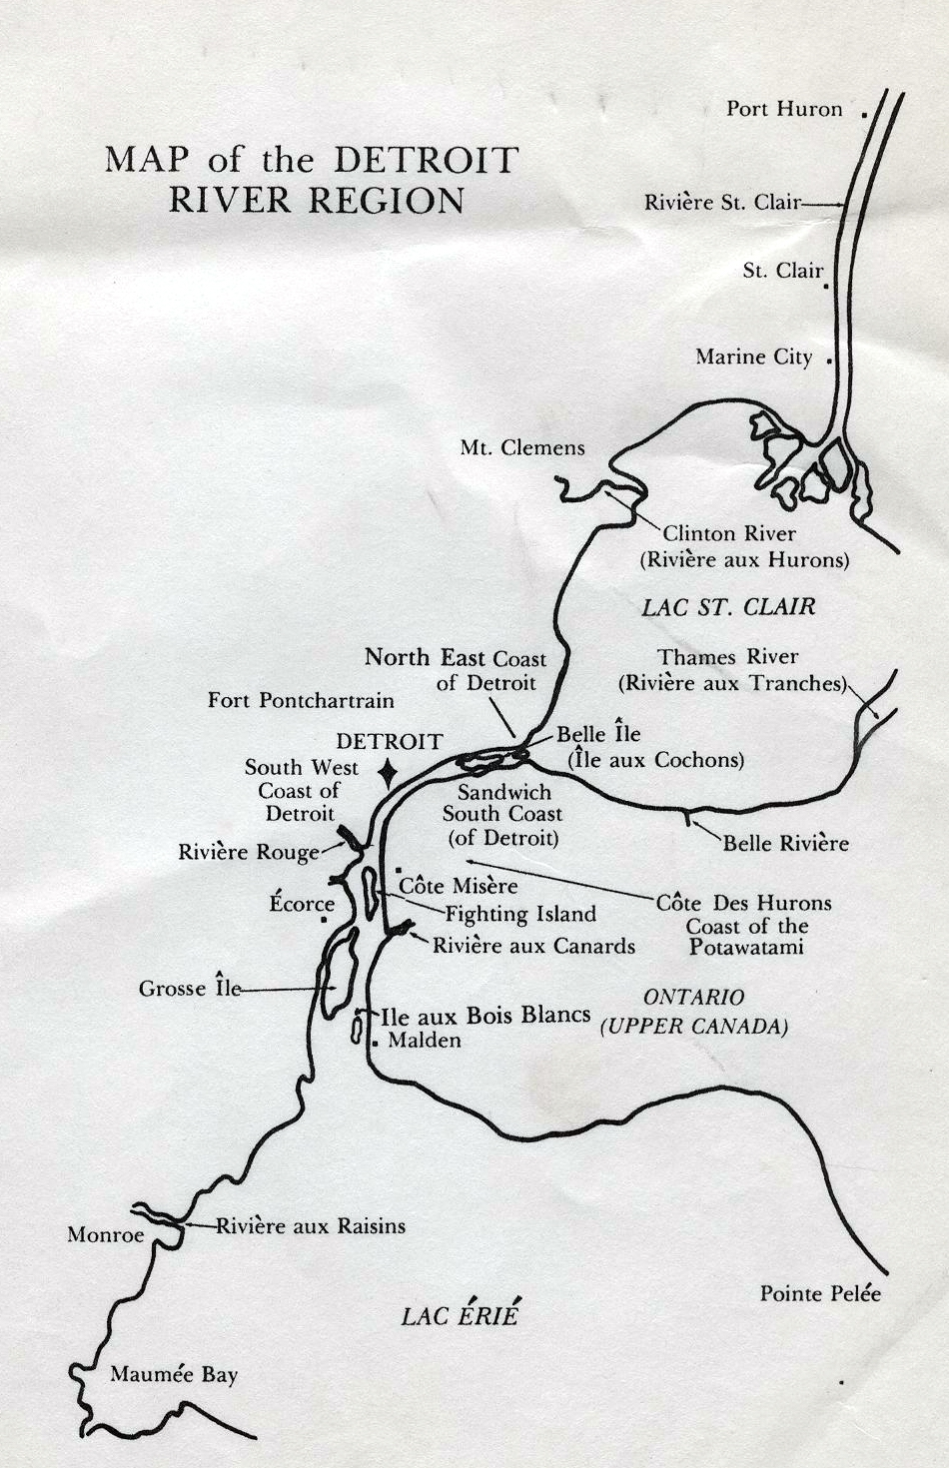

The Michigan Territory was organized in 1805, and Detroit was the seat of government. By 1810, the population was 4,500; by 1820 it had nearly doubled. By 1812, 12 counties had organized. The western boundary of the territory included the eastern tip of the present Upper Peninsula. By 1830, after the Erie Canal’s construction, the arrival of a steam freighter on the Great lakes and the arrival of settlers from the east, the population grew to 32,000 and by 1834, more than 80,000.

It was time for statehood, but problems arose in the territory’s southern border with Ohio. The line between the states, fixed by Congress, gave Toledo to Michigan; but Ohio wanted the profitable Lake Michigan harbor for itself, prompting the bloodless Toledo War. Washington decided in Ohio’s favor, but as an appeasement, included the Upper Peninsula. The territory was accepted for statehood in 1837. Toussaint was 30 years old.

Most of the territory’s early settlements were along the Detroit River and the Clinton River, first called the Huron River, which runs north of Detroit. The Clinton was first settled near Mount Clemens.

**This map shows the main rivers around the Detroit region. The map was taken from the Father Christian Denissen Papers, which are part of the Burton Historical Collection at the Detroit Public Library.**

Toussaint’s heritage was both English and French. While his mother, Suzanne Pineau dit LaPerle, was completely of French extraction, his father, Laurence Moore, was a product of the two cultures.

Charles Lapelme, chorister and catechist for the chapel of St. Francois, Clinton River, privately baptized Toussaint. He was baptized solemnly at Detroit on 29 Jan 1808.

Toussaint was married for the first time to Monica Charon who lived along the Thames River in Canada, on 15 July 1828. He was 20 years old. Monica, who was born in 1812, was 16 years old. She was the daughter of Peter Charon and Jane Peltier. Monica died in childbirth and was buried at Mt. Clemens 22 Dec 1855.

Left with a newborn and 11 other children, Toussaint married again a short three months later, on 21 Mar 1856. His second wife was **Clareta Thibault** (some sources name her as Clara), the widow of David Gay. Clareta was 30 years old when she married Toussaint.

The daughter of Louis Thibault and Archange Bertrand, Clareta Thibault brings to this genealogy a rich and colorful history of voyageurs at Fort Michilimackinac.

**TOUSSAINT MOORE10**; (LAWRENCE and **SUSANNE PINEAU dit** **LAPERLE9**); b. 1 Nov 1807 in Clinton River; married 1st Monica Charon; married 2nd **Clareta Thibault.**

**CLARETA THIBAULT;** LOUIS and ARCHANGE BERTRAND); b. 29 Oct 1826 at St. Clair River; married 1st David Gay; married 2nd **Toussaint Moore**.

Toussaint’s children with **Monica Charon[1]1:**

1. Toussaint Moore; b. 1 Dec 1829 at St. Francois, Clinton River; married 12 July 1853 at Mt. Clemens to Lovia Charon (Michael Charon and Rose Pepin).
2. Julia Moore; b. 1832, Mt. Clemens.
3. John Baptist Moore; b. 1833, Clinton River; married 28 Oct 1856 at Mt. Clemens to Mary Ann Hebert (b. Assumption, Sandwich 17 July 1838; Eustache Hebert and Sophia Beaupre).
4. Matilda Moore; b. 1836 at Clinton River; Macomb County; married 12 July 1853 to Louis Charbonneau (b. 1834, son of Louis Charbonneau and Julia Petit).
5. Andrew Moore; b. 1838; married 21 Feb 1859 at Immaculate Conception, Anchorville, to Sophia Hebert (b. 1837; Oliver Hebert and Susanne St. Luc).
6. Christopher Moore; b. 1841, Mt. Clemens.
7. Philomene Moore; b. 1842; married 16 Nov 1863 at St. Peter, Mt. Clemens, to John Baptiste Biscornet (b. 1838; Louis Biscornet and Louisa Surprenant).
8. Leo Lafayette Moore; b. 4 July 1845, baptized 21 Sept 1845 at Mt. Clemens; married 1st 14 May 1866 at Assumption Church, Greinerville, to Melinda Moore (Oliver Moore, [HIS UNCLE?]; d. at New Baltimore, 1890); married 2nd to a Reaume woman (daughter of Charles Reaume).
9. Helena Moore; b. 11 Jan 1848, baptized Mt. Clemens 4 Mar 1848.
10. Alice Moore; b. 1850, Mt. Clemens.
11. Lovina Moore; b. 27 Nov 1852, baptized 2 or 3 Dec 1852.
12. Charles Moore; b. 21 Dec 1855, baptized Mt. Clemens 23 Dec 1855; married 5 Oct 1875 at St. Mary’s, to Veronica Rivard (b. 22 Oct 1857, baptized Immaculate Conception, Anchorville 30 Mar 1858; daughter of Louis Rivard and Elisabeth LaForge).

Children with **Clara Thibault[2]2**:

1. Clemence Moore; b. 2 Dec 1856, Mt. Clemens.
2. **GEORGE MOORE11**; b. 10 Nov 1858, baptized Mt. Clemens 19 Dec 1858.
3. Ann Moore; b. 11 Nov 1869, baptized Mt. Clemens 18 Dec 1860.

Clareta Thibault was born 29 Oct 1826 at St. Clair River, which connects Lake Huron with Lake St. Clair and the Detroit River. She was baptized 23 Jun 1827 at St. Francois, Clinton River. Her forebears bring several new elements into this history: Fort Michilimackinac and the Casse family of Detroit. We begin first with her parents.

# LOUIS THIBAULT/ ARCHANGE BERTRAND

# Parents of Clareta Thibault

**Louis Thibault** was born 20 Apr 1771 in Grand Marais, northeast of Detroit, a son of Ignatius Thibault and Catherine Casse St. Aubin. Louis married **Archange Bertrand** on 30 Jan 1816 at St. Francois, Clinton River. He was buried 29 Sept 1847 in Mt. Clemens.

Archange’s parentage is unknown. She was the adopted daughter of the widow of Claude Gouin.[3]3 Archange Bertrand’s first husband was Joseph Ricard.

Clareta was the youngest of four children of Louis and Archange. The other children were Francis, who was born 13 Feb 1819; Emily, who was born 11 Sept 1820 at St. Francois, Clinton River; and David, who was born 15 Dec 1824 at St. Clair.

# IGNATIUS THIBAULT/ CATHERINE CASSE ST. AUBIN

**Paternal grandparents of Clareta Thibault**

# Parents of Louis Thibault

**Ignatius Thibault** was born 1 Feb 1737 at Chateau Richer, Quebec, a son of Francis Xavier Thibault and Madelaine Poulin. He married **Catherine Casse dit St. Aubin** on 1 Dec 1768 in Detroit. (The origin of her *dit* name is likely her grandfather’s birthplace, St. Aubin, France.) Catherine was born 18 Jan 1748 at Detroit. Catherine’s parents were: Jean Casse dit St. Aubin (son of Jean Casse and Mary Louise Gautier) and Catherine Jean dit Vien.

Ignatius and Catherine had eight children. They are: Ignatius, the first born and namesake, born 30 Apr 1769; **Louis,** born 20 Apr 1771 in Grand Marais; Alexis, born19 Feb 1773 in Grand Marais; Gabriel, born 30 Jan 1775; Catherine, born 27 Jan 1777 in Grand Marais; Mary Joseph, born 20 May 1779 in Detroit; James, born 21 Aug 1781 in Detroit; and Francis, born 28 Aug 1783 in Detroit and buried 30 Jul 1844 in Grosse Pointe.

Jean Casse, Catherine’s grandfather, was born circa 1659 in St. Aubin, Bourdeau, France. His parents were William Casse and Anne Grenier. Jean Casse was married 7 Feb 1707 to Mary Louise Gautier. Jean died 27 Feb 1759. Mary Louise was born 29 Sept 1678 in Quebec to Mathurin Gaultier and Anne Giraut. Mary Louise died 26 Apr 1768.

Mathurin was born in 1633 to Jean Gaultier and Louise Barbotine. He and Anne Girault were married 16 Jul 1669 in Quebec. His death date is unknown. Anne Girault was born in 1643, a daughter of Antoine Giraut (Girault and Giraut are interchangeable in most records) and Jeanne Girodelle. Anne died after 7 Feb 1707 in Quebec.

**FRANCIS XAVIER THIBAULT/ MADELEINE POULIN**

**Paternal great-grandparents of Clareta Thibault**

**Parents of Ignatius Thibault**

**Francis Xavier Thibault** was baptized 17 Apr 1695 at Chateau Richer, Montmorency, Quebec, a son of Nicholas Thibault and Marie Francoise Boucher. He was buried 12 Jul 1756. He married twice.

Francis married Madeleine Bourbon on 30 Jan 1719. She was born 2 Aug 1700 at St. Anne, Lower Canada. (Canada at the time generally was divided into two halves, Lower and Upper. The upper generally was Quebec, the lower Ontario.) Her father was Etienne Bourbon and her mother was Madeleine Mandin.

Francis married **Madeleine Poulin** in 1724. She was born 21 Dec 1706 in St. Anne, Quebec. Ignatius was their only child. Madeleine’s parents were **Peter Poulin** and **Ann Giguere.**

**NICOLAS THIBAULT/ MARIE FRANCOISE BOUCHER**

# Paternal great-great-grandparents of Clareta Thibault

**Parents of Francis Xavier Thibault**

**Marin Boucher** was born in 1589 in Langy, in the bishopric of Montagne, France. His parents are unknown. Marin died 29 Mar 1671 at Chateau Richer, Quebec.

Marin was married twice. His first wife was **Julienne Barry.** Her parents are unknown. Marin and Julienne were married in 1625 in Quebec. Their son, Francois, was their only child.

Marin’s second wife was Perrinne Malet. They were married in 1632. She was born in 1606 and died 25 Aug 1687. They had six children: Jean-Galeran, who was born in 1633, and married Marie LeClerc; Francoise, who was born 22 Jun 1636 and married Jean Plante on 1 Sept 1650; Pierre, who was born 13 Feb 1639 and married Marie St. Denis on 4 Apr 1663 at Chateau Richer; Madeleine, who was born 4 Aug 1641 and married Louis Houie on 12 Jan 1655; Marie, who was born 15 Apr 1644 and married Charles Godin on 6 Nov 1656; and Guillaume, who was born 5 May 1647 and married Marguerite Thibaut on 21 Nov 1672.

## THE FORT

# JEAN CASSE dit ST. AUBIN/ CATHERINE ANGELIQUE JEAN dit VIEN

**Paternal great-grandparents of Clareta Thibault**

Fort Michilimackinac is introduced through Clareta’s great-grandmother on her father’s side, **Catherine Angelique Jean dit Vien.**

Catherine was born and baptized at Fort Michilimackinac on 5 Jun 1726; records of her baptism are still in the chapel at the fort, which was reconstructed in the 1960s and 1970s.

Catherine married **James (Jean) Casse dit St. Aubin** on 27 Dec 1745 in Detroit. He was born in 1718 in Detroit. He also lived on the north coast of Detroit. He was buried on 11 Oct 1804.

Catherine was the last of nine children born to **Ignace Jean dit Vien** and **Angelique Dandonneau**, who had been married on 2 Feb 1710 in Montreal. The marriage was the second for Angelique. Her first husband was Charles Chaboille.

Angelique’s birth date is unknown. Ignace was 36 when they married. He was born on 6 Aug 1673 at Beauport, Quebec.

Ignace was buried 23 Oct 1751 in Detroit. Angelique died 11 Aug 1764 in Detroit. Her parents were Jane Margaret Lenoir and Louis Dandonneau.

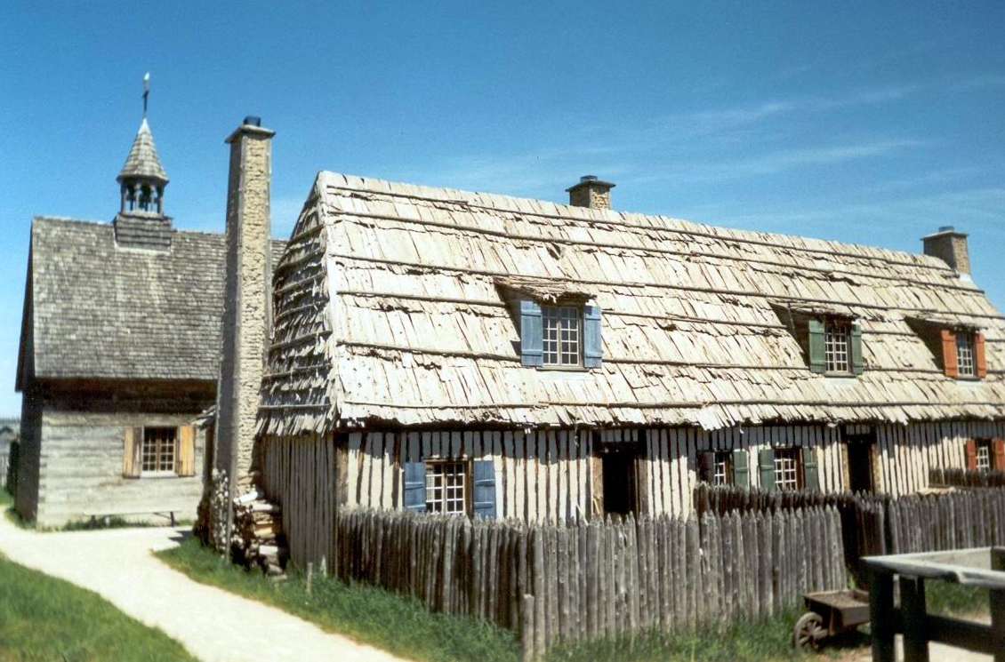

**Reconstruction and renovation at Colonial Michilimackinac, a Michigan state historic park, shows what a typical house would have looked like in the 18th century. The restoration work began in the 1960s. (Barbara Bannister photo)**

Several generations of the Jean family may have been in the fur-trading business. Several sons – Ignace and Michel – of Vivien Jean dit Vien and Catherine Gateau were “engage Ouest,” or enlisted in the service in the West, according to Rene Jette’s Dictionnaire Genealogique des Familles du Quebec, des Origines a 1730. Jette also listed Ignace Jean dit Vien’s occupation as “voyageur.” A cousin, Jean Jean dit Godon, the son of Elie Jean dit Godon, a brother of Vivien Jean, also was “engage Ouest” in 1703. Louis Jean dit Denis, the son of Denis Jean dit Denis, was “engage Ouest” in 1725 but his relationship, if any, to Ignace is unknown. Generally the “engages” as related to the fur-trading business in Detroit and Michilimackinac, were known as “common hands.”[4]4

The *coureurs de bois,* or “runners of the woods,” were of two classes, those who traded with Indians for pelts and those who attached themselves to native tribes. The latter lapsed into barbarism and became lawless. Later a third class of traders appeared when the governors were allowed to grant licenses to frequent the forests.[5]5

An 1872 report gave this description of voyageurs[6]6:

“Voyageurs … manned the ‘Mackinac barge’ and the canoes of the fur-traders that still plied along the northern waters of the Hudson’s Bay Company.

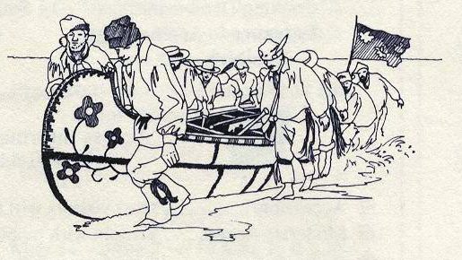

**This drawing of voyageurs pulling their birch bark canoe in to shore was taken from a March 1998 State of Michigan Historical Park pamphlet on Colonial Michilimackinac. The canoes, considered the workhorses of the fur trade, were sometimes 35 to 40 feet long.**

“A wild-looking set were these rangers of the woods and waters! …Picturesque, too, they were, in their red flannel or leather shirts, and cloth caps of some gay color, finished to a point, which hung over one side with a depending tassel.

“They had a genuine love for this occupation and muscles that seemed never to tire at the paddle and ore. From dawn to sunset, with only a short interval, and sometimes no midday rest, they would ply these implements, causing the canoe or barge to fly through the water like a thing of life; but often contending against head winds and gaining but little progress in a day’s rowing. But how sweet was the rest, when a favoring breeze sprung up, enabling the little craft to carry sail. Then in came the oars and down lopped each mother’s son, and in a few minutes was in the enjoyment of a sound snooze.

“The morning and evening meal consisted, almost universally, and from choice, of bouillon, a soup made from beans, peas, or hulled corn, with a piece of pork boiled in it, and hard bread or sea-biscuit. To the northern voyageurs rations were generally served hot, of one quart of hulled corn and half a pint of bear’s grease or oil, this being the daily and only food.”

Fort Michilimackinac, a military outpost, commanded the traffic of three lakes. As a commercial center, it controlled the rich fur region of Lake Superior and the upper Mississippi.

Father Dablon, a French Jesuit, began the Mission of St. Ignatius on Mackinac Island, or Michilimackinac Island, as the Indians called it, in 1670. The next year Father Marquette arrived and the mission was moved to the mainland of the Upper Peninsula, on the present site of St. Ignace, where there was already a fur station. A small fort was added for the mission’s protection and to regulate trade. The settlement was called Michilimackinac. It’s likely this is where Catherine’s brother Constant was born. He was born 23 Mar 1714 at Fort Michilimackinac. In 1715, soldiers began erecting a new Michilimackinac on the south side of the straits, at the site of the now-reconstructed fort in Mackinaw City. Catherine’s sister, Louise-Therese, was born there in 1721 and baptized 17 May 1721 and her sister Marie-Judith was baptized there 20 Oct 1724.

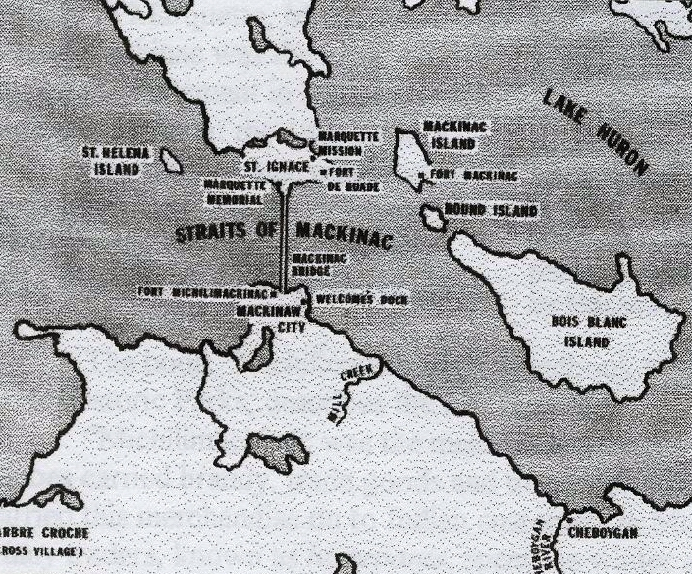

Catherine’s other siblings were born in Montreal. Only a few survived. The children of Ignace Jean dit Vien and Angelique Dandonneau were[7]7:

1. Marie-Josephe; b. 8 Apr 1711 in Montreal; buried there 20 Oct 1711.
2. Ignace; b. and baptized 11 July 1712 in Montreal; buried there 26 Mar 1714.
3. Constant; b. 23 Mar 1714 at Michilimackinac.
4. Ignace; b. Feb 1716; buried 20 Dec 1716.
5. Marie-Angelique; b. 3 and baptized 4 Mar 1717 in Montreal; buried 29 Aug 1717.
6. Philippe; b. May 1719; buried 18 Dec 1719 in Montreal.
7. Louise-Therese; b. 17 May 1721 at Michilimackinac.
8. Marie-Judith; b. 20 Oct 1724 at Michilimackinac.
9. **CATHERINE-ANGELIQUE**; b. 5 Jun 1726 at Michilimackinac.

According to questionable records[8]8 at the chapel at Fort Michilimackinac, Louise-Therese was a male who died at Detroit in 1743. The records also say that Marie-Judith married a Gendron and died at St. Joseph in 1744.

In *The Story of the Fort*, a paper by Howard H. Peckham of the William L. Clements Library found at the Marquette County Historical Society in Marquette, Mich., Fort Michilimackinac was the most important settlement in Michigan until near the middle of the 18th century.

Michilimackinac remained under French rule until the fall of Montreal in 1760, during the French and Indian War. The victorious English occupied the fort in 1761.

The book *Michilimackinac: A Handbook to the Site*, published by the Michigan State Historic Parks, describes the fort this way:

“Michilimackinac was the major depot for the northwestern fur trade. The large canoes carried brandy, trade goods and munitions from Montreal. Traders and voyageurs carried this merchandise on to Indian customers in Michigan and other locations beyond. Many traders, known as *hivernants*, spent the winter among Indian hunting camps. In spring, they brought their furs to Michilimackinac for shipment to Montreal. At the Straits, they rendezvoused with their friends and recent arrivals from Montreal and spent their wages in a few days of wild celebration.

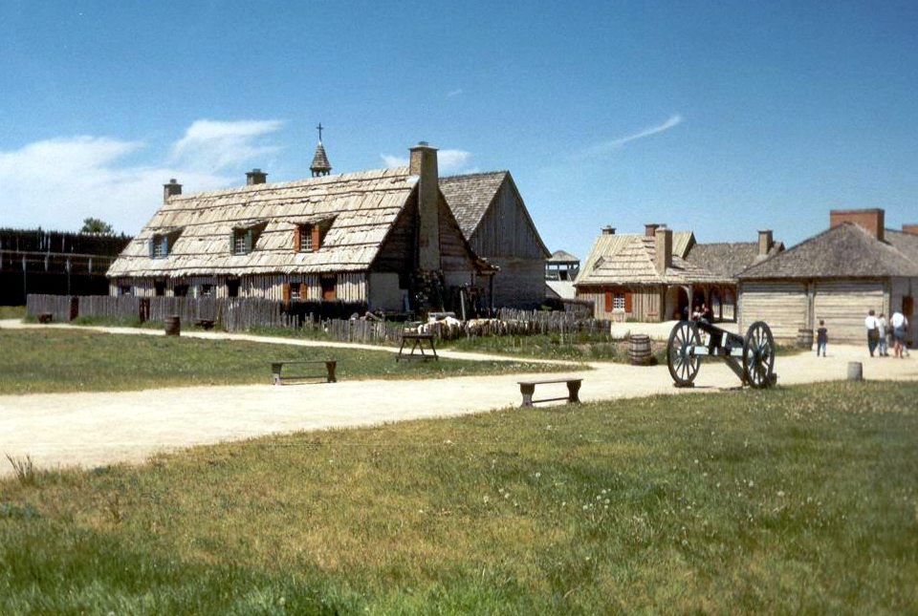

**Here’s an example of what voyageurs would have seen when they ventured into Fort Michilimackinac. This photo was taken in Mackinaw City, Mich., at Colonial Michilimackinac, which the Michigan State Historic Parks has been renovating since the 1960s. The photo was taken in the late 1990s.**

“Since most traders wintered among the Indians, few Frenchmen lived at Michilimackinac all year. By 1749, only 10 families and a garrison of about 20 soldiers resided at the fort. Few bothered to raise vegetables. Instead, they subsisted on corn, deer or moose grease, and fish purchased from Indians. Winters, when ice made canoe travel impractical, were long, cold, and lonely.”

### VIVIEN JEAN dit VIEN/CATHERINE GATEAU

**Maternal great-great-great-grandparents of Clareta Thibault**

**Parents of Ignace Jean dit Vien**

**Vivien Jean dit Vien,** the son of Vivien Jean and Suzanne Herault, was born in 1651. He was buried 6 Aug 1703 in Quebec. In 1669, he was a laborer at Tasdon, in the French parish of d’Aytre, near La Rochelle, Aunis, and the Charente River. In 1671, he lived in the outskirts of Tasdon, parish of St. Nicolas, La Rochelle, France. In 13 Mar 1669, his marriage contract to Anne Trollet was annulled at Rabusson (La Rochelle). It’s not known when he traveled to Quebec.

He married **Catherine Gateau**, daughter of Odart Gateau and Genevieve Doucet, on 29 Nov 1671 in Quebec, at Beauport. Catherine’s marriage contract to Abraham Albert was annulled 11 Oct 1671 in Becquet, Ile d’Orleans.

Catherine was from the outskirts of St. Marceau, parish of St. Medard, archdiocese of Paris. She died in Gentilly and was buried 21 Apr 1726 in Champlain, Quebec.

Vivien and Catherine were parents of nine children[9]9:

1. Noel; b. in Beauport and baptized 20 Aug 1672 in Quebec.
2. **IGNACE**; b. 13 July and baptized6 Aug 1673 in Quebec; married 1710 to **ANGELIQUE DANDONNEAU;** *engage Ouest* 12 June 1706.
3. Marie-Catherine; b. 31 Aug Charlesbourg, baptized 1 Sept 1676 in Quebec; married 1690 Jacques Sauvage.
4. Joseph; b. about 1679; married 1722 Jacqueline de Billy.
5. Marie-Madeleine-Angelique; b. 1680 Batiscan; religious convert at the Hotel-Dieu in Quebec (Sister of the Presentation), novitiate 9 Apr 1713, took vows 5 Feb 1715.
6. Pierre; b. 2 baptized 6 June 1685 in Champlain.
7. Jacques-Rene; b. and baptized 6 Jun 1685 in Champlain; died 3 and was buried there 4 Aug 1686.
8. Marie-Marguerite; b. 24 Aug 1688 in Champlain; married 1712 to Jean de Billy.
9. Michel; b. 19 Aug 1696 in Champlain; *engage Ouest* 23 Aug 1719.

**VIVIEN JEAN dit VIEN/SUZANNE HERAULT**

**Maternal great-great-great-great-grandparents of Clareta Thibault**

**Parents of Vivien Jean dit Vien**

**Vivien Jean dit Vien** was from Petit Fetilly, parish of St. Maurice, Aunis, France. According to the Father Christian Denissen Papers, he was born in 1595, the son of **Vivien Jean** and **Marthe Joslain**.

Vivien apparently traveled from France to Canada twice, first entering 30 Jan 1647 and again 13 Mar 1669, traveling from the French port of La Rochelle on the Bay of Biscay, France. He was an expert blacksmith[10]10, a “maitre marechal,” in La Rochelle in 1641 and at Ecoyeux, France, in 1650.

Vivien married **Suzanne Herault** of La Rochelle, Aunis, along the Charente River, before 18 Oct 1641. She entered Canada in 1669 and again on 28 Feb 1685, traveling from the port of La Rochelle.

Vivien and Suzanne had eight children[11]11:

1. Pierre; b. about 1643; married Francoise Favreau in 1671.
2. Elie; b. about 1645 in the outskirts of Tasdon, parish of St. Nicolas of La Rochelle; married in 1676 to Marie Gagne.
3. Marie; b. 27 Nov 1650 at St. Barthelemi in La Rochelle; married there 3 Aug 1677 to Jean Roy, a sailor from Poitou, France. It’s believed they ventured to Canada.
4. **VIVIEN**; b. about 1652, married 1671 to Catherine Gateau.
5. Suzanne; birthdate unknown; died about 1669. (Journeyed to Canada.)
6. Guillaume; born about 1661; married Marie-Anne Campagna in 1685; confirmed 19 May 1682 in Quebec; marriage annulled 8 Oct 1684.
7. Antoinette; birthdate unknown; marriage contract 8 Sept 1675 in Drouyneau, la Rochelle, with Jean Bidet, a wheelwright from St. Michel de May, Anjou. (Journeyed to Canada.)
8. Jeanne; birthdate unknown; died about 1675. (Journeyed to Canada.)

**VIVIEN JEAN/MARTHE JOSLAIN**

**Maternal great-great-great-great-great-grandparents of Clareta Thibault**

**Parents of Vivien Jean dit Vien**

Little is known about these French progenitors. According to Rene Jette, **Vivien** **Jean** died before 4 Aug 1639 and **Marthe** **Joslain** died after 1646. Since their son Vivien, the only child we know of, was born about 1595 in the parish of St. Maurice, Aunis, France, Vivien and Marthe could have been born 20 to 25 years earlier, about 1570 to 1575.

1. Father Christian Denissen Papers, Burton Historical Collection, Detroit Public Library.
2. Ibid
3. Ibid
4. Herbert Eugene Botton and Thomas Maitland Marshall, *The Colonization of North America – 1492-1783* (New York: The Macmillan Co., 1925) p. 422.
5. Herbert Eugene Botton and Thomas Maitland Marshall, *The Colonization of North America – 1492-1783* (New York: The Macmillan Co., 1925) p. 90.
6. Hubbard, *The early colonization of Detroit, Pioneer Collections – Report of the Pioneer Society on the State of Michigan* (Lansing: W.S. George & Co., 1877) Vol., P. 365
7. Rene Jette, Dictionnaire Genealogique des familles du Quebec, des origines a 1730 (Montreal, Quebec: L’Universite de Montreal, 1983) P. 594-597
8. Reuben Gold Thwaites, LLP. *Collections of the State Historical Society of Wisconsin, Vol. XIX*, 1910.
9. Rene Jette, Dictionnaire Genealogique des familles du Quebec, des origines a 1700 (Montreal, Quebec: L’Universite de Montreal, 1980) P. 594-597.
10. Ibid
11. Ibid