Chapter 11

NORTH TO THE UPPER PENINSULA

# George Moore/Eliza Wilson

**George Moore** was born on 10 Nov 1858 and baptized in Mt. Clemens 19 Dec 1858, 21 years after statehood and just at the time Michigan’s economy was exploiting its timber and mineral resources.

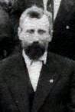

Between 1845 and 1860, a short 15 years, 116 copper mining companies were formed and in operation.[1]1 Ontonagon, Houghton, Rockland, Hancock, Calumet and other cities grew up with these mining operations. The great copper rush began in 1843, when a few prospectors arrived at Copper Harbor. The following spring the influx began in earnest. Every ship brought parties of copper hunters from the East. By 1869, the Upper Peninsula’s population had soared to 20,000[2]2.

In 1846 came the exploiting of the iron mines, bringing Marquette, Ishpeming, Iron Mountain, Bessemer, Ironwood and other cities into existence, followed by the completion of the Sault canal in 1855 and the opening of Lake Superior to the world. By 1857, the first railroad in the U.P. extended from Marquette to Ishpeming.

George Moore, taken on the occasion of his daughter Gertrude’s marriage in 1910.

But it was the lumber industry that was a part of George’s life as well as that of many young men at the time who spent a winter or two in a logging camp. At one time, George worked as a lumber camp foreman.[3]3 His brother, Leander, also worked in the lumber business. On the 1880 census for Mount Clemens, Leander listed his occupation as “working in a saw mill.” Some census records list the family name with the French spelling, More.

While it’s not known when he first made the move, George was living in the Upper Peninsula by 1883, perhaps part of a great migration of lumbermen to the U.P. in the 1880s. The harvesting, sawing and marketing of lumber dominated Michigan’s economy from 1860 to 1900, and the U.P. was no exception. The first sawmill in the U.P. was built at Sault Ste. Marie in 1822[4]4; others were built on the southern half of the U.P. on the Lake Michigan side.

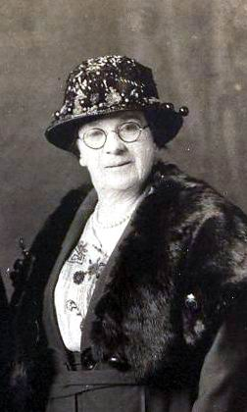

**Eliza Wilson Moore Fuhriman, about 1925.**

The sawmills were usually two-story buildings made of wood and located close to a river or lake. The work of cutting the timber was done in winter, when it was possible to transport logs to the banks of streams, using huge bobsleds. As soon as the ice melted in spring, and while the stream was still flooded, the logs were sent downstream.

The main rivers used by lumbermen were the Tahquamenon and the Ontonagon flowing into Lake Superior and the Escanaba and Menominee emptying into Lake Michigan. Lumberjacks were a hardy, tough lot, capable of heavy labor. Unlike the voyageurs, they did not sing while working; but in the bunkhouse in the evening, they sang ballads, most of them with a sad ending. When the hard winter’s work was over, the lumberjacks ventured into the nearest town to let off steam. The most notorious lumbering town in the U.P. was Seney.[5]5

George was 25 in 1883. He was living in Manistique and working as a laborer and apparently met 18-year-old **Eliza Wilson**, a Manistique resident, there. They were married in Manistique, in Schoolcraft County, on 25 Nov 1883. She listed her birthplace as Canada; George listed his as Mount Clemens. Eliza’s family name was written on the marriage certificate as Mcmann. It’s not known why the justice of the peace, A.L. Hill, did not list her name as Wilson.

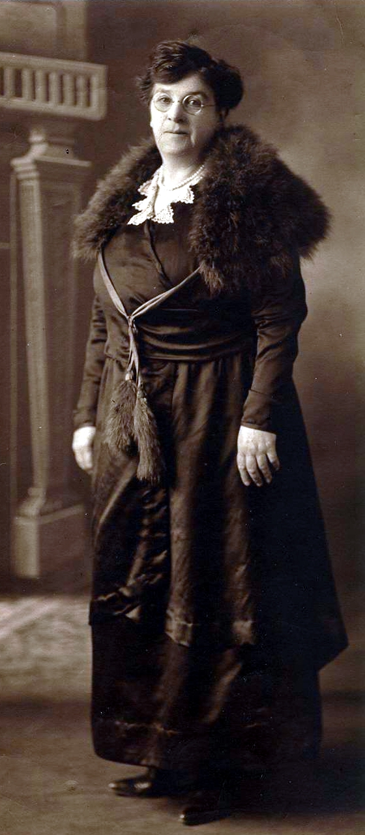

**Eliza Wilson Moore Fuhriman, taken about 1925.**

Mrs. J.C. Beckett of Manistique and Mrs. A.L. Hill of Manistique witnessed the marriage.

George’s birth and baptism are registered in Latin at St. Peter Catholic Church in Mount Clemens. His birth and baptism also were recorded by Father Christian Denissen and are part of Denissen’s papers in the Burton Historical Collection in the Detroit Public Library in Detroit.

Eliza’s death certificate from 14 Oct 1931 listed her as being “66 years, 7 months, 26 days” old, which would put her birthdate at 16 Feb 1865. Her daughter, Matilda, however, remembered her mother’s birthday as 18 Feb.[6]6

According to Matilda, who in 1964 was a widow and owned a rooming house in Duluth, Minn., Eliza and George lived in Rapid River (Masonville Township) and Trenary. They moved to the Delta County area at about the turn of the century.

Mrs. M.R. (Mabel Marie) Oslund of Escanaba, the granddaughter of Leander Lafayette Moore, writing in 1972 remembered in her youth visiting “Uncle George and Aunt Liza.” Leander, also called “Leo,” was George Moore’s half-brother. Leo was the son of Toussaint Moore, George’s father, and Toussaint’s first wife, Monica Charon.

“Our entire family,” wrote Mabel, “went to visit them on a Sunday afternoon and we had supper with them. In my young days this was a highlight, as we had no horses or car, so we walked. My Dad pushing the baby buggy and we other children walking ahead so Mom and Dad could keep an eye on us. But you didn’t have to worry about traffic in those days. The sidewalks were wood and the streets were dirt streets. You could get plenty dirty just going for a walk.”

George Moore died at 5 a.m. the morning of 7 Aug 1917 in Escanaba. According to an Escanaba newspaper, he was 61 years old and had been ill a long time.[7]7 But according to his death certificate, George was 60 years old when he died 7 Aug 1917 in Escanaba. He died of hepatitis. The death certificate mistakenly indicates he was born in Canada. His parents were not listed on the certificate.

George Moore’s funeral was held at 9 a.m. Friday, Aug. 10, 1917, at St. Anne’s Church in Escanaba, with the Rev. Father Jacques officiating. He was buried in St. Anne’s Cemetery but the church as late as 1972 could not find his grave; the front section of Holy Cross Cemetery in Escanaba is the old St. Anne’s Cemetery.[8]8 It could be that George was interred at Holy Cross, in either an unknown grave or a lot under someone else’s name.[9]9

**GEORGE MOORE11 (TOUSSAINT10** and Clareta Thibault); b 10 Nov 1858, baptized Mount Clemens 19 Dec 1858[10]10; d. 8 Aug 1917 in Escanaba; buried St. Anne’s Cemetery, Escanaba.

**ELIZA WILSON;** (LEVI GEORGE WILSON and MARY DOLAN[11]11; b. 18 Feb 1865 in Michigan; d. 14 Oct 1931 in Rapid River, Masonville Township.

The children of this marriage were:

1. Elmer Moore
2. Myron Moore
3. Roy Moore, b. 27 May 1900 in Masonville Township[12]12.
4. **GERTRUDE12;** b. 5 May 1896 in Rapid River; married Ira Bannister 14 Oct 1910; d. 18 Dec 1949 in Escanaba; buried in Rapid River.
5. Belle Moore**;** married William Gagnon.
6. Matilda Moore, known to Andy Bannister as “Auntie Mack”; married Earl Bowers and lived in Superior, Wis.; then was widowed and married Phil Vitten; then was widowed and married Ed Byers and lived in Duluth, Minn.
7. Margie (or Clarissa); married Wilbur Moore and lived in Port Allegheny, Pa. Andy Bannister believed she had her name changed when she married a second time.

Andy, Bill and Gladys Bannister (children of Ira Bannister and Gertrude Moore) believed their grandmother Eliza Wilson gave birth to another girl, named Margaret, whose father was an O’Brian. They did not believe Eliza and O’Brian were married but O’Brian raised Margaret. In later life Margaret lived in Milwaukee.

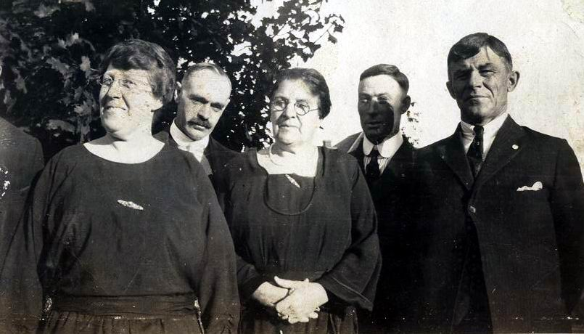

Eliza Wilson Moore Fuhriman, center, with some members of her family. From left are sister Anne Brink; an unidentified man; Eliza; an unidentified man; and George Fuhriman.

After George’s death, **Eliza Wilson** married a second time, to George Fuhriman of Rapid River. She died at her home in Rapid River at 10 p.m. 14 Oct 1931[13]13. She had been ill with pneumonia and heart trouble for two weeks. Her death certificate listed her father as George Wilson, born in Canada, and her mother was unknown. (Her daughter Matilda has said her grandfather’s name was Levin.) Her occupation was listed as housewife. She was 66.

Eliza had moved to Rapid River in 1922. She had lived in the area since about 1901. She was a member of the Order of Rebecca at Gladstone.

Another clipping from an unidentified newspaper said this about Eliza Wilson’s funeral:

“Funeral services for Mrs. George Fuhriman of Rapid River were held Saturday afternoon at 2 o’clock at the family home and at the Congregational church at 2:30, with Rev. H. Heafield of Garden officiating. The many flowers received from a wide circle of friends proved the esteem in which the family is held in the community.

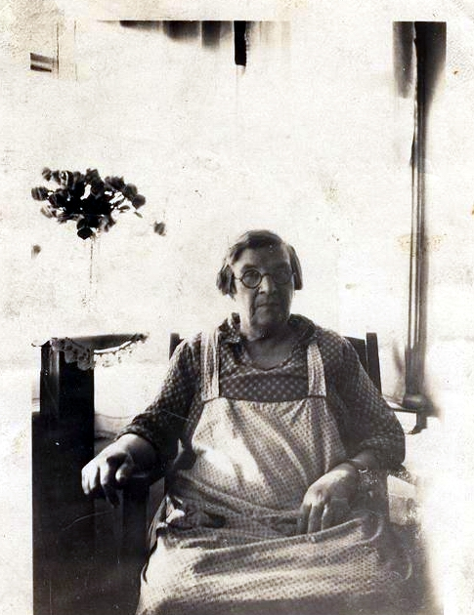

Eliza Wilson Moore Fuhriman, taken in later life.

“The pallbearers were James McPherson, Sam Minor, Andrew Bannister, Henry Pfeiffer, Mr. Tebo and Angus Pineau.

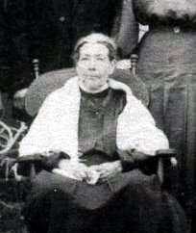

**Mary Dolan Wilson, on the occasion of her granddaughter Gertrude’s wedding to Ira Bannister in 1910.**

“Out-of-town relatives were Mr. and Mrs. Wilbur Moore, Alleghany, Pr. {Pa.}; Mr. And Mrs. Robert Wilson, Crystal Falls; and many friends from Escanaba, Gladstone and Groos.

“Burial was in the Rapid River cemetery.”

Little is known about Eliza Wilson’s parents, George “Levi” Wilson and Mary Dolan, although a photo was taken of Mary Dolan at her granddaughter’s wedding to Ira Bannister in 1910.

Mrs. Lee George (Alice) Wilson of Wakefield, answering a request for information in June 1972, wrote that George Wilson and Mary Dolan had several children:

1. Robert Wilson; married Catherine Daugherty. Children were Lee, George, Maude, Grace, Robert Jr. and Maybelle. Alice Wilson wrote that Lee George was born 20 Jan 1887 in Manistique, was married 9 Aug 1911 in Crystal Falls, and died 3 Jun 1961 in Wakefield, where he is buried. He attained a Ph.D. but it’s not known in what course of study. According to Robert Jr., Robert Wilson died 26 Jan 1939 at the age of 71 years seven months and four days. He was buried in Crystal Falls. He died of a cerebral hemorrhage. He was born in Canada. He was chief of police in Crystal Falls. His father’s name was Levi. Alice Wilson believed George Wilson and Mary Dolan were buried in Manistique. She also believed they came to the United States from Canada.

**2. ELIZA WILSON**, b. 18 Feb 1865 in Michigan; d. 14 Oct 1931 in Rapid River, Masonville Township.

3. William Wilson, lived in Roscommon.

4. Anne, married a Brink, lived in Manistique; according to Bill Bannister, grandson of George Moore, Anne’s children with Brink were Levi, Delbert and Margaret; she later married a man named Saley and with him, had a son named Billy John.

5. Jane Wilson, married Levi Fred Vidal.

6. Daughter; married a Tuck; children were Reginald and Grace; lived in Sarnia, Canada.

1. Joseph H. Steere, *The Upper Peninsula: A Sketch*, read before the Witenagemote Club of Detroit; some time after 1913; published by the Michigan Historical Commission; copy Peter White Public Library, Marquette.
2. Willis F. Dunbar, *Michigan: A History of the Wolverine State*, (Wm. B. Eerdmans Publishing Co., Grand Rapids, 3rd printing Aug. 1966) P. 358.
3. Questionnaire answered in 1964 by Mrs. Ed (Matilda) Byers of Duluth, Minn., George Moore’s daughter.
4. Willis F. Dunbar, *Michigan: A History of the Wolverine State*, (Wm. B. Eerdmans Publishing Co., Grand Rapids, 3rd printing Aug. 1966) P. 474.
5. Ibid, 477.
6. Questionnaire answered in 1964 by Mrs. Ed (Matilda) Byers of Duluth, Minn., George Moore’s daughter.
7. Escanaba Daily Mirror, Wednesday, Aug. 8, 1917, P. 1, col. 3.
8. Letter of July 12, 1972, the Rev. Glen G. Weber, pastor at Saint Anne’s Rectory, Escanaba.
9. B. Morin letter of 28 Oct 1965, Holy Cross Cemetery, Escanaba.
10. Father Christian Denissen Papers, Burton Historical Collection, Detroit Public Library.
11. Questionnaire answered in 1964 by Mrs. Ed (Matilda) Byers of Duluth, Minn.
12. William E. Butler, Delta County Clerk and Register of Deeds; letter dated Nov. 4, 1968.
13. Obituary, Escanaba Daily Press, Pg. 2 Col. 3, Thursday, Oct. 15, 1931.