Chapter 12

THE BANNISTER CONNECTION
Gertrude May Moore/Ira Bannister

Gertrude May Moore, the daughter of George Moore and Eliza Wilson, was born in the late 1800s but her exact birth date is difficult to pin down. The family believes she was born 5 May 1896 and her gravestone (1896-1949) seems to support that. But a copy of Gertrude’s baptism certificate prepared by the Rev. Robert A. Haas in 1972 says this: Gertrude was born in Rapid River on 1 May 1895 and she was baptized on 23 Aug 1896 at Saint Charles Borromeo Church, Rapid River, Mich. She was baptized by the Rev. J. A. Saurial (handwriting is difficult to read). Sponsors were Samuel Menard and Annie Guernore (illegible).
The Delta County Clerk’s office in Escanaba was unable to find a record of Gertrude’s birth.1 However, her death record, obtained from the clerk’s office, lists her date of death as 18 Dec 1949, when she was “54 years, six months and 13 days old.” That would make her birth date 5 Jun 1895. The most logical date is 5 May 1896, the date based on family knowledge.
Gertrude married Ira Bannister 14 Oct 1910 in Escanaba.
Gertrude died in Escanaba on 18 Dec 1949 of a coronary occlusion. Her occupation was listed on the death record as housewife. Her obituary in the Escanaba Daily Press said Gertrude had lived in Rapid River for 18 years and four years in Nahma.
Kelly Funeral Home arranged the funeral. The services were held at the family home in Nahma and St. Paul’s Episcopal Church in Nahma, the Rev. Herbert Wilson officiating.

GERTRUDE MAY MOORE12; (George11 and ELIZA WILSON); b. 5 May 1896 in Rapid River, Mich.; m. Ira Bannister 14 Oct 1910; d. 18 Dec 1949 in Escanaba; buried in Rapid River, Whitefish Hill cemetery.
IRA BANNISTER; (ANDREW BANNISTER, a teamster, and HENRIETTA BLADES); b. 14 Oct 1891 in Negaunee2; d. 8 Nov 1954 in Escanaba; buried in Rapid River.
Children of Gertrude Moore and Ira Bannister were:
1. Curtis Lee; b. 26 July 1911 in Trenary; m. 1st Evelyn Laundre on 3 Nov 1931 at St. Charles in Rapid River by Father Guetern; m. 2nd Theresa M. “Patricia” Ross Hall; d. 16 Aug 1981.
2. Gladys May; b. 9 May 1913; Canada; m. Adolph Vietzke 25 Jun 1930, at German Lutheran Church in Rapid River, Rev. Hoffman.
3. Vivian Lyall; b. 14 Feb 1915 in Canada; m. Stanley Mosier 25 Aug 1933 by a Justice of the Peace and were remarried in Rapid River at St. Charles Catholic Church; d. 2 Apr 1993.
4. Violet Pearl; b. 2 July 1917, Escanaba; m. Paul Parlette 15 Aug 1934 in Gladstone by a Rev. Lund.
5. Grace Irene; b. 23 Feb 1919 in Flat Rock; m. 25 Jul 1942 to Arnold Turan (d. Feb 1988) at Garden, Father McKivit; d. 11 Oct 1987.
6. ANDY GORDON13; b. 10 Mar 1921 at home in Flat Rock (too much snow to drive to hospital, he said); married Ellen Mae Stenlund 24 Oct 1942 at the Swedish Lutheran Church in Gladstone; died 15 May 1995.
7. William; b. 10 Jan 1929 in Rapid River (Maplewood); d. 3 Aug 1993.
(Information on the children came from Andy Bannister’s memory and from the family Bible of Alexander Williamson and Alberta A.L. Blades, who were married in Strathaven on 9 Mar 1881. E.D. May Holm, Ira’s sister, said she could not identify Williamson and Blades but one of the witnesses at the wedding, George Blades, was Ira’s uncle on his mother’s side.
Ira Bannister, taken when he was about 18 years old.
Gertrude’s family was living in Trenary when she met Ira Bannister, whose parents, Andrew and Henrietta Bannister, lived in Winters, a settlement just north of Trenary, Mich. on a farm that still stands today.
Ira attended Walls School in Winters in 1905.
Ira and Gertrude were married 14 Oct 1910 at Gertrude’s mother’s home in Trenary. The Rev. John R. Kay, pastor of the M E Church (Methodist Episcopal), performed the ceremony. Witnesses were Leonard Berg of Winters, and E.D. May Bannister of Winters.3 E.D. May was bridesmaid; Olie Holm was best man.
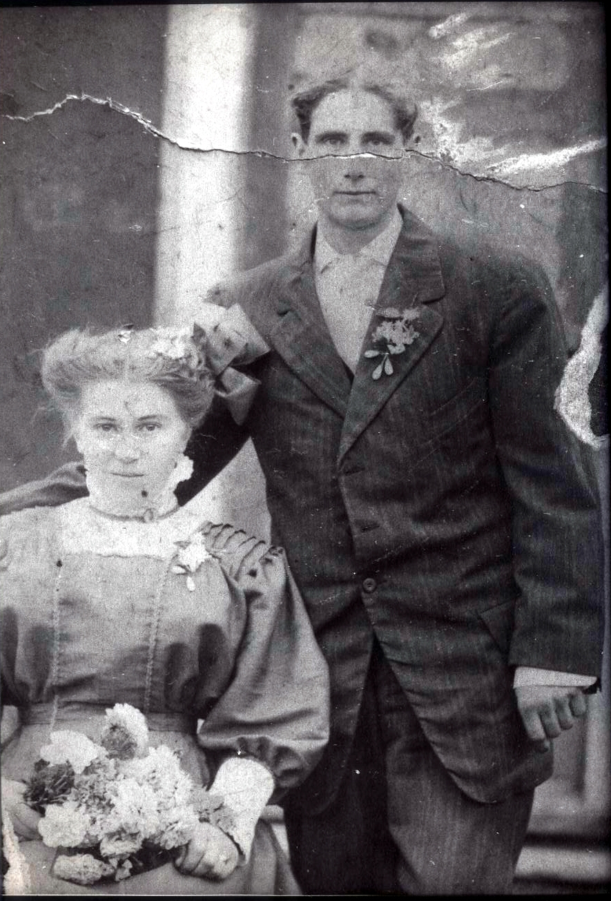The marriage license was acquired on 10 Oct 1910. Ira was 21 years old, a laborer who lived in Winters. Gertrude was 16 and still lived at home, in Trenary. Her father filed consent papers that allowed her to marry.
Gertrude Moore and Ira Bannister, likely taken on their wedding day.
The marriage license listed Ira’s parents as Andrew Bannister and Etta Blades; her parents were George Moore and Eliza Wilson. Neither had been married previously.
During their lifetime together, Ira worked as a farmer, a carpenter, a barber at the Delta Hotel in Escanaba, a laborer at the Mead Paper Mill north of Escanaba and a sawmill worker in Nahma. During World War II, Ira and Gertrude lived in Detroit, where he worked as a night watchman at Timkin Bearing Co. and in Nahma.4
From Trenary, Andrew and Henrietta moved to Saskatchewan some time between 1910 and 1913 around Grace Lake, Regina (Duck Lake). Andrew had a large grain farm there. Henrietta’s family lived in Saskatchewan. Ira and Gertrude visited Canada often. Their first child, Curtis, was born in 1911 in Trenary, but their next two children, Gladys and Vivian, were born in 1913 and 1915 in Canada. Violet, their fourth child, whom the family called “Doonie,” was born in 1917 in Escanaba, Mich. The family then apparently stayed in Michigan, where their last three children were born.
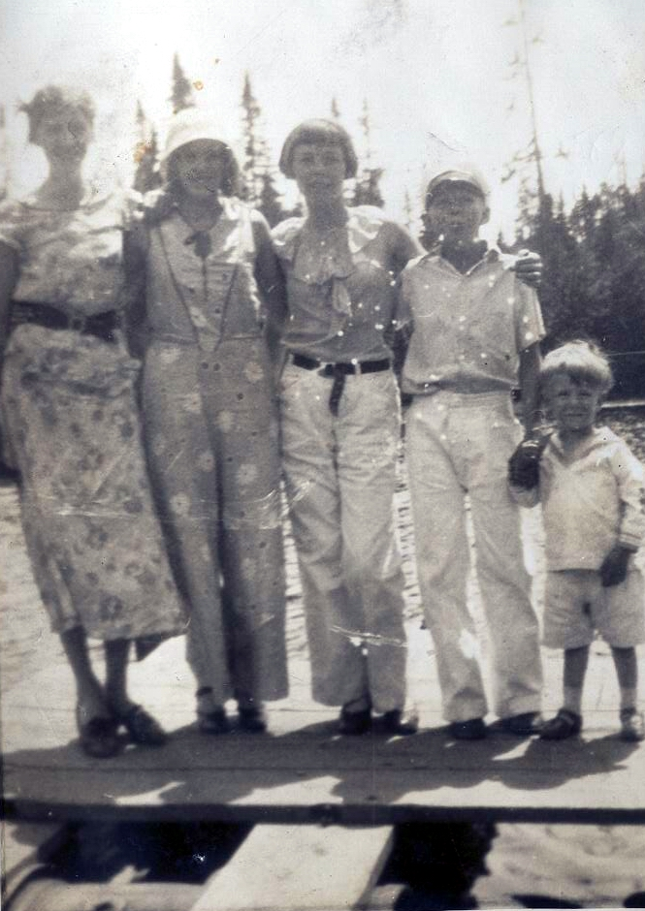Gertrude and Henrietta apparently did not get along. According to Ira and Gertrude’s son, Bill, Henrietta was Gertrude’s midwife when Gladys was born. Ira and Gertrude were living in a small house on Andrew Bannister’s farm. Henrietta decided to keep the child in the Big House, and Gladys did not return to her parents until she was 11 or 12 years old. (Andrew and Henrietta may have moved back to Michigan then.)
Back in Michigan, Ira and Gert moved into a cabin in 1927 behind Fuhriman’s store north of Rapid River, owned by George Fuhriman. Fuhriman had married Eliza Wilson (George Moore’s wife and Gertrude’s grandmother) after Moore died in 1917.
Gertrude worked at the store, which was a combination gas station and distillery during Prohibition.5
Children of Ira and Gertrude Bannister, from left: Gladys, Violet, Grace, Andy and Bill. Curtis, the eldest son, was not in the photo.
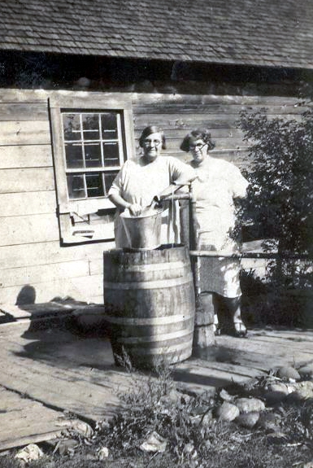It was Gertrude who left this saying, which her son Andy turned into a poem without rhyme: “Isadore, Isadore, get the crowbar. The penny’s in the crack and the lady wants her change.” Andy recited it with a W.C. Fields accent, usually hopping from foot to foot.
Ira and Gertrude moved to Flat Rock (Groos) before their son, Andy, was born in 1921. Both Andy and Grace were born there. Ira worked at the Mead paper mill and Curtis brought his lunch bucket to his father every day.6
Ira and his son, Andy, built a log cabin about three miles north of Rapid River in 1935. The family was living in the log cabin in 1941.
Gertrude Moore Bannister, left, unidentified woman at right.
Ira’s daughter, Grace, and her husband, Arnold Turan, built another house on the homestead in the 1950s. The log cabin stood empty for many years although it was used by several of the children off and on. It was torn down after both Grace and Arnold died and their home was sold.
Ira and his two sisters, Eva and E.D. May, were baptized together on their parents’ farm north of Rapid River.7 E.D. May lived for a time in Escanaba, Mich., and then married Olie Holm, who died in Weyburn, Saskatchewan. She then went back to Escanaba and married Hugo Fenske. He died in Escanaba. Then she went to live with her daughter, Lavinia, in South Beloit, Ill. She returned to Saskatchewan 9 Apr 1952 and married Gustaf Holm, Olie’s brother, on 12 Oct 1952. She had two children by her first marriage, Homer and Ralph, and two by her second marriage, Hugo Jr. and Lavinia. Eva had four children, three of whom lived: Floyd, Zeta and Russell. The first child died soon after birth.
Ira Bannister is buried at the Rapid River cemetery on Whitefish Hill. His gravestone reads: BANNISTER – Father – Ira J. 1891-1954. Mother – Gertrude – 1896-1949.

ANDREW BANNISTER/HENRIETTA BLADES
Parents of Ira Bannister

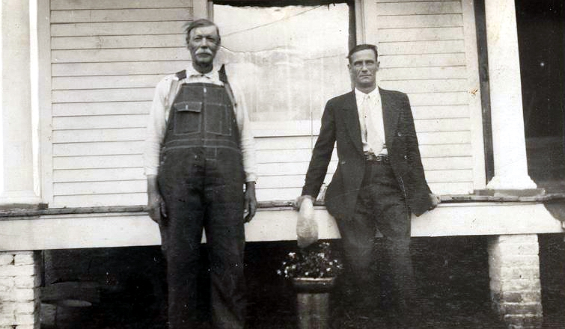Andrew Bannister was 24 years old when he married Henrietta Blades on 8 Aug 1888 in Amabel, Bruce County, Ontario. He was the son of William Bannister and Elizabeth Tedford.8
Andrew was born in Bentick Township, Ontario. Henrietta (spelled Heneratta on the information extracted by the Office of the Registrar General in Toronto for genealogical purposes) was 18 years old when they married. She was the daughter of Elizabeth and Frances Blades and was born in Williamsford, County Grey.
Andrew Bannister, left, and his son, Ira. The photo was taken in about 1910.
Children of this marriage included:
- IRA J.; b. 14 Oct 1891 in Negaunee; m. Gertrude Moore 14 Oct 1910.
- Edith, known as E.D. May; 8 May 1894 in Winters; m. 1st Olie Holm (children Homer, Ralph); m. 2nd Hugo Fenske (children Hugo Jr., Lavinia); m. 3rd Gustaf Holm, 12 Oct 1952.
- Eva; b. 23 Oct 1889 in Canada; m. Henry Ross (children Floyd, Zeta, Russell, one died at birth.
- Ludington; b. 4 Mar 1899; d. 21 Mar 1899; buried in Trenary Cemetery, Michigan.
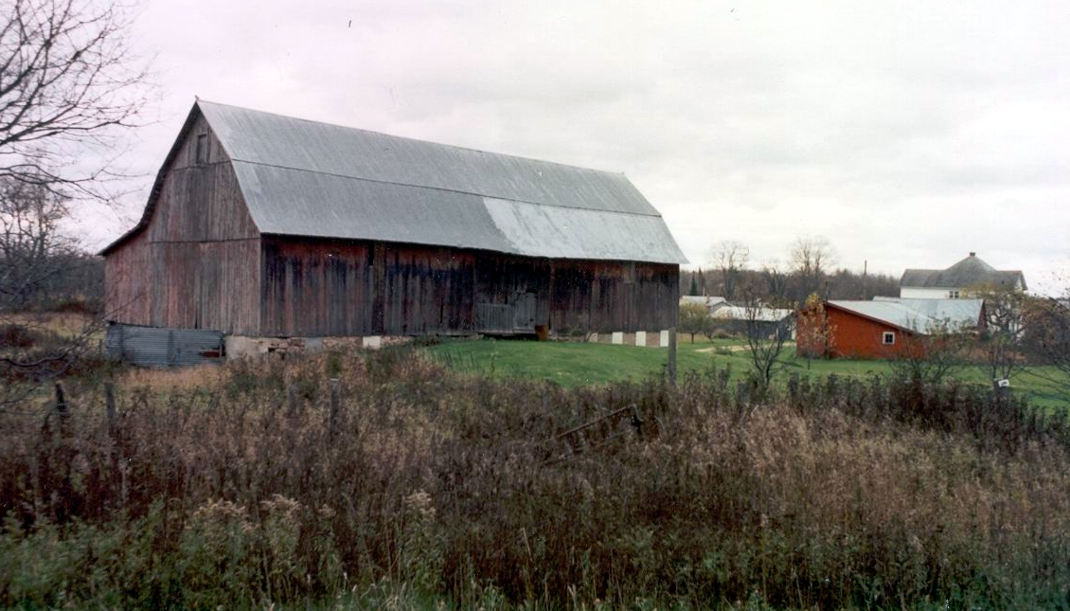According to his daughter, E.D. May Holm, Andrew was born in Hanover on 10 Mar 1864. He was baptized in the Methodist Church. He died in Rapid River on 24 Sept 1946 and was interred in the Trenary Cemetery at Trenary.
Andrew’s places of residence included Hanover, Ontario; Negaunee, Mich.; Winters, Mich.; Foam Lake, Saskatchewan; Escanaba, Mich. and Rapid River, Mich. He was a farmer and worked in a pulp mill. E.D. May listed the marriage date as 18 Aug 1888. She believed he farmed on the C Line when he married Henrietta. In 1890 they moved to Trenary and in 1916 to Rapid River, according to his obituary in the Escanaba Daily Press.
The Bannister farm in Winters was still standing when this picture was taken in the early 1990s. The home at right was not original. But the barn was the same one erected by Andrew Bannister when he bought the property in 1904, according to the present owner.
At the time of his son Ira’s birth in 1891, Andrew worked as a teamster in Negaunee, according to Ira’s birth certificate.
In 1904, Andrew bought a farm in Winters, north of Trenary, from Walter Grainger for $675. The contract was dated 5 Sept 1904 and a deed was recorded 4 Oct 1904, according to an abstract of the land.
The Andrew Bannister family was counted in the 1910 census for Alger County, Mathias Township. According to census records, the family included Andrew, who was 46 and had been married 21 years; Ira, who was 18 and single; and Edith, who was 15 and single. There was no mention of wife Enrietta. The census continued to say Andrew’s father was born in Ireland. Andrew came to the United States in 1890. Andrew was a farmer; Ira was a laborer. All three were able to read and write. Andrew owned the farm, which was not mortgaged. He was a naturalized citizen.
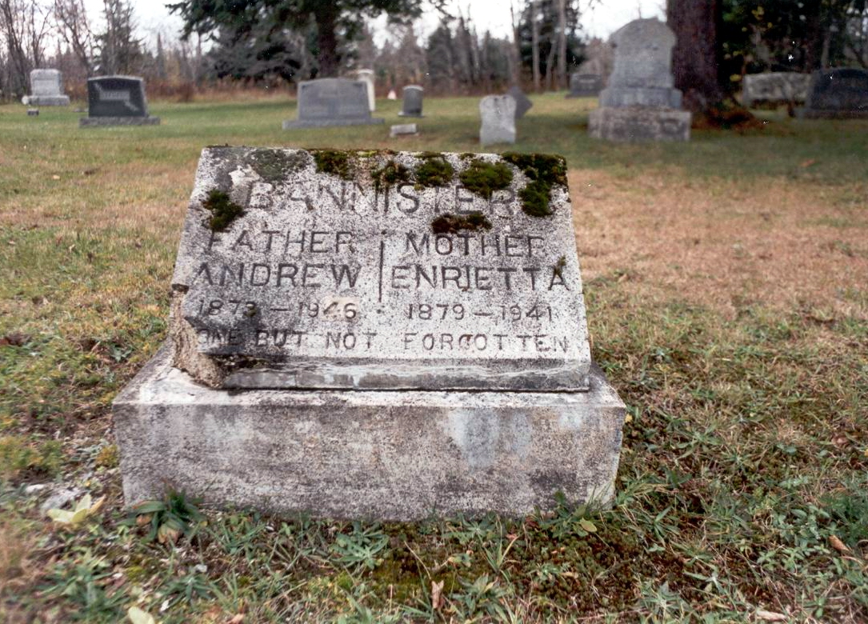Andrew and Henrietta Bannister lived in Rapid River when their grandson Andy, Ira’s son, was going to Rapid River High School. They lived in a white house directly across from the high school. Andy remembered his grandmother as sickly and confined to bed. Andy walked to school every day and his grandfather always made him breakfast.
The headstone of Andrew and Enrietta Bannister still stands in the Trenary Cemetery in Trenary, Mich.
According to Andy, Andrew got the Rapid River house by trading with Lowell Thibault for a white farm house (it was called Maplewood) that Andrew owned about five miles or so north of Rapid River. Andrew and Henrietta apparently moved into town in 1939, when Henrietta became ill.
According to Andrew’s obituary, he died 24 Sept 1946 at the age of 82 at his home north of Rapid River. His death was caused by “complications attendant with old age.” He had four sisters and two brothers living in Canada at the time. The Kelly Funeral Home arranged his funeral. His body was returned to the family home for funeral rites conducted by the Rev. Karl J. Hammar.
Andrew was a widower when he died. His wife, Henrietta, had died in 1941.
The obituary for Mrs. Andrew Bannister was published in the Escanaba Daily Press Tuesday, May 13, 1941 edition, Page 7, Column 8. It reads:
“Rapid River woman claimed by death.
“Mrs. Andrew Bannister, 71, passed away at the family home in Rapid River Sunday morning at 10:30 following an illness of two years duration. She had been an invalid for the past 18 months.
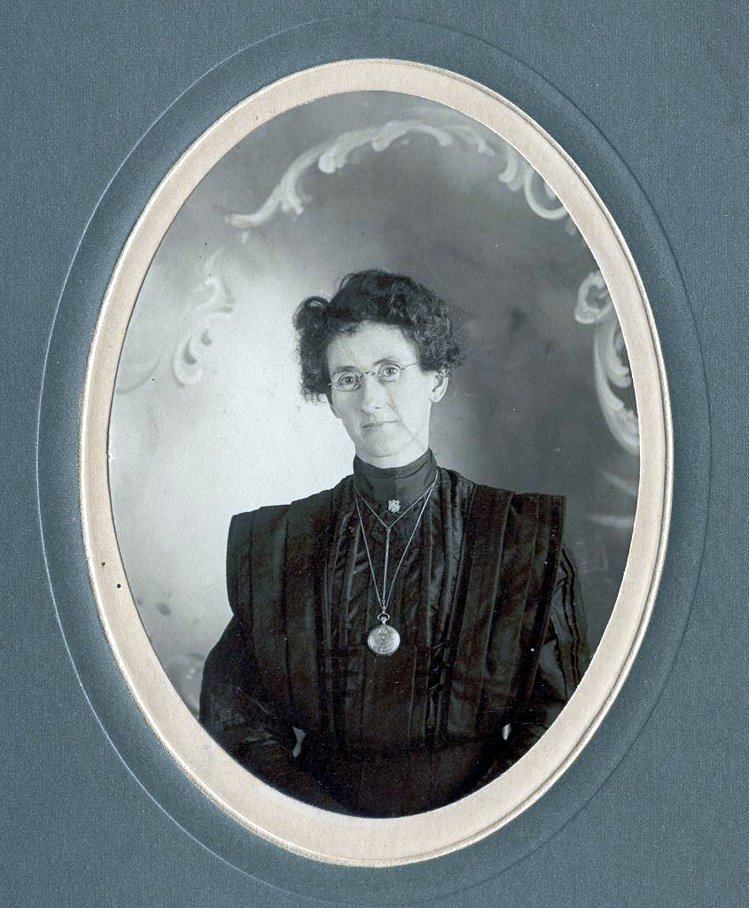“Mrs. Bannister, nee Henrietta Blades, born March 27, 1870 in Canada, and on Aug. 8, 1889, while still in Canada, was united in marriage to Andrew Bannister.
“The family resided in Escanaba for years previous to going to a farm north of Rapid River, which they occupied for nine years, moving into Rapid River 18 months ago.
“Surviving are the widower; one son, Ira, of Rapid River; two daughters, Mrs. Henry Ross, Rapid River, and Mrs. Hugo Fenske, Escanaba; three sisters, Mrs. Vina McNabb, Seattle, Wash., Mrs. William Gower, Hardesty, Alberta, Canada, and Mrs. Henry Elmer, Tweedy, Wash.; and two brothers, George and Ransom Blades, both of Seattle, Wash.
“The body was removed to Swenson Brothers funeral parlors.
“Last rites were conducted Wednesday afternoon at 2 o’clock at home in Rapid River, the Rev. Karl Hammar, Escanaba, officiating. Burial will be in the family plot in the Trenary Cemetery.”
Henrietta Blades Bannister
The Bannister gravestone reads: “Bannister – Father Andrew, 1873-1946; Mother Enrietta, 1879-1941. Gone but not forgotten.”
According to her death certificate, Henrietta died in Masonville Township, Delta County, Michigan. She had spent 11 years in the community. Her birth date was listed as 27 Mar 1870. She was a housewife. Her parents were Taun Blades and Elizabeth Bernard. Both were born in Canada.
From left are Andrew Bannister, friend Ralph Holm and Enrietta Blades Bannister in a photo from the 1930s.

TAUN BLADES/ELIZABETH BERNARD
Parents of Henrietta Blades

Henrietta’s father was Taun Blades, who was born 2 Apr 1846 near Windsor, Ont. He was the only boy of the family. Taun married Elizabeth “Lizzie” Jane Bernard, Henrietta’s mother, on 26 Dec 1868 and moved to Michigan in 1890. They had six children. Taun died in July 1910. He was a small man, with gray eyes and curly hair, and “loved by all,” according to his daughter, Florence.
According to a genealogy by Theresa B. Smith of Spokane, Wash., Taun was born in Pickin, Windsor, and was probably named after his father to carry on the tradition. Taun and Elizabeth moved to Michigan in 1890, when their youngest child, Florence, was 3 months old. They had six children, two boys and four girls.
Taun Blades took up a homestead a few years later near Winters and the family lived there until 1902. This homestead was in the dense timberland miles away from the nearest town. Taun Blades engaged in truck farming.
He was naturalized in AuTrain, Alger County, on Wednesday, May 19, 1897.
On March 2, 1902, the family moved to North Bend, Wash. In October 1906, another move was made, this time to the eastern part of Stevens County, which later became Pend Oreille County, Washington, near Newport. Here, his son Ransom, took up a homestead. A group of log buildings were built which are still in a good state of preservation (in 1940).
While engaged in woods work, a pine needle became lodged behind one of Taun Blades’ eyeballs, causing a tumor. This brought about his death at the home on 7 Jan 1910. He was buried in the Newport Cemetery.
Taun Blades and Elizabeth Bernard Blades, as depicted in a tintype dating back to 1882. The photocopy is courtesy of Gertrude Clark, great-great granddaughter of Taun Blades. Although it is of poor quality, it is the only photo we have of the two.

Taun Blades was a small man, weighing about 180 pounds. He had twinkling gray eyes, curly brown hair, and wore a beard. A love of humor and hospitality made him popular and his home a gathering place.

TAUN BLADES/UNKNOWN
Parents of Taun Blades

Taun Blades was the son of Taun Blades, who came to Canada from Cornwall, England. The senior Taun Blades was the only boy in his family. As far back as is known, there had been only one boy in each Blades family. The wife of the senior Taun Blades may have been German or English. They lived at Sullen, Ontario, where both died near Windsor, Ontario. After the elder Taun Blades died, his wife married again. Her second husband’s name was Newlove Hanley. He had a peg leg and kept a small store and many hives of bees.
The senior Taun Blades and his wife had five children: Taun, b. 2 Apr 1846, d. 7 Jan 1910; Elizabeth; Allie, who married a Williamson; Ena, b. 1 Aug 1865 in Canada and married Alex Laycock and died 5 May 1933; and Mary, who married Jack Gollie of Holland Center, Ontario.
Elizabeth Jane Bernard, “Lizzie,” was born 18 Apr 1852. She married the junior Taun Blades at Twinbery, Ontario, Canada and shared his life until his death. Later she moved to Montana in the Bitterroot Mountains, at Chester, with her son, Ransom, where she took up a homestead, and he raised horses. Still later they moved to Irma, Alberta, Canada in 1918. They left Canada in the fall of 1922 and returned to the United States, living at Newport and Seattle.
The headstone of Elizabeth Jane Bernard Blades, found in the Trenary Cemetery, Trenary, Mich.
After Ransom’s marriage, she lived at Newport with her daughter, Florence Elmer, for a time and then went to Rapid River to live with her eldest daughter, Etta Bannister, in whose home she died on 29 July 1931. She was buried on 1 Aug 1931. Her gravestone reads Elizabeth Jane, Wife of Taun, 1852-1931, Blades.
Her death certificate, on file at the Delta County Clerk’s office, lists the cause of death as old age, a stroke. Swenson Brothers Funeral Home of Gladstone arranged her funeral. The funeral was held at the home of her daughter, Enrietta, and at the Congregational Church in Rapid River, with Oscar Lund of Whitefish officiating. Survivors included her daughters, Anna Gowers of Hardisty, Alberta; Vina (Sophia Nulivinia) McNabb of Seattle; Florence Elmer of Newport, Wash.; Enrietta Bannister, of Rapid River; George of Blanchard, Idaho; Ransom of North Bend, Wash.; 22 grandchildren, 20 great grandchildren and one great-great-grandchild.

WILLIAM BERNARD/UNKNOWN
Parents of Elizabeth Jane Bernard

Elizabeth was the daughter of William Bernard. Her mother’s name is unknown.
William was born in England in 1811 and joined the army when he was 16 years old. He served Queen Victoria for 15 years as Life Support, and went through field day or sham fight for the queen before she was crowned. One of his sisters bought him out of the army when he was about 40. He then came to Canada, at Line, and settled on a homestead at Windsor, County Essex, Ontario. He lived there until he was more than 80 years old. When he died, he was buried at Comber, Ontario, which is near Windsor.
There were 10 children in William Bernard’s family.
His wife was born in England and died at Comber, in Essex, Ontario.
Children of William Bernard include: Robert, William, Elizabeth Jane, Annie and Sopia.

WILLIAM BANNISTER/ELIZABETH TEDFORD
Grandparents of Ira Bannister

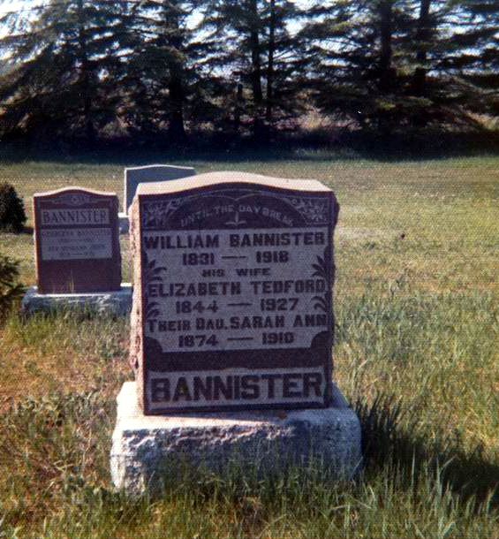William Bannister and Elizabeth Tedford both were born in Northern Ireland. They were the parents of Andrew Bannister and were considered pioneers of Amabel Township in Ontario.9
The gravestone of William and Elizabeth Bannister in Hepworth, Ontario. (Photo courtesy of Gertrude Clark)
William Bannister was born 20 Mar 1831 in Armagh County, Ireland, the son of Andrew Bannister and Elizabeth (surname unknown). He died 21 Apr 1927, at the age of 87 years.
He was a retired farmer. The cause of death was senile gangrene. The attending physician was Dr. F. Campbell. He had been ill for three weeks and suffered from asthenia (weakness) for ten days.10
A copy of his obituary (newspaper unknown) reads:
“Death of Mr. Wm. Bannister.
“After an illness of two years, Mr. Wm. Bannister passed away at his home near Hepworth, in Amabel Twp., on Sunday, April 21st, at the age of 87 years and one month.
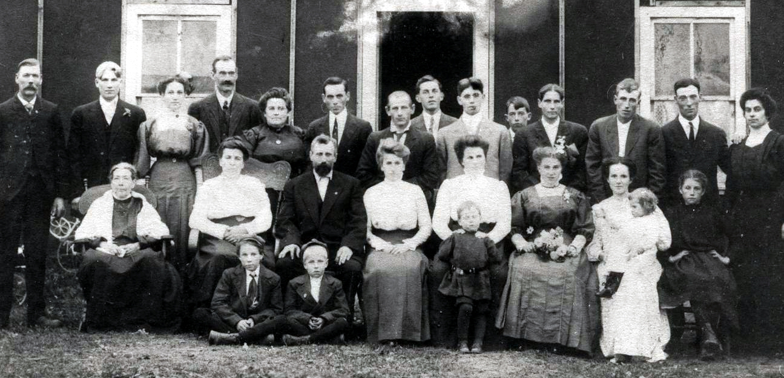 “He was born in the County of Armagh, Ireland, and came to Canada when he was 16 years of age. He was married 51 years ago, near Hanover, to Elizabeth Tedford. After living at Hanover for five years, they moved to Elmwood, where they lived for ten years, later coming to their present home in Amabel township, where they have resided for thirty-eight years.

Family members gather on the occasion of Gertrude Moore and Ira Bannister’s wedding in 1910. In back from left are Andrew Bannister, father of Ira; Olie Holm; E.D. Mae Holm, Olie’s wife; Henry Ross; Eva Ross, Henry’s wife; unknown; Philip Viton; unknown; Willie Gagnon; unknown; Ira; Elmer Moore; Levi Brink and Margie (Clarcy). In front are Gertrude’s grandmother, Mary Dolan Wilson; Eliza Wilson; George Moore; Ira’s aunt, Matilda Viton, Phil’s wife; Ira’s aunt, Belle Gagnon, wife of Willie; Gertrude; Elmer Moore’s first wife; and a Fountain from Manistique. Children in front are Roy Moore, Myron Moore and Clifford Gagnon. The baby is unknown. (Photo and identifications given by William Bannister, Ira’s son.)
At left, Henrietta and Andrew Bannister are in back, from left. Ira Bannister is kneeling in front, left. The others are unidentified.

“Mr. Bannister is survived by his widow; six daughters, Mrs. George Walker, Mrs. Richard Yates, Mrs. D. Morton, all of Hepworth, Mrs. Kesselring, housekeeper at the G&M Hospital (Owen Sound), Miss Etta Bannister, a nurse in Owen Sound and Miss Hannah, at home; and three sons, Andrew, of Rapid River, Mich., Samuel, at Hepworth, and John of Sarawak.
“The funeral will take place today from the late residence to Zion Cemetery, the Rev. Mr. Almack of Hepworth Methodist Church, of which Mr. Bannister was a member, conducting the services. Mr. Bannister was a prominent member of the Orange Order and a staunch Conservative.”
The Orange Order is a Protestant fraternal order based mainly in the United Kingdom and Ireland. In Northern Ireland it is exclusively associated with the Ulster Unionist Party. Its name comes from the victory of the Protestant William of Orange over his father-in-law, the Catholic King James II in 1690. In Canada, the order was established in 1830 and organized community and benevolent activities. It remained a predominant political force in southern Ontario well into the 20th Century but today has completely lost its former importance.11
Elizabeth was the daughter of Edward Tedford (d. 21 Feb 1900), who was born in Ireland and came to Canada in 1845; and Elizabeth Walker (d. 11 Mar 1856). Edward and Elizabeth were married 24 Jan 1844, according to a family Bible in the possession of Emerson Bannister in Hepworth. The Bannisters in the 1970s were living on the original Bannister homestead.
Based on information from Emerson Bannister that was compiled by Gertrude Clark, the children of William Bannister and Elizabeth Tedford Bannister are:
- ANDREW; b. 10 Mar 1864, Bentick Twp., Grey County, Ontario; married Heneratta Blades 8 Aug 1888; 4 children: Eva, Ira J., E.D. May, Ludington; d. 24 Sept 1946 at Rapid River; b. Trenary.
- Elizabeth Walker; b. 23 Feb 1866, married George Walker (no relation); 10 children: Fannie, Lizzie, George, Jack, Harvey, Edward, Mary and Violet (twins), Rachel, Etta; d 11 mar 1933.
- Sammuel; b 7 Jan 1868; married Agnes, Naomi Gates; 6 children: Robert, Emerson, Martha, Fredrick, twin girls who died in infancy; d 25 Aug 1954, Hepworth, Ont.
- Mary Jane; b 8 Dec 1869; married Henry Kesselring; 1 child, Henretta; d. 9 May 1956.
- Ellen Moriah; b 6 May 1871; married William Gates; 10 children: Emily, Edith, George, Fred, Mary, Agnes, Russell, Grace, Annie and Lavinna; d. 27 Aug 1948.
- Sarah Ann; b 9 Aug 1874; died of typhoid fever 13 Dec 1910, Hepworth; never married.
- Eliza Etty; b 22 May 1876; married Harold Lannin, no children; d 23 Mar 1935.
- John; b 22 Oct 1878; married Georgina Buchanan; 6 children: Muriel, Eva, Gladys, Ray, Nora, Ethyl; d ?
- Hannah Margaret; b 3 May 1881; married James Minary (1858-1925); d 8 May 1967.
- Matilda Lavinna; b 19 July 1889; married David Morton; 4 children: Etta, Earl, Clarence, Selena; d 13 Nov 1965.

When Elizabeth Tedford Bannister died in 1927, the funeral was one of the largest ever held in Amabel. Three newspaper obituaries announced her death.
The first obituary reads:
“Died on Thursday
“Late Mrs. William Bannister, a Pioneer of Amabel Twp.
“Following an illness of five weeks, one of the pioneers of Amabel Township, Mrs. William Bannister, passed away at the home of her daughter, Mrs. H. Menary, of Shallow Lake. The sad end came at 6 a.m. Thursday morning, exactly nine years, even to the hour after the death of her husband. The funeral is to be held on Saturday afternoon at 3:00 o’clock from the United Church in Shallow Lake to Zion Cemetery.”
The second obituary, published in The Daily Sun-Times of Owen Sound, reads:
“Late Mrs. Bannister was a pioneer of Amabel Township
“Passed Away on Thursday Morning at Home of Daughter in Shallow Lake
“One of the early pioneers of Amabel, and one of the best known citizens in the Township died on Thursday morning at 6 a.m. in the person of Elizabeth Tedford, relict of the late William Bannister. The late Mrs. Bannister, who had been living with her daughter, Mrs. H. Menary, at Shallow Lake, for the past year and a half, had been ailing for about a year, and for the past five weeks she had been confined to her bed. The end came not unexpectedly. Her death occurred exactly nine years, to the hour, after the death of her husband. She was 82 years and four months of age.
“The late Mrs. Bannister was born in County Armagh, Ireland, the daughter of the late Mr. and Mrs. Edward Tedford. At the tender age of three months, she came to Canada with her parents, who, after a short time in Toronto, settled in the Township of York, about five miles from Toronto. She lived there with her parents, and came with them when they moved in 1863 to Brant Township in the County of Bruce. A year later she was united in marriage to William Bannister. For five years they lived near Hanover, and for another five near Elmwood. Then in 1877, they moved to Amabel, where they were among the very early settlers. Since that time, practically all her life has been spent in Amabel, where she was universally loved and respected for her many fine qualities. She has been a member of the Methodist Church since girlhood.
“Surviving to revere the memory of a loving and faithful mother are three sons and six daughters as follows: Andrew, of Escanaba, Mich.; Samuel, on the old homestead, Hepworth; John in Sarawak; Mrs. George Walker, Mrs. Richard Gates, Mrs. David Morton, of Hepworth; Mrs. Hannah Menary, Shallow Lake, Mrs. M. Hesserling {Kesselring}, and Miss Etta Bannister, of Owen Sound. One daughter, Sarah, died 16 years ago.
“The funeral is to take place on Saturday afternoon. The service will commence at 3:30 o’clock in the United Church, Shallow Lake, and will be conducted by Rev. Mr. Bartlett, assisted by Rev. Mr. Barbaree, of Hepworth. Interment will be made in Zion Cemetery.”
The third obituary reads:
“Late Mrs. Bannister buried on Saturday
“One of the Largest Funerals Held in District
“The funeral of the late Mrs. Elizabeth Bannister was held in the United Church, here, on Saturday afternoon and was among the largest held here in a number of years.
“A memorial service was held at the home of her daughter, Mrs. Hannah Menary, previous to the public one held in the church. Friends and relatives were present from far and near to pay their last respects to a beloved one.
“Both services were conducted by Rev. Mr. Barbaree, representing the Hepworth circuit of which she was a member for half a century and Rev. W.H. Bartlett, pastor of the local United Church. The former paid a glowing tribute to her character and extended in behalf of that community, sincere sympathy to the bereaved relatives. Rev. Mr. Bartlett gave a very beautiful message based on a favorite Bible text of the deceased.
“The old hymns of “What a Friend We Have in Jesus” and “Asleep in Jesus,” were sung by the congregation and by her request, “My Heavenly Home is Bright and Fair,” one of the oldest hymns sung in the former Methodist church, of which she was a member since early childhood.
“Her remains were carried to and from home and to the church by six grandsons and the numerous floral tributes were carried by eight grand-daughters, the tributes being from the family, United Church, Hepworth, Ladies’ Aid and W.I. Shallow Lake besides many others.
“Her remains were taken to Zion Cemetery, Amabel, and laid beside her husband who passed away nine years ago and a daughter, who predeceased her by 16 years.
“Deceased came to this district over fifty years ago, when it was solid bush and saw it grow into good farms besides two villages in less than four miles from her home. She was one of those women who cherished home ties and family yet always was ready to help others.”
According to her death certificate from the Registrar General, Toronto, Ontario, Elizabeth Bannister died of myocardial failure with pneumonia. She had been ill for three months and hemorrhaging for eight months. The attending physician was Dr. F. Williamson of Hepworth. There was no autopsy

ANDREW BANNISTER/ELIZABETH ??
Great-grandparents of Ira Bannister

Andrew Bannister was born about 1787 in Wicklow, Ireland. He died 31 March 1873, at the age of 86, in Bentick, Grey County, Ontario. He was a weaver. He was buried in Hanover, Ontario.12
His gravestone in Hanover reads: Andrew Bannister aged 86 yrs died 31 March 1873, also his wife, Elizabeth, died 3 Oct 1892. Aged 92 yrs.13
Elizabeth, whose parents and family name remain unknown, was born about 1800 in Wicklow.14

- Letter dated Aug. 10, 1964, Delta County Clerk’s office, William E. Butler, clerk.
- Certified copy of record of birth, Marquette County Clerk’s office, Marquette, Mich.
- Certified copy of record of marriage, Alger County, John P. Carr, Clerk.
- Information obtained from Ira’s son, Andy Bannister.
- Ibid.
- Ibid
- Letter of 24 Aug 1964 from E.D. May Holm, Ogema, Saskatchewan.
- Office of the Registrar General, D. Evans, executive officer, Toronto, Ontario, 20 March 1972.
- Photostatic copy of obituary from The Daily Sun-Times, Owen Sound, Ontario, April 22, 1927.
- Office of the Registrar General, Ontario, record from Bruce County, Hepworth, Ontario.
- BrainyEncyclopedia.com/encyclopedia/o/or/orange_order.html
- Office of the Registrar General, Toronto, Ontario, Canada.
- Gertrude Clark, who visited the cemetery in the 1970s.
- Ibid.

