Chapter 13

INTO THE 20TH CENTURY
Andy Bannister/Ellen Stenlund

Andy Gordon Bannister, the son of Ira Bannister and Gertrude Moore, is the first in this family history to be born in the 20th Century.
Andy was born 10 Mar 1921. It was a time of great change. World War I, known then as “the war to end all wars,” claimed 10 million lives from 1914 to 1919. Women gained the right to vote. Radio was the hottest technology. Ty Cobb recorded his 4,000th career hit in 1927. In 1929, the stock market crashed, causing the Great Depression.
When Andy graduated from Rapid River High School in 1941, he was the first of his then-five brothers and sisters to complete a high school education. But the world was in turmoil. By 1941, Hitler’s Nazis had invaded Europe; they had bombarded England; and they had set up the first experimental gas chambers at Auschwitz. On Dec. 7, 1941, Japan bombed Pearl Harbor and the United States declared war. By May 1943, Andy was drafted.
ANDY GORDON BANNISTER13; (IRA12 and GERTRUDE MOORE) b. 10 Mar 1921 in Flat Rock, Mich.; m. Ellen Mae Stenlund 24 Oct 1942 in Gladstone; worked as a cheesemaker in Rapid River, Mich., Armstrong Creek, Wis., and Perkins, Mich. and later worked on road construction with Lindberg Construction Co.; served in World War II; d. 15 May 1995.
ELLEN MAE STENLUND; (PETER and HELGA ALBERTSEN) b. 3 Sept 1924 at home on the farm in Ensign, Mich.; sang for gatherings (and once in a competition in Marquette) with sister Catherine; m. Andy Bannister 24 Oct 1942 in Gladstone; worked for Perkins High School as a teacher’s aide and then secretary to the superintendent; secretarial work at Branch Intermediate School District in Coldwater, Mich.
Children of this marriage are:
- BARBARA ELLEN14; b. 26 Aug 1943 in Escanaba (5 lbs. 10 oz.); bap. 28 May 1944, with sponsors Mr. And Mrs. Alfred Lundberg; m. 1st Joseph Eli Vestich, Dec. 30, 1961 in Perkins, Mich. (4 children: twins Laura and Larry, b. 22 Dec 1965 in Menominee, adopted 1966; Andrew Thomas, b. 7 Mar 1970 in Wakefield; and Christina Marie, b. 22 July 1971 in Wakefield); m. 2nd John Charles Swift, 2 Oct 1981, divorced 2 Jan 1986; m. 3rd, Gary Paul Gagnon, 9 May 1987 (bringing his children Kelle Marie, b. 3 July 1968, and Mark Anthony, b. 19 Aug 1970, into the family).
- DONALD ANDREW14; b. 30 Aug 1949 in Laona, Wis. (7 lbs. 3 oz.); bap. By Rev. Clifford Peterson, with sponsors Arnold and Kay Siitar; m. Nancy Johnson 25 Dec 1976; 3 children: Amber Lee, b. 15 Nov 1973, Escanaba; John Caleb, b. 23 Sept 1977, Escanaba, and Bethany, b. 14 Apr 1980, Memphis, Tenn.
- BRUCE DAVID14, b. 7 Jan, (7 lbs.); d. 7 Jan 1958.
Andy Gordon Bannister was born 10 Mar 1921 at home in Flat Rock, Mich., on a day he later would say was too snowy to drive to the hospital.
Andy was the son of Ira Bannister and Gertrude Moore. The family had moved between Saskatchewan and Michigan for several years, but apparently settled in Michigan by the time Andy’s sister Violet was born in 1917. Both Andy and his sister Grace were born in Flat Rock (Groos). At the time, Andy’s father, Ira, worked at the Mead Paper Mill a few miles north of Escanaba, Mich.
Andy was small as a child, and was nicknamed “Tiny.” When he became an adult, the nickname grew into “Tinse,” and many of his nieces and nephews called him “Uncle Tinse.”
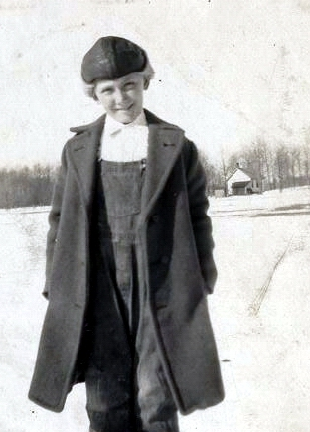For a period when he was very young, perhaps 2 or 3 years old, Andy and his brother Curtis and sisters Gladys, Vivian, Violet (“Doonie”) and Grace spent some time in an orphanage in Delta County, the girls in one facility and the boys in another. Later in life Curtis would remember working hard at the orphanage, and carrying the toddler Andy on his back while he plowed fields.
Andy Bannister as a boy, in the late 1920s.
In 1927 Ira, Gertrude and the children moved to Rapid River and lived for a time in a house behind Fuhriman’s store. The store was owned by George Fuhriman, who married Eliza Wilson Moore after her first husband, George, died in 1917. Eliza was Gertrude’s paternal grandmother.
When he was about 14, in 1935, Andy helped his father build a log cabin about three miles north of Rapid River. Years later, Andy talked about how he and his father drilled holes in each log and pushed in a metal pin to hold the logs together.
The log cabin was on a dirt road that ran parallel to U.S. Highway 41, about a quarter of a mile away. Andy remembered getting a job on U.S. 41 when it was being paved for the first time, between 1935-37. He wrote trip tickets for trucks that traveled the highway.
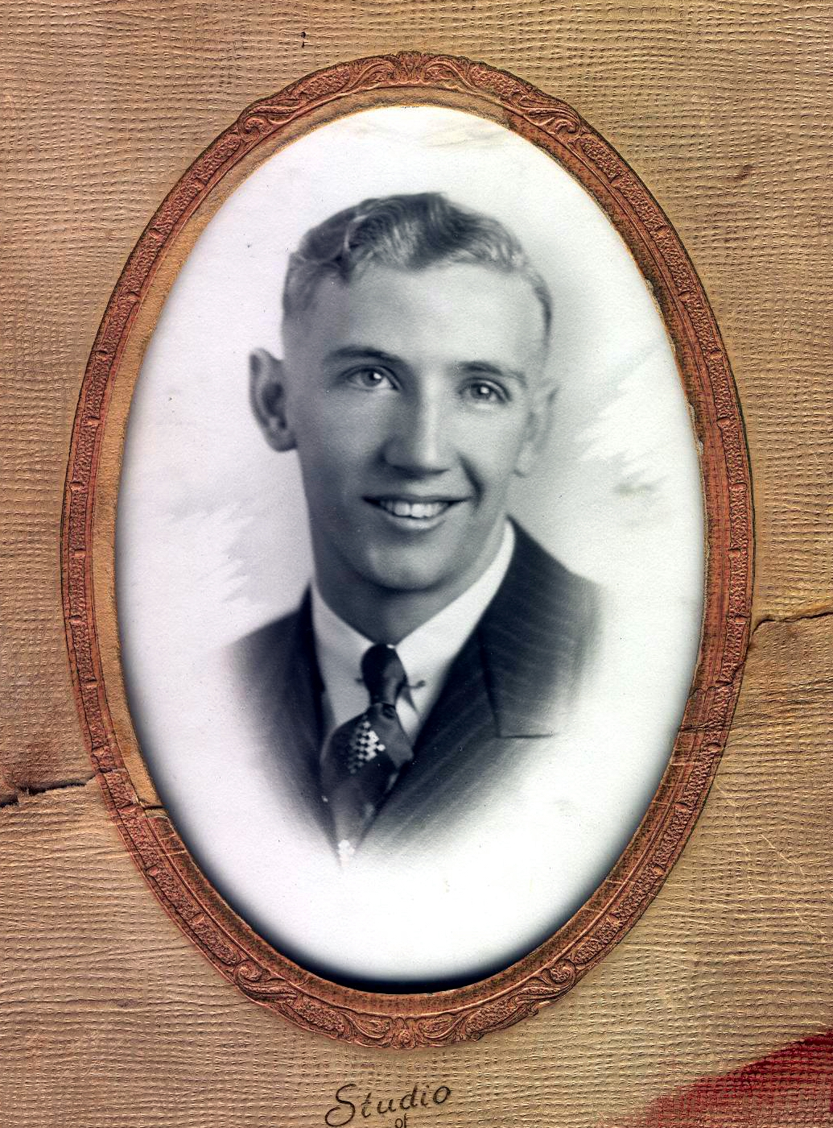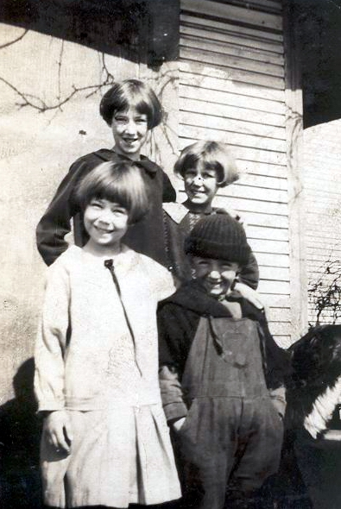The family lived in the log cabin when Andy went to high school in Rapid River. He graduated in 1941. The cabin stood for more than 50 years. Andy’s sister, Grace, and her husband, Arnold Turan, built another house on the homestead in the 1950s. The cabin was empty for many years although it was used by several of the children off and on. It was torn down after both Grace and Arnold died in the 1980s and the home was sold.
Andy Bannister’s graduation picture. Andy graduated from Rapid River High School in 1941.
Andy Bannister, right, and three of his sisters, in the 1920s. At top is Vivian; at right is Gladys and at left is Grace.
Talking about his youth, Andy in the 1990s said that when he was going to high school, his paternal grandparents, Andrew and Henrietta Bannister, lived in a house across from the Rapid River High School. She was sick and confined to bed when he was in school. His grandfather always made him breakfast. His favorite was pancakes. Andy was a basketball player in high school (he loved the game) and stayed at his grandparents’ home overnight on the nights he had a game. He was on the starting team, and also ran track.
Andy met his sweetheart, Ellen, when they were in high school. He graduated in 1941, she in 1942. He worked as a cheesemaker at the Perkins factory while Ellen finished school. They married five months after she graduated, on 24 Oct 1942. They lived for a month or so at the Bannister family home north of Rapid River, then moved to an apartment above Beauchamp’s Grocery in Perkins.
Andy made cheese and butter at the Riverside Cheese factory in Rapid River, which was owned by Bill Gudwer. He also had a milk route, picking up milk from farmers, mostly in the St. Nicholas area west of Perkins.
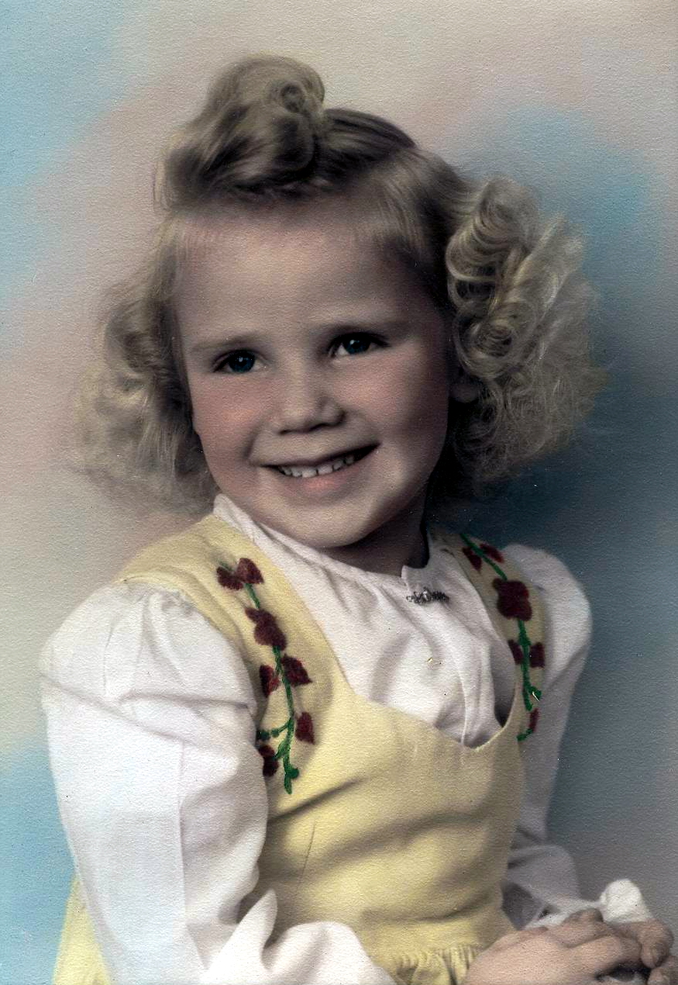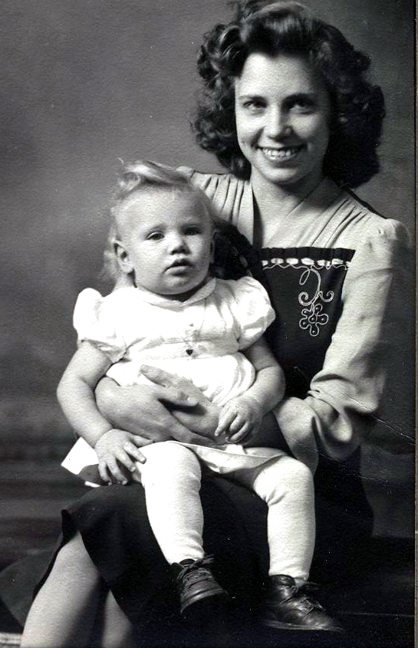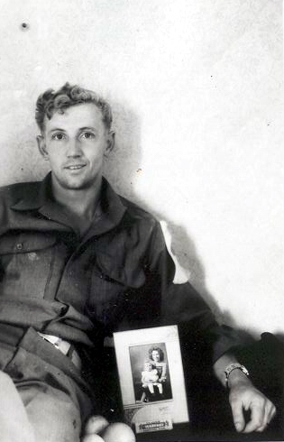Andy was drafted into the Army in May 1943, and took basic training in Illinois. His daughter Barbara was born that August. She weighed 5 pounds 10 ounces. Andy was unable to get a leave so the first time he saw her was when she was 3 months old, when he came home on furlough. He left the states in May 1944, serving in the European Theatre of war as a surgical technician in field hospitals in France, Belgium, Luxembourg, Germany and Austria. He never carried a gun during the war. One of his first battles was the D-Day invasion of Normandy on June 5, when an armada of 6,000 different types of naval vessels left English ports, supported by more than 13,000 aircraft, intent upon liberating France. Andy also took part in the month-long Battle of the Bulge in Belgium and Luxembourg, Hitler’s last counterattack, in December 1944- January 1945.
Ellen Stenlund Bannister and her daughter, Barbara, in a 1944 photo.
Andy Bannister in the Army in 1944, with a photo of his wife, Ellen, and his daughter, Barbara. Ellen had the photo taken specifically to send to Andy, who had not seen his daughter since she was 3 months old.
During the war years, Andy sent letters back home. In a 21 Apr 1945 typewritten letter to his parents, sent in an American Red Cross envelope to 486 Peterboro, Detroit, Michigan, Andy wrote:
“Somewhere in Germany.
“Dearest Folks;
Barbara Ellen Bannister, in a photo taken when she was about 4 ½ years old, in 1948.
“Well Mom I just picked this typewriter up so will try and drop a few lines. It’s a brand new typewriter and it’s pretty hard to type on but I think I’ll manage. The only difference there is is the z is where the y should {be} and the y is where the z should be so if you see a few errors on the y and z keys please excuse them. How is everything back there anyway? Everything is okay over here. The sun shines just about everyday and it really is warm out. It rains once in awhile but just enough to keep the dust down.
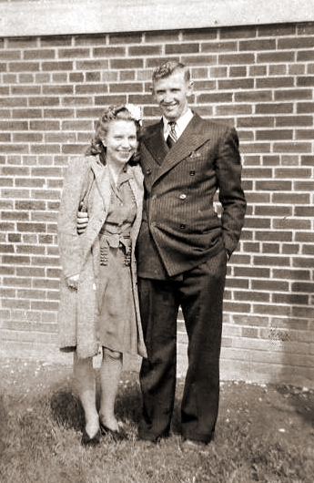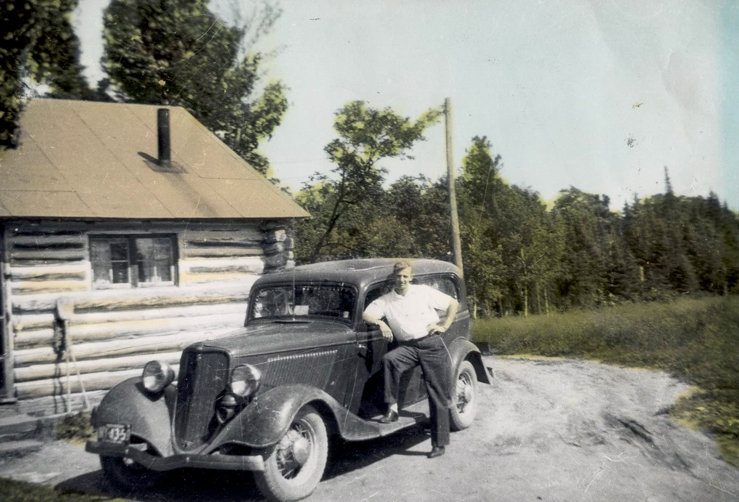 “Well Mom were sure seeing the country and Im not kidding it won’t be long before I’ll be writing from another country. I’ll sure be glad when this is all over with and we can go back home. That will be a happy day for a lot of people. The more I see of these German people the madder I get. It isn’t very safe to walk down the streets alone if you haven’t got a gun. A lot of the fellows are picking up German pistols. They sure have some nice pistols. The German Lugar is a wonderful pistol I wish I had about a dozen of them to take back home with me. Whatever we need for the Hospital we just go out and take it. If we need a building for the Hospital and the people are living in it all we do is kick them out and put the Hospital up. You have to treat the Germans rough to let them know who is boss over here. If you don’t there is bound to be another war in another 20 years. How are you feeling Mom? Better I hope. I haven’t had much time to write the last couple weeks we’re traveling pretty fast as you probably know by the papers. I have some pictures of a building where we set the Hospital up quite a ways back I’ll send them along with this letter if I don’t forget to put them in. It was a very nice building but we don’t always strike a building like that. It was way back in Wiitlich.
Ellen and Andy Bannister in 1943, on a visit in Detroit with his parents, Ira and Gertrude Bannister, before he was sent to the Army. Ellen was six months pregnant with Barbara at the time.
Andy Bannister showing off his first automobile, which had front doors that opened from the left. At left is the log cabin Andy and his father, Ira, built when Andy was a teenager.
“How is Billy making out in school these days? Tell him he better study hard. Does he play and basketball this year? I imagine he’d be pretty fat to run around after a basketball. How much does he weigh now? He’ll probably pass me up if he keeps on. Say Mom I picked myself up a beautiful folding camera. It’s a 120 and I’m just dying to see how it takes pictures so if Billy can pick up some 120 film tell him to send some. I took one roll of German film but I don’t know how there going to turn out I hope they turn out okay, if they do I’m going to send you some. I picked myself up a few beautiful knives, I’d sure like to send them home but I don’t know if I’ll have the time to do so or not. We don’t stay in one place long enough to take a bath and I must say I need one. Time out for chow, so here I am back again but I don’t seem to be able to think of anything to write about. I got a letter from Doonie the other day and everything is okay up there. I sure would like to see her and her kids I bet there devils.
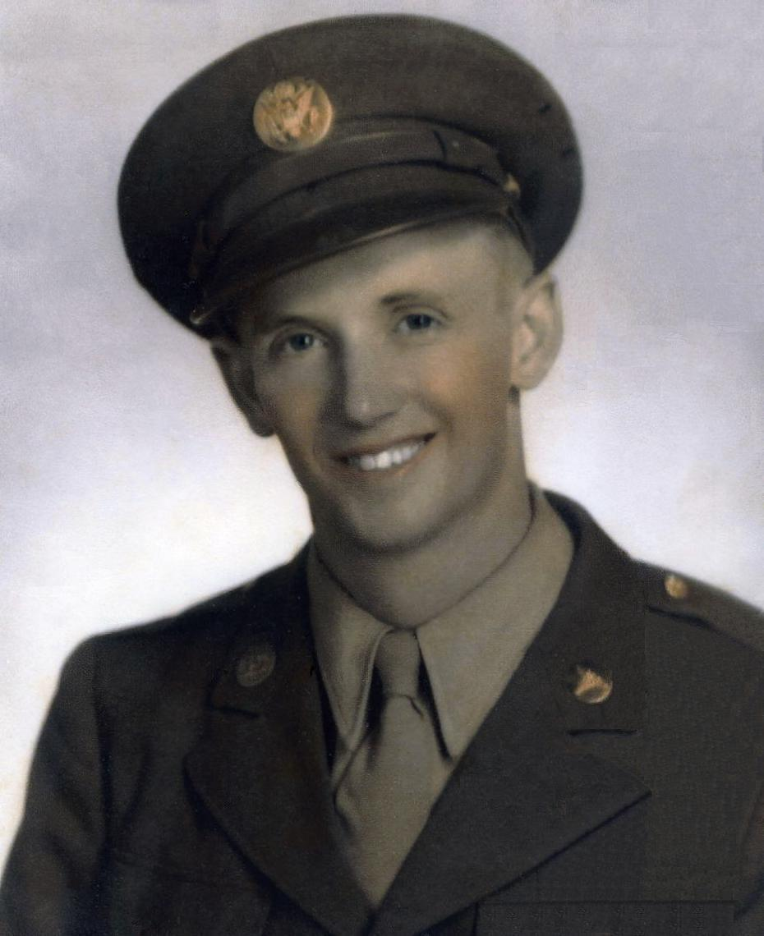 “Well Joe just developed the pictures and the negatives turned out wonderful. I just hope that the pictures turn out as good when he prints the pictures. I’ll send you some if they turn out okay when he prints them. He developes the negatives in our x-ray developer and another fellow has a printing box that he made. I guess the American Soldier can get along nearly anywhere. I hope Billy can get some 120 films so I can take some more. The weather sure has been nice for taking pictures. Nearly everyone in the outfit has a good camera now. You can pick up nearly anything you want. I’m sending a package home to Ellen this afternoon. I’m sending a nice white fur jacket a silver tea pitcure a set of glasses a big German flag and a knife. I could send a nice 16 mm projector but I don’t think she would like it. It’s okay but there isn’t any sound. Well Mom its just about time I stopped before you get tired reading. Say hello to everyone for me. Must close now.
Andy Bannister, in a photo taken while he was in the Army during World War II. He was drafted in May 1943 and was discharged in November 1945.
“L o v e.”
In a 1 Sept 1945 typewritten letter to his parents, who by then had moved to Nahma, Michigan, Andy wrote:
“August 31, 1945
“Kraiburg, Germany
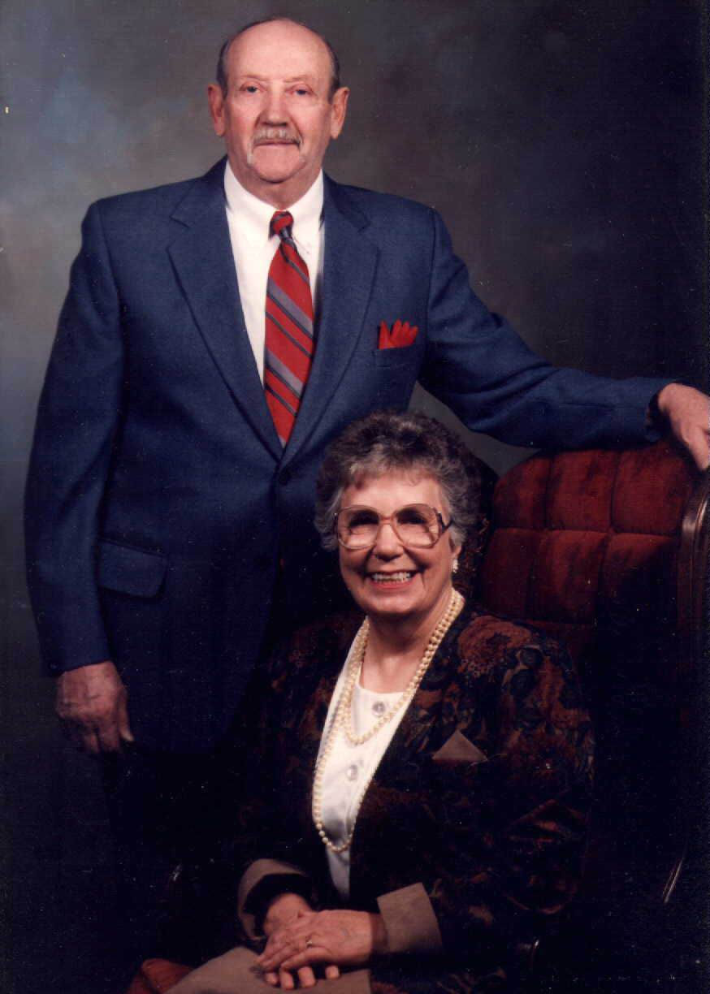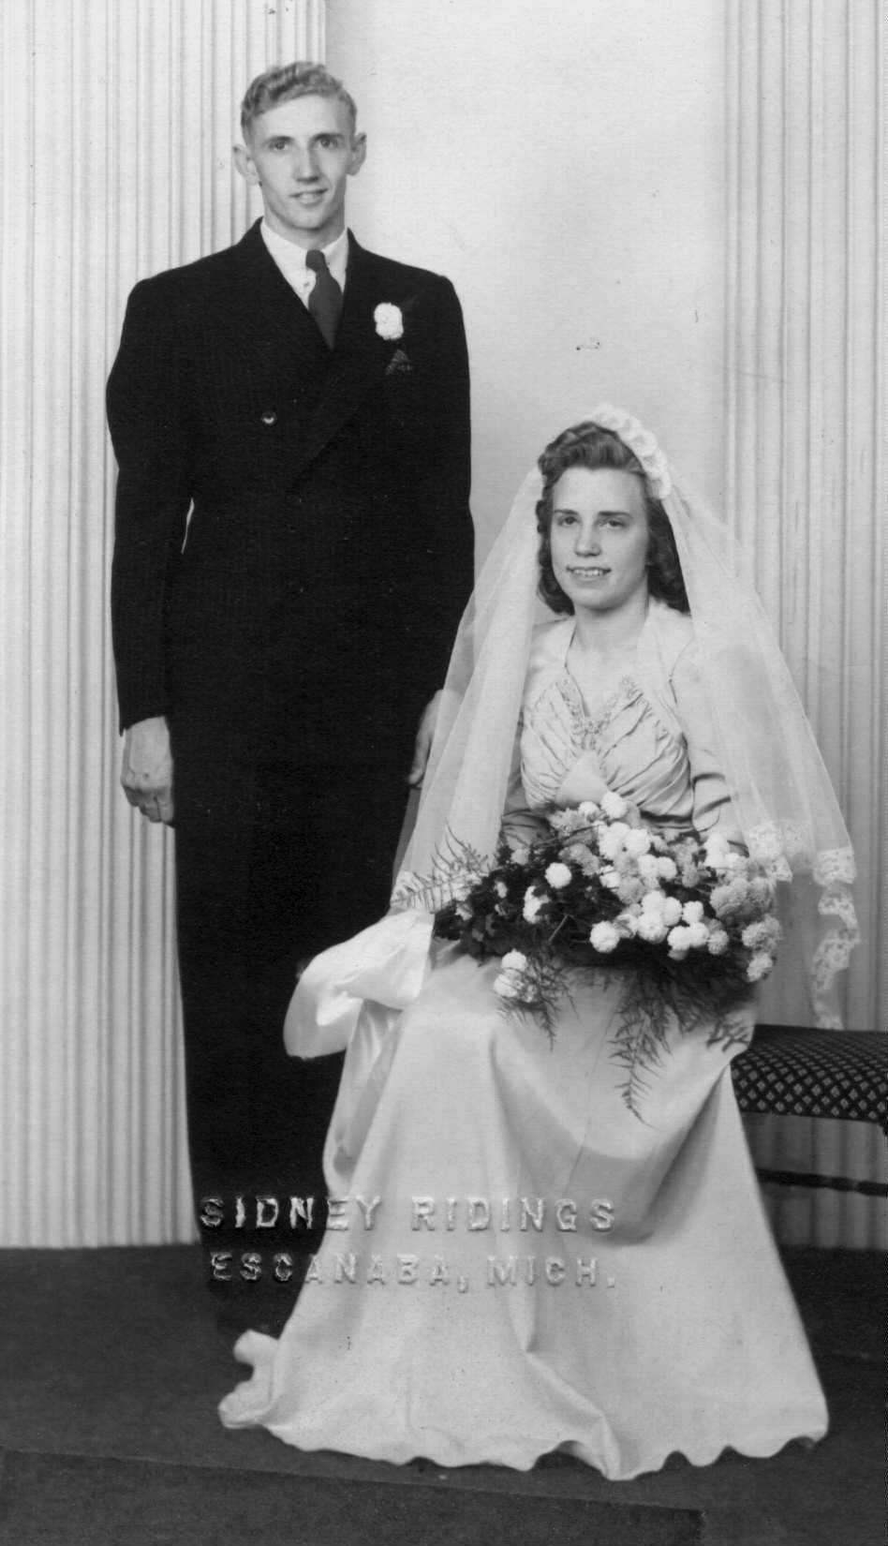 “Dearest Folks;
“Received your letter the other day and just never got around to answer it so here goes before I forget. How is everything back there anyway? Just fine I hope. Everything is okay over here. Yes the war is finally over and everybody sure is glad to hear the good news. We don’t know when we will get home yet but we have a vague idea. Our idea is that we will sail in Nov. some time but we don’t know just when. Before the war ended we were scheduled to sail in September but not for the States. We were to go to the CBI direct. We were so close to going that our Major had us in the office and showed us the route we would take and just where we were to land in China. We can thank God that the war ended before we left. My 73 points don’t seem to be getting me anywhere. If they have a recount I will have 81 points so maybe I will be getting out one of these years. So Curtis is going to Florida for the winter. He sure is a lucky fellow of he can do that. He sure must of saved plenty of money while he was working in Detroit. I wouldn’t mind spending the winter there myself but that’s impossible. I am going to take a vacation when I get back. I think I will rent a cottage on a lake and do nothing but fish and hunt. I could kick myself all over now for not sending Pa and Curtis one of those Czech burp guns. They could really go hunting then. They wouldn’t have to worry about missing. They were beauties but I didn’t have very much time to do any sending.
Andy Bannister and Ellen Stenlund, left, were married 24 Oct 1942. At right, Andy and Ellen were celebrating their 50th wedding anniversary.
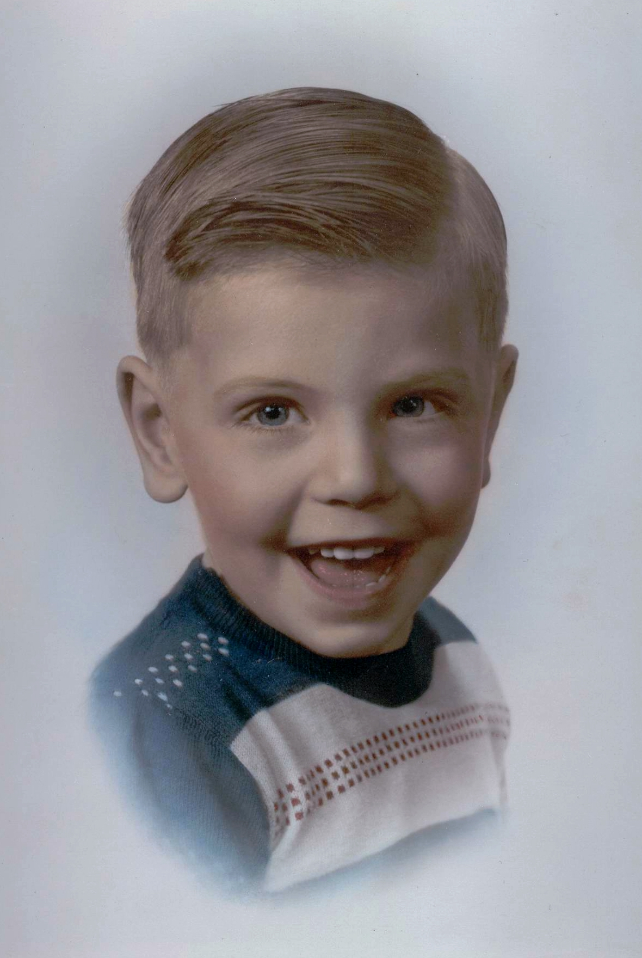“Well the only thing we do around here is eat and sleep. We sure do get plenty of sleep you would think I would gain a little weight but no soap I just stay the same. I must close for this time and write more when I find time.
“Love, Andy.”
Donald Andrew Bannister, shown when he was about 4 years old.
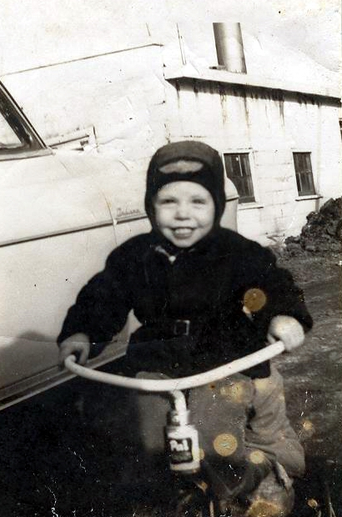Andy was discharged on Nov. 16, 1945. He returned to Michigan to work at the cheese factory in Perkins, which was owned by Paul Rudolph. In 1948, the Rudolphs offered Andy a position as manager at the cheese factory in Armstrong Creek, Wis. and the family moved there. A year later, on 30 Aug 1949, their son, Donald Andrew, was born in Laona, Wis. He weighed 7 pounds 3 ounces.
In early 1950, the Rudolphs sold the cheese factory in Perkins to Michigan Dairy. Andy and Ellen moved back to Perkins, where Andy managed the plant. They lived in a three-bedroom apartment above the cheese factory. For a time, Ira lived with Andy and Ellen after he had surgery. When the plant closed in 1954, Andy went to work for the cheese factory in Rapid River and Andy and Ellen moved into a house about two miles east of Perkins. In August 1955, they bought a house in Perkins, where Ellen still lived in 2008. In 1959, Andy went into the construction business, building homes and eventually roads across the Upper Peninsula.
Donald Andrew Bannister, in a photo taken while the Bannister family lived in an apartment above the cheese factory in Perkins, about 1953.
Andy retired in 1982. He spent much of his time after retirement visiting Barbara and Donald and their children; in creating a garden from the acreage behind the house; in creating wooden craft items to give to his grandchildren or for church fund-raisers. He and Ellen took many winter trips south to Florida or out west.
Andy Gordon Bannister died on 15 May 1995 from an embolism in his abdomen. He was 74 years old. Services were held at 7 p.m. Wednesday, 17 May 1995 at Bethany Lutheran Church in Perkins.
His obituary in the Daily Press in Escanaba read:
“Andy G. Bannister
“PERKINS – Andy G. Bannister, 74, of P.O. Box 112, 5735 M-35 Perkins, died Monday, May 15, 1995, at St. Francis Hospital, Escanaba.
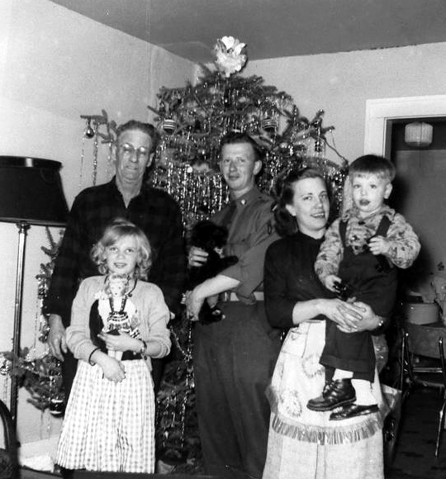“He was born March 10, 1921, in Flat Rock, son of Ira Bannister and the former Gertrude Moore. He was raised in the Rapid River area, graduating from Rapid River High School. He had lived in Perkins most of his life.
“He was a veteran of the U.S. Army, serving during World War II in the European Theater at Normandy, Northern France, Rhineland and Central Europe.
“He married the former Ellen M. Stenlund Oct. 24, 1942, at First Lutheran Church in Gladstone. She survives.
“He was employed at Perkins Cheese factory until its closure and in construction until his retirement.
“He was a member of Bethany Lutheran Church of Perkins, and Perkins American Legion. He enjoyed hunting, woodworking and gardening.
“In addition to his wife, Ellen, survivors include: one son, Donald (Nancy) Bannister, Neenah, Wis., one daughter, Barbara (Gary) Gagnon, Marquette; one sister, Violet Parlette, Oregon; nine grandchildren; four great-grandchildren; numerous nieces and nephews.
The Andy and Ellen Bannister family celebrates Christmas in 1951 in the apartment above the Perkins cheese factory. From left in back are Ira Bannister, William Bannister, Ellen Bannister holding Donald. In front at left is Barbara Bannister, holding the doll she got for Christmas.
“He was preceded in death by his parents, two brothers, Curtis and William Bannister, and three sisters, Vivian Mosier, Grace Turan and Gladys.
“Visitation will be from 3 to 6 p.m. Wednesday at Skradski Funeral Home in Gladstone. Funeral will follow at 7 p.m. at Bethany Lutheran Church in Perkins with Rev. David Hueter officiating. Burial will be at 9 a.m. Thursday in Rapid River Cemetery, where military rites also will be conducted.”

Ellen Mae Stenlund was born at home in Ensign 3 Sept 1924. Her parents were Peter Stenlund and Helga Mae Albertsen. Her sister, Catherine, was 5 years old.
The family lived in a small log house on 120 acres of wooded land. The barn and chicken coop were also made of logs. Gradually the trees were cleared from the land to provide room for farming and the wood was used for heating the house and for cooking. Eventually the family grew to include sister Linda and brothers John, Theodore and Jerry. Another brother, Sammy, died when he was 6 years old.
Writing her memoirs in 2005, Ellen recalled that it was her job as a young girl to keep the wood box in the kitchen full of wood, which became quite a chore in the wintertime.
“My dad had built a cart with skis on the bottom for runners to haul out the milk cans when the snowplow could not get up to clear the roads, and I could use that to take the wood from the shed to the house,” she wrote. “That was a big help, for the wood was heavy and the snow was deep.”
Later an addition was added to the house, a living room and a bedroom, and a new barn was built.
Ellen’s father, Peter, emigrated from the northern part of Sweden to the United States and her mother, Helga, was from Fish Creek, Wis. Helga’s parents were natives of Denmark. Ellen never met Grandfather Albertsen and saw Grandmother Albertsen only once.
The farmhouse of Peter and Helga Stenlund, in Ensign Township, was where Ellen Stenlund, her two sisters, Kay and Linda, and her brothers Jack, Ted and Jerry were raised.
“I remember seeing my grandmother only once when she visited my mother and dad and stayed with us for awhile,” Ellen said. “She babysat when the rest of the family went picking blueberries. She was a very nice grandma.”
Ellen wrote that she liked to follow her father around when he was building things.
“I must have got into his keg of nails once too often, for one day he said to me, ‘Come out into the woodshed. I have something for you,’” she wrote.
There stood a cedar block of wood and a small hammer and some nails, used and bent.
“This is yours,” her father told Ellen. “You can pound as many as you want into this block. Straighten out the nails and they’ll go in easier. …The good nails are going to be used for building.”
So hammer in her left hand, she went to work, straightening nails and pounding them back into the cedar block, using any piece of scrap lumber her dad didn’t want.
“I’d try to build ‘things,’” Ellen wrote. “I’m still trying to build things. Old habits die hard.”
In 1929, when Ellen was 5 years old, the stock market crashed, sending the country into the Great Depression, which lasted until the early 1940s. It was the worst economic collapse in history. Companies suddenly stopped producing and selling goods; unemployment rose severely. Businesses and banks closed their doors; people lost their jobs, homes and savings. Many depended on charity to survive.
Ellen, left, and Kay Stenlund, as teenagers growing up on the Stenlund Farm in Ensign Township.
“Everyone was affected,” Ellen wrote. “It was hard for all but somehow we made it through. We lived on the farm and had our own produce and meat and wood for heating and cooking so that made us fare much easier than many others.”
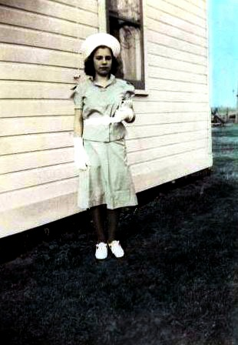The Depression produced lasting effects in the United States. It led to the creation of programs known as the New Deal, which expanded government intervention into social and economic concerns and created social assistance programs such as Social Security.
Ellen started school in 1930 at the Stone Anderson School in Ensign. The schoolhouse had two rooms with a wood furnace in the classroom and a place for wet mittens to dry after recess. She stayed at Stone Anderson School until she graduated from the 8th grade, then attended Rapid River High School. In her junior year she helped out in the office doing secretarial work. She was graduated in 1942.
It was at Rapid River High School that she met her future husband, Andy Bannister. He was graduated in 1941. On 24 Oct 1942, they were married in the Lutheran Parsonage at Gladstone, Michigan. The Rev. Otto Magnusson performed the ceremony.
Ellen Stenlund, at about 12 years old, in a dress she made for a 4-H project in Ensign Township.
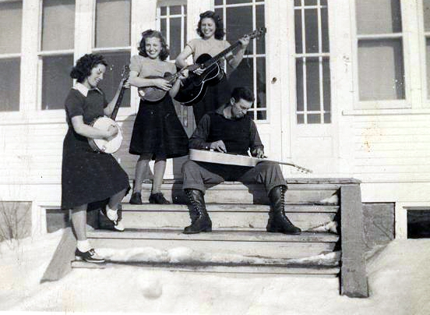Three things have remained dominant in Ellen’s life: Music, the Lutheran church and sewing. Her Grandfather Albertsen was a tailor who passed on the love of sewing through Helga.
“I was blessed with a mother who taught me how to sew at a very early age,” Ellen wrote. “She would make us a dress by looking at a picture of one that we had picked out in the Sears Roebuck catalogue. It would be ready to be worn at the annual Christmas program at school.”
Through the years, Ellen has continued to sew for herself and her family. Christmas gifts were usually homemade, such as flannel nightgowns for the girls and pajamas for the boys, piece quilts for wedding gifts and Nordic sweaters, knitted afghans.
Ellen Stenlund and her sister, Kay, often sang for church gatherings and with their friends. At left are Mary Lundberg, Ellen, Kay, and Axel Lundberg.
She was a young girl when her parents bought a player piano with piano rolls.
“I loved it,” Ellen wrote. “I could sit and after inserting a roll and pumping two foot pedals could watch the piano play the most wonderful music.”
When her sister Catherine took piano lessons, Ellen would sit very quietly and try to absorb all the teacher was telling Catherine to do. Even after she was asked to move into the kitchen, she’d listen hard through closed doors.
After supper and the dishes were done, the girls would try to harmonize, with Catherine at the piano.
“We liked listening to WLS Barn Dance on the radio,” Ellen wrote. “Every Saturday night we’d turn on the radio, curl up in a big chair and spend the evening listening to the Grand Old Opry.”
Later, Ellen and Kay joined a group to learn to play stringed instruments.
“Mom sent out in the catalog, probably Sears Roebuck, for a guitar for Kay and a mandolin for me,” Ellen wrote. “Now we would use the guitar when we sang.”
Years later, Andy bought her an electric Wurlitzer organ.
“I learned to play all my favorites – waltzes, polkas, Stephen Foster songs, country music, hymns – and never tired of the sound of music in my home,” she wrote. “That organ was the best gift he could ever have given me.”
Ellen Stenlund graduated from Rapid River High School in 1942. This was her graduation photo.
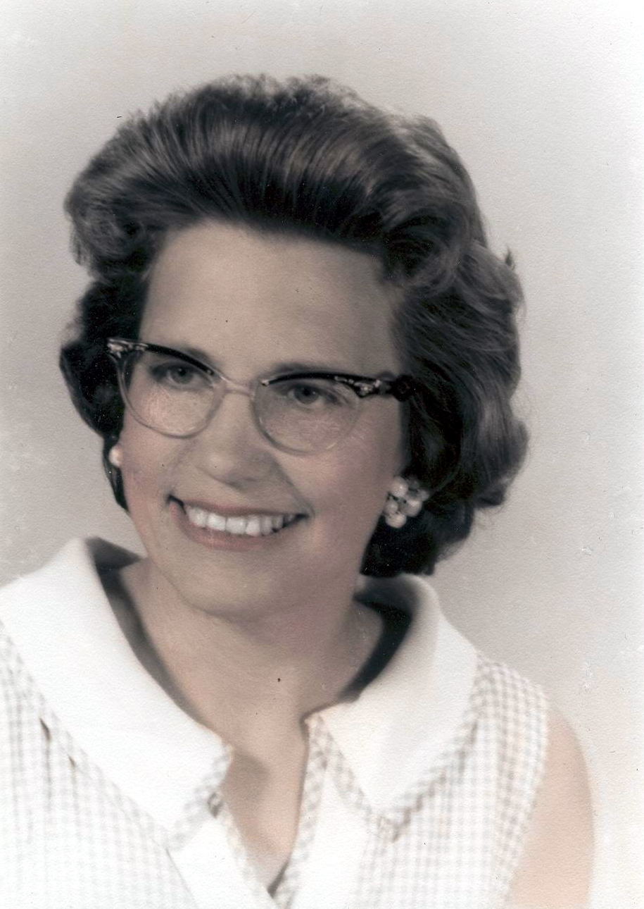Ellen was baptized Oct. 5, 1924, by the Rev. C.E. Olson. The family belonged to Bethany Lutheran Church in Whitefish. Later when a new church was built in Rapid River, the name was changed to Calvary Lutheran. The Rev. Ralph B. Hult confirmed Ellen and her cousin, Ethel Stenlund, in October 1940. It was the first class to be confirmed in the new church.
Later, when Andy and Ellen and their two children, Donald and Barbara, moved to Perkins, they joined Bethany Lutheran Church. Ellen belonged to the Ladies Aid, taught Sunday school and served on the church council; and was Lutheran Church Women president from 1977 to 1988 and WELCA (Women of Evangelical Lutheran Church of America) president from 1988 to 1997. She spent much time making altar clothes, paraments and banners; and in organizing and typing recipes for a church cookbook the LCW put out to commemorate Bethany’s 90th anniversary.
Ellen Stenlund Bannister in a photo taken when she worked as a secretary at the Perkins High School. Ellen was about 40.
Ellen Stenlund Bannister, at 83, in a 2007 photo.

