“It was Andy’s job to make his special baked beans for church dinners,” Ellen wrote. “Each year he helped with the bazaar by donating his wooden crafts. We put on plays for Christmas and Lent and had lots of fun doing it.

“Our lives were centered around our church and our family,” Ellen wrote. Andy died on May 15, 1995 of an abdominal aneurysm, one week after their pastor and friend, Fred Scholer, had died.

“I remain in my home here in Perkins,” Ellen wrote in 2005, as her eyesight was failing. “In the summer I have a large yard to maintain filled with flower beds and shrubbery to keep me busy.”

Ellen wrote the following family history on the occasion of their 50th anniversary on Oct. 24, 1992:

The Bannisters

Andy and Ellen

**By ELLEN BANNISTER**

Andy and Ellen started going together when she was in the 11th grade at Rapid River High School. That was the year he graduated – 1941 – and five months after she graduated they were married, on Oct. 24, 1942. There wasn’t much advanced planning. She sent a telegram to her sister Kay in Detroit, saying little more than “come.” The wedding was performed by the Rev. Otto Magnusson in the parsonage at First Lutheran Church in Gladstone. Kay Stenlund was the bridesmaid and Bob Rentschlar, a school friend of Andy’s, was best man.

Andy’s family had all moved to the Detroit area to work during the war years so Andy and Ellen moved into the Bannister family home in Maplewood. He worked at the Riverside Cheese factory for Bill Gudwer, making cheddar cheese and butter. He also had a route picking up milk from farmers, mostly in the St. Nicholas area. Shortly after, they moved into the apartment above Beauchamp’s Grocery store in Perkins, which was owned by Albert and Exilda Beauchamp.

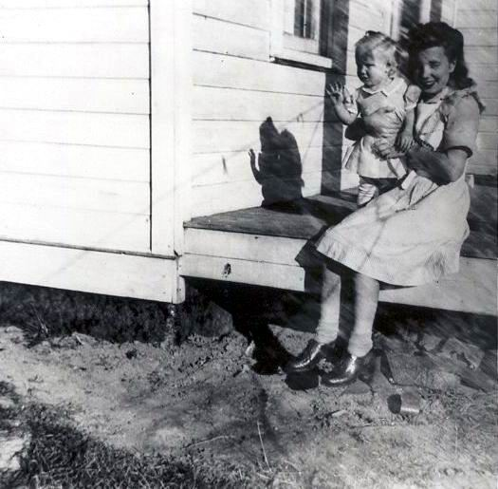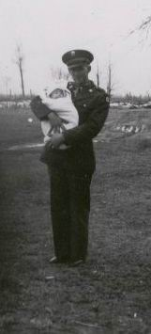

Andy was drafted into the Army in May 1943. He took basic training at Camp Grant, Ill., then was transferred to Camp Ellis, Ill. He left the States in May 1944, serving in the European Theatre of war as a surgical technician in field hospitals in France, Belgium, Luxembourg, Germany and Austria. He says he also served in the Battle of the Bulge – then and now.

Andy and baby Barbara, in 1943, when he came home on furlough.

Ellen and Barbara at the Stenlund farm in Ensign in 1944, when Andy was away during World War II.

Ellen moved back to her folks’ farm in Ensign when Andy left for the Army. Three months later, on Aug. 26, 1943, Barbara Ellen was born at St. Francis Hospital in Escanaba. Andy was unable to get a leave so the first time he saw his daughter was when he came home on furlough in November. At Christmas they met in Detroit at Andy’s folks on Peterboro Street before he returned to Europe.

Barbara was baptized May 28, 1944 by the Rev. Clifford Peterson at Calvary Lutheran Church in Rapid River. Mary Lundberg Hansen is her godmother.

Andy was discharged on Nov. 16, 1945 and returned home to work at the cheese factory in Perkins. They moved into the Thibeault home in Rapid River for the winter, then into the Beauchamp cabins in Perkins in the spring. Joe Ghidorzi was the cheesemaker for Michigan Dairy at the time. His wife, Mary, was a teacher at the Perkins school and their children, Anthony, Joseph and Charlie, attended the school.

Andy sits on the throne while Barb peeks around the corner of the outhouse at the Thibeault home in Rapid River in 1945.

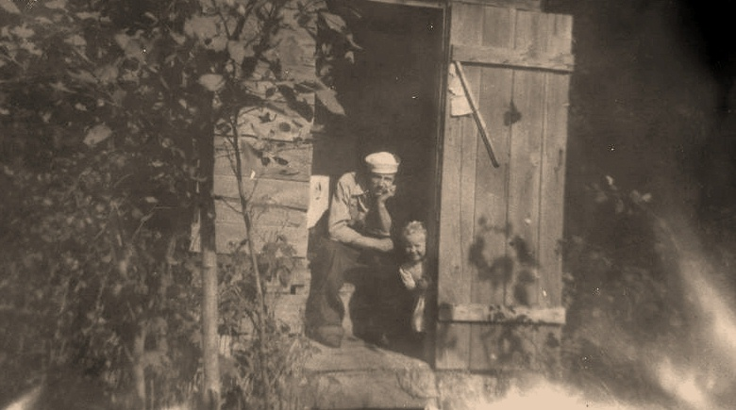

The Ghidorzis and Bannisters became close friends. Andy and Ellen stopped to see them this summer in Crystal Falls. What a nice reunion that was.

The cheese factory later changed hands when Paul Rudolph purchased it.

Andy and Ellen moved into the upstairs apartment of the Norden Grocery owned by Rosanna Norden. Sylvia and Judy Gerou lived in the next-door apartment. Barb loved the girls, who dressed her up in their clothes. They made her a cheerleading outfit and she cheered with the girls as a team mascot at the basketball tournaments that spring.

In 1948 the Rudolphs operated a cheese factory in Armstrong Creek, Wis. And Andy took over as manager. Andy and Ellen lived in a house next door to the factory and Barb started kindergarten that fall.

Donald Andrew was born Aug. 30, 1949, in Laona, Wis. This time, Andy was there. On Oct. 23, 1949, they met Kay and her husband Arnold Siitar in Gladstone for Donald’s baptism at First Lutheran Church. Again, Pastor Peterson officiated.

Andy Bannister poses with the truck he used to pick up milk from farmers around the Perkins-Rapid River area. Andy worked for a cheese factory right out of high school.

In November of that year, Michigan Dairy purchased the Perkins factory and Andy was asked to return to Perkins as manager. He gladly accepted and they moved into the apartment above the cheese factory. Barb entered the first grade at Perkins School.

Art Stevenson Sr. did all the plumbing for the factory so Andy and Ellen saw him often. Art Jr. also worked at the factory. Andy and Ellen developed a very close relationship with Art and Margaret – the whole family.

Butch [Donald] was a colicky baby and medication from the doctor didn’t help. One day Ellen called Margaret to tell her about the baby. “I’ll be right over with something to settle his tummy,” she said. A couple of drops of peppermint in sugar, followed by freshly squeezed orange juice 10 minutes later, did the trick. What a relief.

The Stevensons made Andy and Ellen feel like part of the family. Evora was their babysitter and is also their godchild. The Stevensons had a farm and Andy helped with haying and sometimes with the milking. They all belonged to a canasta club.

The Kleins – Alba, Gus and their daughters, Ann and Laurie – lived next door to the cheese factory in Perkins. The Kleins owned a cabin at Garth and the three families spent many enjoyable hours together. During this time, Lorraine Porath and Ellen became friends. Lorraine would bring her husband, Wally, to work and then run upstairs for coffee or get hot water from the factory for washing clothes.

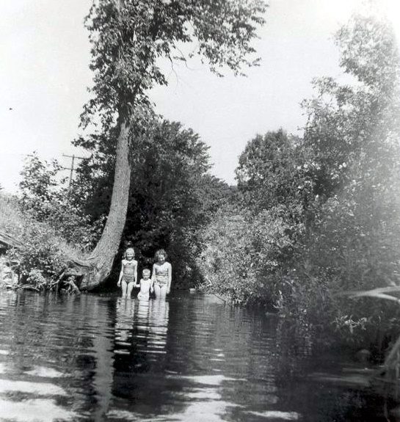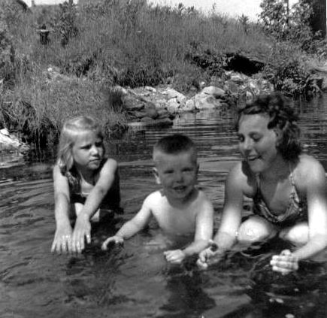

Barb, Donald (“Butch”) and their neighbor Ann Klein play in the Tacoosh River near the cheese factory in Perkins.

Barb and Butch enjoyed swimming in the Tacoosh River, which ran right behind the cheese factory. Sometimes they carried salt to help them remove the bloodsuckers that used to stick on their toes. There was always a gang of kids hanging around to play hide-and-go-seek at night or catch June bugs or capture crabs hiding under the old cement bridge. Once when Butch was trying to jump up onto the bridge, he fell – with his mouth open – and jammed one of his front teeth up underneath his nose. It was serious, painful and bloody, unlike the time a few years later when he tossed a croquet ball into the air and failed to catch it, cracking off his other front tooth.

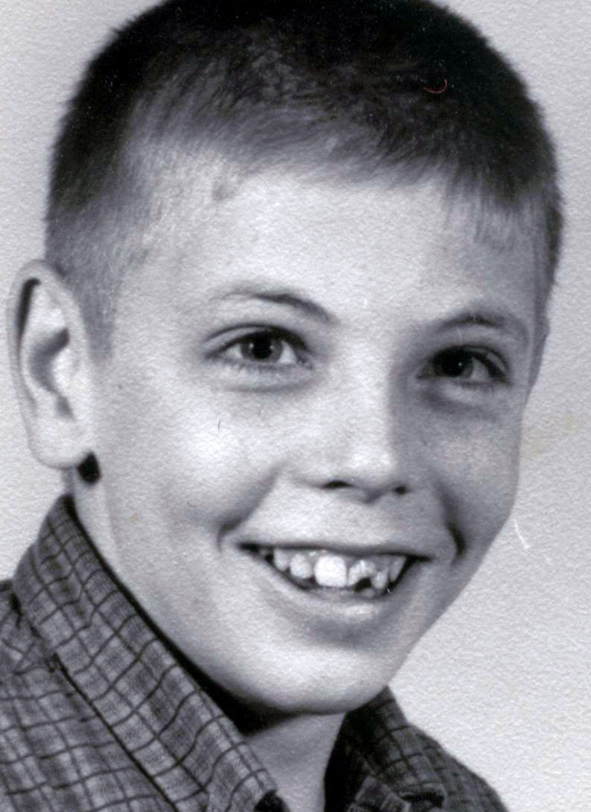

Donald Bannister in a late 1950s school photo that shows his broken front tooth.

The factory closed in May 1954. Andy and Ellen moved into the old Stevenson family home in October, across the road from Margaret and Art, and Andy went to work at the cheese factory in Rapid River. The house was across the street from Lawrence and Cleo Wils and the Axel Satterstroms. Axel grew the most beautiful flowers. Andy and Ellen had chickens and rabbits, and their own eggs.

This was the year Butch started kindergarten, and he and Barb rode to school by bus. Ellen saw Cleo Wils and the kids every day and Cleo tried to teach her to swim in the river by the Seventh Day Adventist Church. Ellen never mastered the art but she sure had fun.

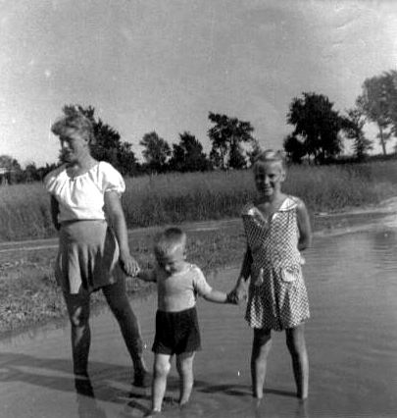

Cleo’s daughters, Kathleen and Theresa, liked to watch television with Barb, and Kathleen was especially excited when Elvis Presley made his first appearance on the Ed Sullivan show. She ran across the road that Sunday night, expecting to watch The King on TV. But Andy, paying heed to the “Elvis the Pelvis” reputation, banned them both from the living room. They peeked in from the kitchen anyway, but couldn’t see much.

In August 1955, Andy and Ellen bought their house in Perkins from Ronald Beauchamp. Ron’s dad, Philip, lived next door. He was a wonderful man who told the most interesting stories about Perkins history.

A month later, Bea and Budd moved their house across town to the lot next door to the Bannisters, beginning a friendship that has lasted 37 years. Bea and Ellen and Elsie Aasen were 4-H leaders together for many years.

Linda Stenlund walks with her niece, Barbara, and her nephew, Donald, on the farm in Ensign Township.

In 1959, Andy went to work with Arnold Siitar in Detroit in the dry wall business. He hurt his knee and required surgery. After surgery, he tried to strengthen his knee by sitting on the kitchen table, extending his leg with the handle of a purse draped over his foot. Inside the purse were old pieces of scrap iron for weights.

After Andy recovered, he worked for Arnold at Kincheloe Air Force Base. During this time, a Birthday Club was begun that included Lorraine, Ruby Sharkey, Ellen and later on, Cleo. It has lasted to this day.

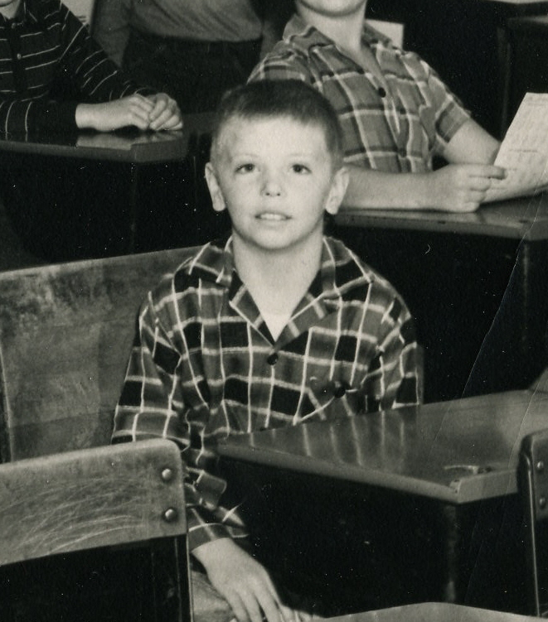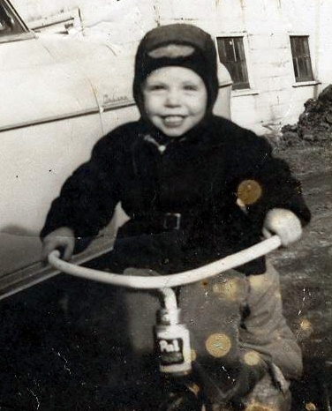

In 1961, Barb graduated from Perkins High School and left for Milwaukee to find work. She lived with Margaret’s sister, Eleanore Bye. In December, Barb married Joe Vestich, a teacher at Perkins High. Ellen started working at the Perkins School in the fall of ‘61 as a teacher’s aide, caring for kindergarten kids in the afternoon. Elsie Aasen was the teacher. The following year Ellen was hired full time as a secretary to the superintendent in the morning and working with the kids in the afternoon.

In ‘65, Andy worked in Palmer for George Hocking and later, the Lindberg Construction Co.

In July – a red-letter day – Barb and Joe adopted twins, Laurie and Larry. They were seven months old, dark-haired, tiny –and the sweetest babies ever seen. Barb quit her job at Clairmont Transfer Co. to care for them. They lived in a trailer across from the school and every day, when Ellen was finished with her job, she crossed the road to play with the kids until it was time to go home and make supper. Life was great. Butch was a junior in high school, played basketball, was in school plays and worked at Bud & Tom’s grocery store.

Donald Bannister poses for his first grade class photo in 1955.

In November, Andy was transferred downstate to Coldwater. Budd also worked for Lindberg and was transferred there too. Andy and Ellen closed up the house and moved again, this time, reluctantly. They were leaving their kids, the twins, Ellen’s job, the church and Sunday School teaching. There were tears all the way down but much to Ellen’s surprise, she learned to love the town and its people. Butch decided to stay with Barb until the second semester and then join his folks in Coldwater. He was a junior in high school at the time. Barb made him wipe dishes, which he didn’t like – but he did it.

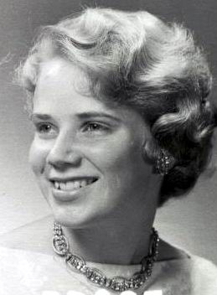

Lindberg Construction Company was out of Ishpeming and employed many people from the U.P. Bea and Budd moved to Coldwater, too, so Andy and Ellen weren’t alone in a strange place. They had a lot of picnics and get-togethers with the Lindberg group. Jim and Jean Branstrom were there and Jimmer was just a baby. Jean and Ellen would take him shopping — they tired out before Jimmer did.

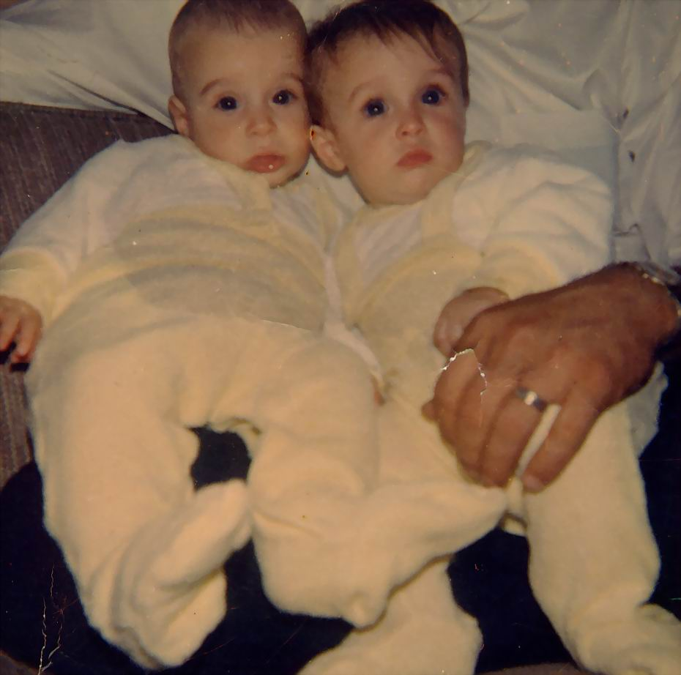

Larry and Laurie were 6 ½ months old when this photo was taken in July 1965 at their mom and dad’s home in Perkins. It was the first photo taken after they’d been adopted.

Barbara Bannister, shown at the time of her graduation in 1961 from Perkins High School in Perkins.

Andy and Ellen found a nice apartment and Ellen applied for a job at the high school. Nothing was available but there was an opening at the Branch Intermediate School office for part-time work. She applied and got the job, which was only two blocks from their apartment. She went to work after Thanksgiving in the mornings and after Christmas began working afternoons at the Quincy High School District five miles away. They attended Reformation Lutheran Church and Ellen joined the women’s group there, where she met many more U.P.’ers.

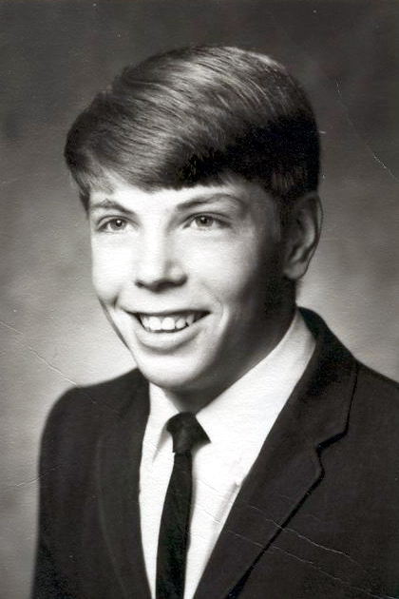

Donald Bannister, as shown in his 1967 graduation photo at Perkins High School.

When Butch joined them in Coldwater, they bought a trailer and parked it at 530 Grand. Butch lived there his second semester, occasionally working at the Intermediate School office; but wanted to graduate from Perkins with all his friends. He moved back to Barb’s and worked at Bud and Tom’s grocery.

Butch graduated in May 1967. That summer Andy and Ellen moved back to the U.P. and Andy worked at Big Bay. They moved their trailer from Coldwater and parked it in Perkins. When Andy was sent to work on the highway near Lake Linden, they moved the trailer to the Pioneer Trailer Court in Houghton. Later they sold it to a Tech student and his family and moved into an apartment in Lake Linden across the street from John and Olive Kalcich.

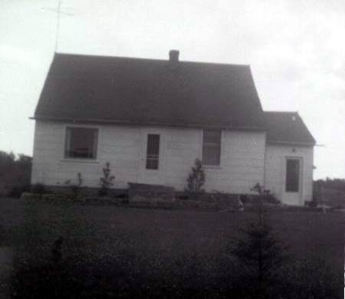

The Bannister home, on M-35 in Perkins, Mich., as it looked when it was first purchased in 1955.

The Bannisters and the Kalciches became friends and together with Bea and Jim Lasich spent many evenings playing their favorite card game, pinochle. The Lasiches lived in the next-door apartment and Jim also worked for Lindberg. Butch worked with Andy that summer and bought his first car, a white Chevrolet with red upholstery. He started at Bay de Noc Community College in the fall and later joined the military. He was stationed at Fort Devin, Mass.

Later in 1967, their kids gave Andy and Ellen a surprise 25th wedding anniversary party at the Lions Club in Perkins. Barb was looking for pictures for the party but couldn’t find the key to get into the house. She and Bertha Vallier attempted a break-in through the bathroom window, which is pretty high and pretty small to be crawling through. Especially when you’re laughing so hard.

Andy and Ellen took their first trip to Florida in 1969. That summer, Andy worked at White pine. They lived at Green and then in a little house in Silver City. Ellen learned to pick agates with Nell Bridges, Betty Carr and Dolores Pence. Dolores taught Ellen how to spot agates in the water and which rocks should be saved.

At first Andy and Ellen just had jars full of rocks. But by the time the summer ended, they had boxes of beautiful agates and jasper stones they later made into necklaces. They grew into seasoned agate pickers, carrying an old pair of tennis shoes in the trunk of the car at all times, ready to find the elusive agate, which was best seen while treading water just off the beach.

Barb’s son, Andy Thomas, known as “Little Andy,” was born in March 1970. Barb had moved to Watersmeet and many weekends were spent fishing and exploring the lakes, parks and forests. Larry was a great little fisherman.

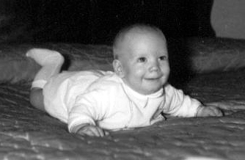

Andrew Thomas Vestich was born 7 Mar 1970.

Big Andy went to work on Highway 45 out of Greenland. Andy and Ellen rented a house in Greenland and met Mary Lou and Eli Isotalo, who lived in the house next door and attended the same church. The Isotalos had five children and every day when the kids arrived home from school, Mary Lou had a cake waiting fresh from the oven. Ellen was usually invited to join in. It was to Greenland that Butch came home on leave when he was hurt in a motorcycle accident in Ethiopia. Steve Branstrom and Brenda also lived in Greenland while Steve worked for the same company. Bertha and Gilbert Vallier also lived there for a short while. When Butch’s leave was over, he was sent to Thailand.

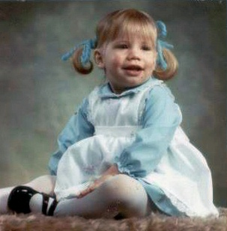

Christina Marie Vestich was born 22 July 1970 in Wakefield, Mich.

Christina was born July 22, 1971. What a sweet little girl. Butch’s tour of duty was over; Andy was laid off in February so they returned to Perkins. In April he started working in Escanaba.

Living at home that summer, Andy and Ellen started building a garage. Late that fall, Andy was sent to work on the Houghton Airport and they lived in Kearsarge until he was laid off Jan. 25 because of snow. They moved back to Perkins. Andy worked at the Tilden Mine until May 17, when he returned to the Houghton Airport. They lived in a cabin in Dollar Bay. The Lasiches also had a cabin there, making the stay much more fun. Andy and Ellen moved to South Range into an apartment owned by Albert Ozanich, leaving in November for home because of the weather.

Near the cabins in Dollar Bay was a strawberry patch where Ellen and Bea picked crate after crate of strawberries until they couldn’t give them away any more. While they were away, Lynn Vallier cared for the lawn in Perkins.

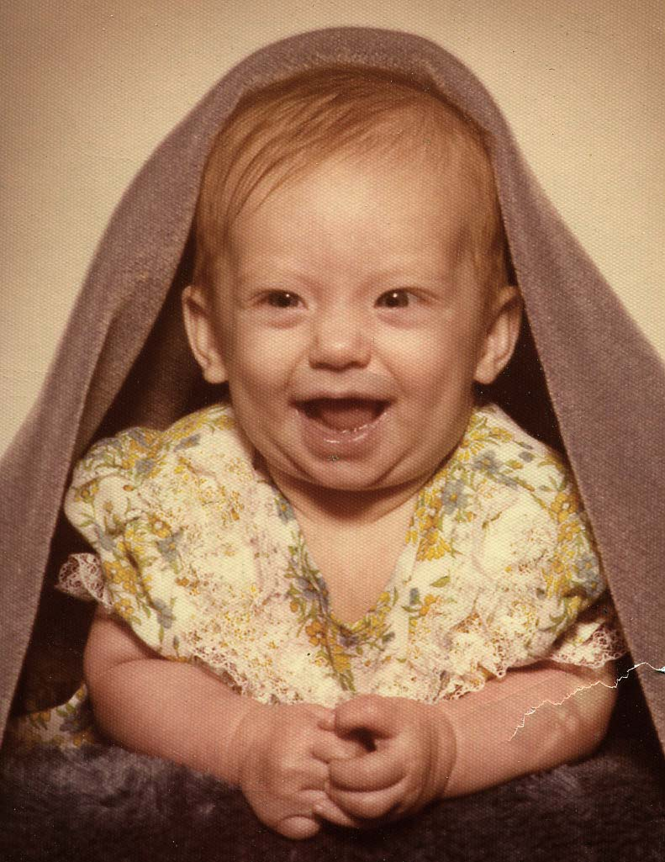

Amber Lee Bannister was born 15 Nov 1973.

In 1973, Andy worked in Marquette and Deerton so they were able to live at home in Perkins. This year they built the living room addition, complete with fireplace. This is also the year they attended the joint graduation of Jim Bannister from Northern Michigan University, his daughter Faith from high school and his daughter Robin from the 8th grade.

Amber was born on Nov. 15. Butch was enrolled at Grand Valley State University.

In 1975, from March 6 to May 6, Andy worked at the Tilden Mine, June 6 at Shelter Bay. June 9 to Dec. 19 found them living in Watersmeet with Andy working on road construction.

They rented an apartment from Nick Kolinski for $60 a month, a couple of blocks from Barb. What a great time that was for Grandma. Laurie and Larry were 11. Every afternoon they would stop at the apartment on their way home from school. Laurie just wanted to talk. But it never failed that Larry’s first question was, “What you got to eat, Grandma?”

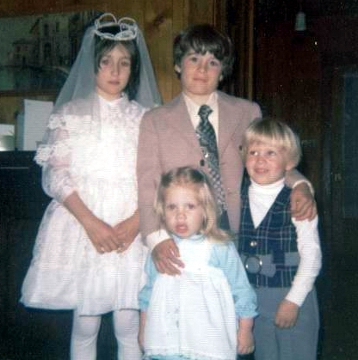

Laura and Larry, in back, pose with their sister and brother, Christina and Andy, after being confirmed in 1973.

Little Andy was in kindergarten and Chris went to preschool, which was just down the block from Barb’s. Andy and Ellen lived close enough to Barb’s house so that Chris could come over to Grandma’s alone or with her little friend, Brucie. Grandma helped them make little pies and cakes that they decorated themselves and then brought home.

Eventually the snow and cold closed the job down for the winter and Andy and Ellen went home to Perkins. Just before Christmas Barb and the kids moved to Whitefish on the Whitefish River in 1976. Her grandmother lived with her during the coldest part of the winter. In 1976 Andy and Ellen went on a trip to Grand Marais with Grace and Arnold Turan. Curtis and Pat parked their trailer at Wilderness Trailer Park in Gladstone, moving up from their Florida home for the summer. Andy was working in Munising. And this year, on Dec. 25, Don and Nancy were married.



John Caleb Bannister was born 25 Sept 1977.

In 1977 Andy was working at AuTrain, Tilden, and Ishpeming, ending the year in Marquette. John Caleb was born Sept. 25, 1977. In 1978, Barb and the kids bought a home in Gladstone and Don and Nancy moved to Memphis, Tenn., where he entered the seminary.

Barb worked as a reporter and photographer for The Delta Reporter in Gladstone. In 1979 Andy and Ellen visited Don and Nancy in Memphis. Donald worked at a printing firm in Mississippi and attended the seminary full time. John was 2 years old. Andy worked in Gwinn; Laurie went to her first prom. Despite her father's warnings that her kids would get lost in a snow bank, Barb moved to Hancock in October, taking a reporting job with The Daily Mining Gazette. She bought a house on Franklin Street.

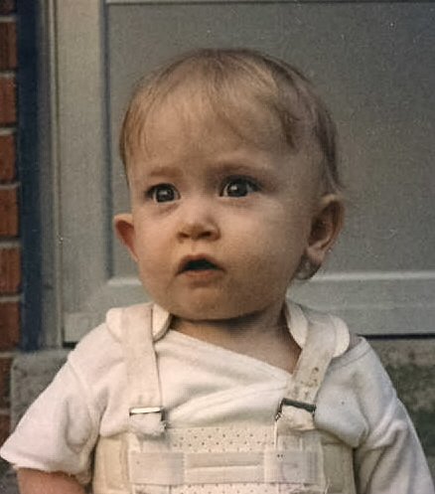

Bethany Bannister remained hospitalized in Memphis for many months after her birth on 14 April 1980. Doctors called her a miracle baby.

Bethany was born in Memphis on April 14, 1980. The doctors called her a miracle baby. Bethany was in the hospital for many months. When she was six months old, Don and Nancy took her up to Perkins to see her grandparents. Five years of surgery and doctors were in store for Bethany. The last surgery on her hip was in Childrens Hospital in Milwaukee.

In 1982, Andy and Ellen went to Lyn's in Livonia to meet her cousin, Gun, and Gun's daughter, Annica, from Sweden. Annica was an exchange student in Pennsylvania. Also that year, Kay and Ellen took their mother to Fish Creek, Wis., to revisit her hometown and visit with her sister‑in‑law, Anna Albertsen, and her lifelong friend, Emma Hansen. Emma guided them through all the old places: the schoolhouse where they attended school, their church, the family cemetery, the houses where they were born. 1982 was the year Andy retired.

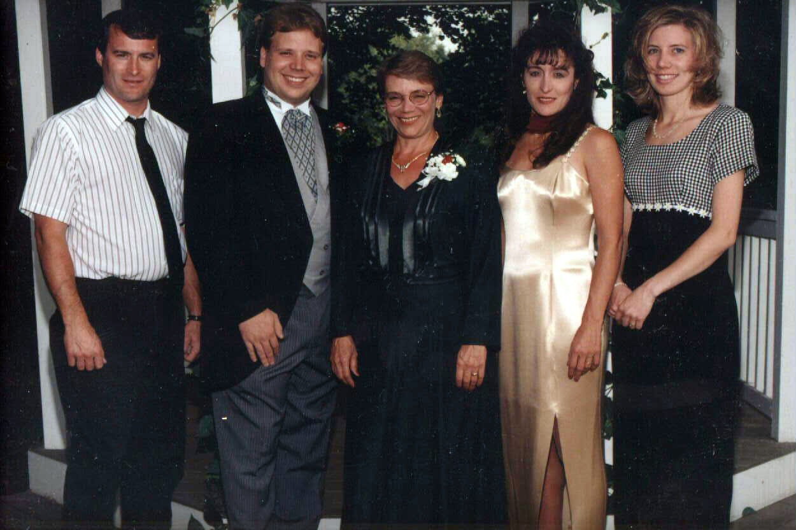

Barb and her crew, from left: Larry, Andy, Barb, Laurie and Christina, in the mid 1990s.

In 1983, Andy and Ellen toured the Lake Superior Circle in October, taking them through Wisconsin, Minnesota and into Canada. Larry and Laurie graduated that year, Laurie from Hancock and Larry from Watersmeet. Donald and Nancy moved to Menasha, Wis., where he took a job doing pre‑press work at a printing company called Master Litho. He's now a supervisor. Several years later, Nancy took a job testing tissues – her job title is "sensory technician" – with Kimberly Clerk in Neenah.

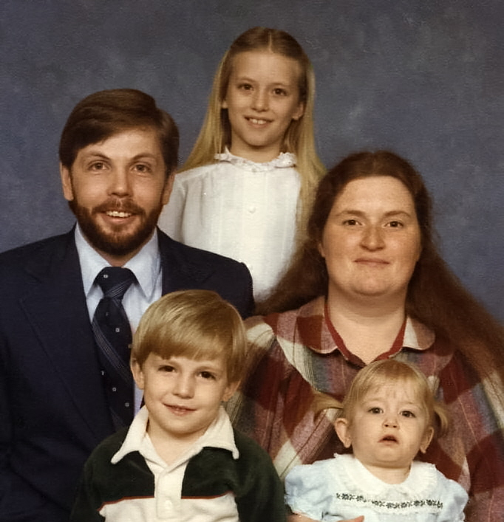

Donald and Nancy Bannister and their three children: Amber, in back, John, front left; and Bethany, front right. The photo was taken in the early 1980s.

On June 3, 1984, Larry and Connie were married in the Lutheran Church in Ironwood. Barb became managing editor of the Daily Mining Gazette. Nicole was born Dec. 21, 1984, missing her dad's birthday by one day. Laurie and Duffy Kopsi were married Aug. 10, 1985, in Ewen.

By this time Ellen's mother had fallen and broken her hip, requiring her to stay at the Northwoods, a nursing home in Escanaba.

In 1986, Andy and Ellen drove to the Yellowstone National Park, and then went on to Idaho to visit her niece and nephew, Susie and Donnie Stenlund, and Susie's daughter, Amanda.

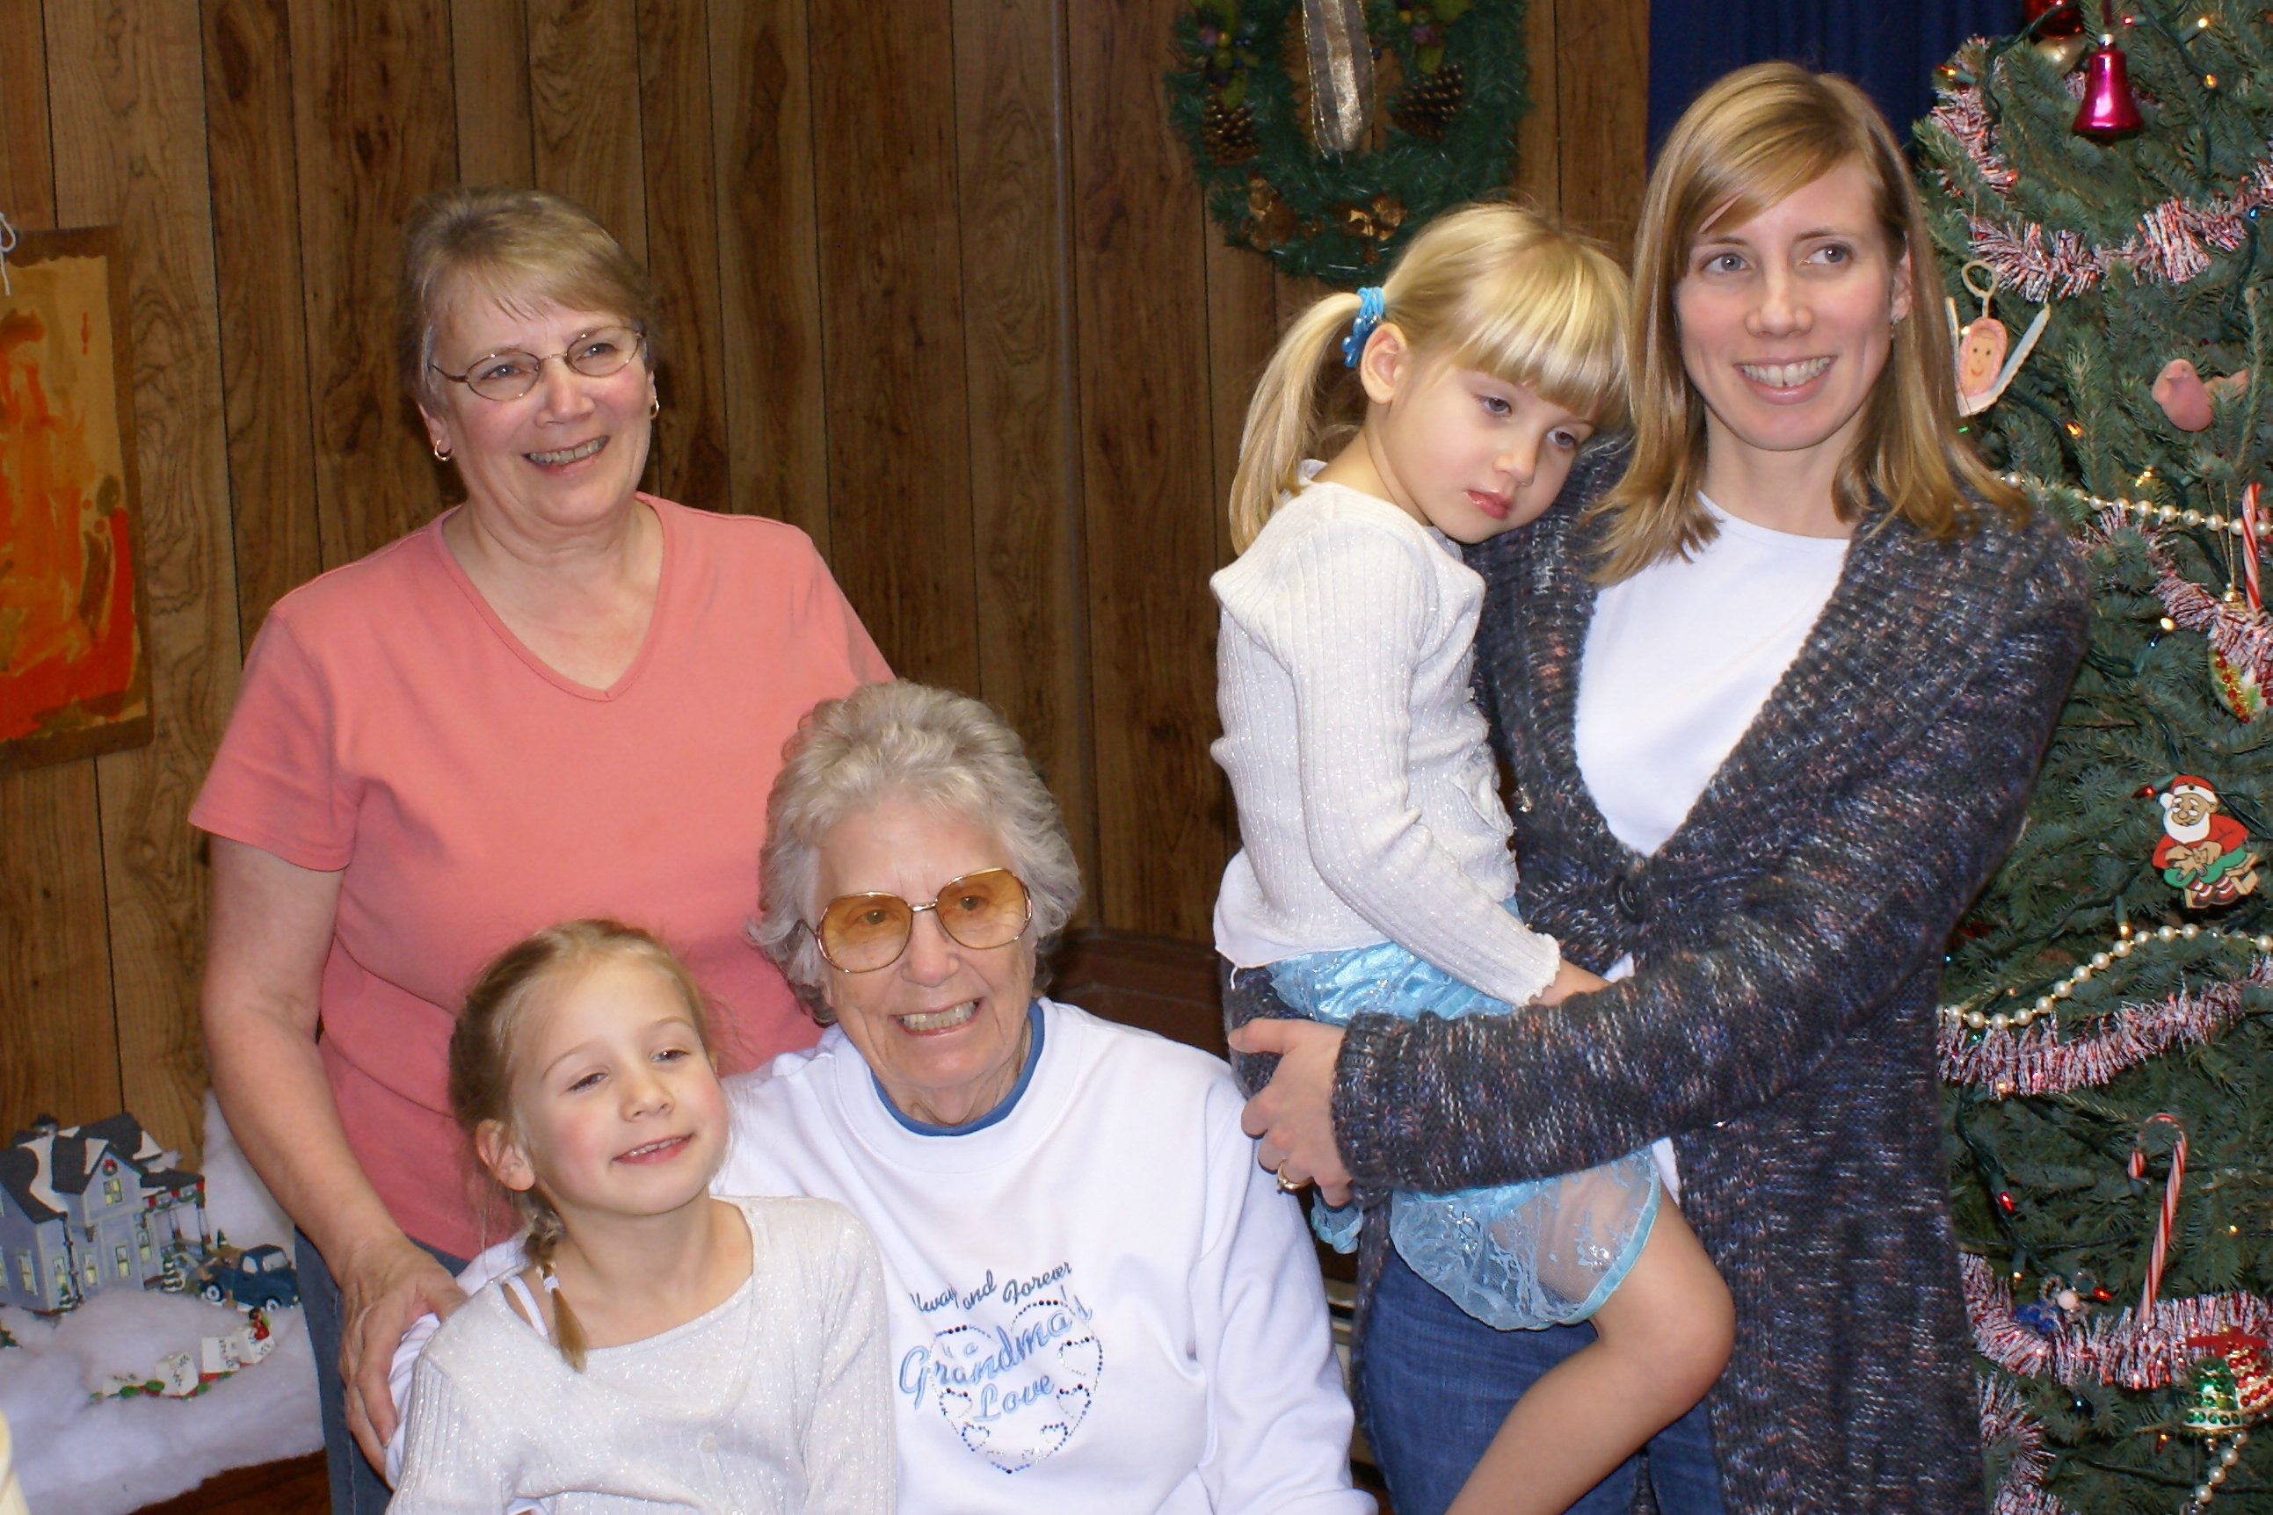

Ellen Stenlund Bannister, center, poses with her daughter Barbara, back left; granddaughter Christina, right; and great-granddaughters Lindsay, left, and Megan.

In 1987, Barb and Gary Gagnon were married on May 9 in Hancock, so two more grandchildren – Kelle and Mark – were added to the family.

1988 gave us Nathan Lee, born March 16, to Larry and Connie. Little Andy – not so little any more – graduated from Hancock Central High School and enrolled at Michigan State University in East Lansing. In 1989, Christina and Mark graduated from Hancock and Barb moved to Marquette to work for The Mining Journal as news editor. Christina enrolled at Northern. Barb and Gary bought their home on M‑28 in Marquette. Andy and Ellen took a trip through the Blue Ridge Parkway, ending up in Florida to see Pat in Ocala.

In 1990, Alex was born Oct. 21 to Laurie and Duffy. In 1992, Amber graduated from Neenah High School after an enormously successful career in Swing Choir.

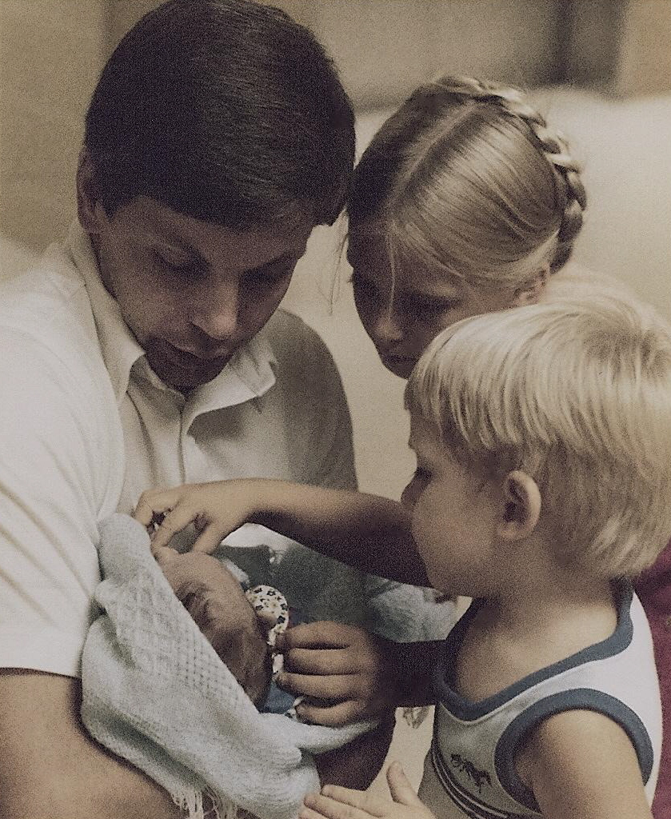

Every year Andy has spent the Nov. 15 hunting season out in the woods hunting deer, usually with good hunting partners like Pete LaBumbard, Andy's brother Curtis, his brother‑in‑law Arnold Turan and Budd Branstrom. Some of his best stories are his deer hunting tales.

Most Octobers have been spent out on his 40 hunting partridge. Then Ellen could go with him into the woods, looking for wild flowers to dig up and take back to her flower beds in Perkins. Andy taught her how to see a fish in the river; where to look for partridge in the trees or on the ground, and to love being out in the woods. They made wood for winter heat together, canned from their garden together, made pies and jam for the freezer together. Most of Ellen's free time was spent making clothes, knitting socks and sweaters and afghans and making quilts. Andy now spends his time in his workshop making his flower stands and kids chairs – and anything else his grandchildren happen to mention they would like.

**Donald presents newborn Bethany Hope to her siblings, Amber and John.**

###### 2008 Update

**Ellen Bannister** remains in her home in Perkins, although she has been looking into assisted living homes. She had a minor stroke in late spring but did not suffer paralysis. She is gaining strength every day. She loves playing her organ and working outside in the yard. Bethany Lutheran Church is still a huge part of her life.

**Barbara Bannister** and her husband, **Gary Gagnon**, remain in their home on M-28 in Chocolay Township just a few miles south of Marquette. Barb, a graduate of Bay de Noc Community College in Escanaba, retired from The Mining Journal in 2006 after nearly 30 years in journalism. Gary is still laying natural gas lines for InfraSource but hopes to retire in less than two years. Barb spends her retirement time canning, reading, and taking lots of photos of her grandchildren. Both Barb and Gary are golfers; Barb is active in a women’s league at a course just a few miles from their home. They spend some time during winter in Florida, where Gary has learned to fish from the beach.

**Christina Vestich** is now Christina Kleinheinz. She and her husband, Greg Kleinheinz, live in Winneconne, Wis. Chris, a Northern Michigan University graduate, is a stay-at-home mom raising their two children, Megan, 5, a kindergartener at Winneconne Elementary School, and Lindsay, 7, a first-grader. Both girls are splendid readers. Lindsay worships pink. Both of them love the above-ground pool Dad installed in the back yard this year. Greg is an associate professor of microbiology at the University of Wisconsin in Oshkosh. The family built a cabin on Beaton’s Lake just north of Watersmeet. They also have a travel trailer for summer trips with kids and friends. Sometimes they park it on the lot they bought in Bailey’s Harbor, Door County.

**Laura Vestich**, now Laura Kopsi, lives in Watersmeet with her husband, Duffy Kopsi. They met while attending Gogebic Community College in Ironwood. Laura works in the education department of the Lac Vieux Desert Band of Lake Superior Chippewa Indians. She also is an emergency medical technician for the township. Duffy worked for many years in a lumber mill in Land O’ Lakes, Wis. He is waiting for knee replacement surgery in December in Marshfield, Wis. Their son, Alex, who just turned 18, is a freshman at Gogebic in Ironwood, studying to be a lineman. Andy, 14, is a freshman at Watersmeet High School.

**Kelle Gagnon** is now Kelle Honzik. She and her husband, David Honzik, live in Milwaukee. Kelle, a Gogebic graduate, is a corrections officer at the Milwaukee County Jail. Dave, a fireman, drives a fire engine for the Milwaukee Fire Department. They have two sons. Maxwell, 11, who just got his own cell phone, is a sixth grader at the Milwaukee School of Languages. After six years of German, he decided to study Mandarin Chinese this year. Zachary is a fifth grader at Milwaukee German Immersion School. He loves snowmobiling with his dad.

**Andy Vestich** and his wife, Joanna (Oikarainen) Houle-Vestich live in rural Hancock. Andy teaches social studies at Houghton High School and is near finishing course work on an educational specialist degree. Joanna, a business grad, is a supervisor at Superior National Bank in Hancock. Their son, Hunter Houle, 10, a dinosaur lover, is in fifth grade at Houghton Elementary School. The family usually takes one long trip in summer. They recently visited Colonial Williamsburg.

**Mark Gagnon** and his wife, Leann (Wylie) Kirch-Gagnon, live in Ishpeming. After years of working in a lumber mill at Sawyer, Mark recently got a job driving giant-sized trucks for Cleveland Cliffs, Inc.’s Tilden Mine. Leann is an advertising sales representative for The Mining Journal in Marquette. They have three daughters. Ashley Gagnon, 13, is an eighth grader at Negaunee Middle School in Negaunee. Bailey Kirch, 12, is a seventh grader at Phelps Middle School in Ishpeming. Brittney Kirch, 15, is a ninth grader at Ishpeming High School.

**Larry Vestich** and his wife, Jamie (Reuter) Vestich, live in Watersmeet. Larry, who also attended Gogebic, has worked for many years for the Gogebic County Road Commission, where he drives snowplow in winter and builds roads in summer. Jamie is a social worker with Northcare Community Mental Health in Ontonagon. Larry is hoping for an early retirement in 11 or 12 years and plans to build a home on land they’ve purchased near Chris and Greg’s lot in Bailey’s Harbor. Jamie’s family is originally from Door County. Larry and Jamie’s daughter Nicole, a Michigan Technological University business graduate, is living in Jacksonville, Fla. She and her fiancé Ben Biesterveld, an MTU grad in engineering, plan to marry next summer. Son Nathan, after two years of study at Northern, is attending college in Rhinelander, studying carpentry. He plans to join his uncle’s log home building business in Land O’ Lakes.

**Donald Bannister** and his wife, **Nancy (Johnson) Bannister**, live in Omro, Wis. After many years as a printer, Don went back to school and graduated from Central Michigan University in Mount Pleasant with a Ph.D. in clinical psychology in 2002. He is now a psychologist with the Wisconsin Department of Corrections. Nancy, who studied nursing at Bay de Noc Community College in Escanaba, is a certified nursing assistant with advanced training in asthma and allergy. She works for an Oshkosh physician. Nancy reads, likes movies, and loves spending time with her family. Donald, a poet, is an avid reader who tries to finish one book each week. He’s also an award-winning runner.

**Amber Bannister** is now Amber Buschmann. She lives in the Madison suburb of DeForest with her husband, Josh Buschmann. A UW-Oshkosh graduate, Amber now works as director of Human Resources and Administration at United Way of Dane County in Madison. She enjoys spending time with her kids, running, walking and exercising. She and Josh have joined a bowling league. Josh is an insurance adjustor with WPS in Madison. He enjoys all sports, and coaches T-ball and soccer. They have three children. Abigail, who is 9, is a third-grader at Yahara Elementary School in DeForest. She loves shoes and making jewelry. Ryan, 5, is in pre-school in DeForest. He likes sports, especially baseball, and wants to be a farmer. Tyler is 1 1/2. He likes everything. His nickname is “Tyler the smiler.”

**John Bannister** and his fiancée, Roxanne Biedermann, are remodeling a home they just purchased in Neenah. He works as a drywall finisher. John attended UW-Oshkosh for a time. Roxanne spent a year studying at Baylor University in Waco, Texas. She now works for a landscape company in Appleton. Music is a big part of John’s life. He plays guitar and likes punk music. Roxanne likes to read; they both like going to wine tastings. John makes his own beer. They have a dog named Stanley.

**Bethany Bannister** lives in Neenah. She works as a job coach for vocational services at Goodwill Industries in Menasha. She is engaged to Brewster Deeg and they are busy planning a summer wedding. Brewster is employed by Taco Bell. Both Bethany and Brewster enjoy playing video games, watching movies, and hanging out with friends. They have a cat named Smokey.