Chapter 14

SCANDINAVIA

Olof Petro Stenlund/Helga Mae Albertsen

**Parents of Ellen Mae Stenlund**

**Olof Petro Stenlund** was only 22 when he left Sweden, bound for adventure and a better life in the new country of America. He went directly to Michigan’s Upper Peninsula to join a Swedish community established there by the Wickstroms and the Lundbergs.

In America, Olof Petro met a first-generation American, Helga Mae Albertsen, whose parents emigrated from Denmark and settled in Wisconsin. Helga was in the Rapid River area visiting her sister, Jenny, when she met Olof Petro. They married in 1919.

**OLOF PETRO STENLUND4; (HERMAN3** andIDA CAROLINE HOLMQUIST)b. 1 Oct 1891 in Jorn’s Congregation, Sweden; m. Helga Mae Albertsen on 22 Mar 1919 in Rapid River, Mich.; worked as a woodsman and farmer in the Rapid River area and built a dairy farm in Ensign Township; became an American citizen on 27 Jun 1928; d. 12 Mar 1965.

**HELGA MAE ALBERTSEN**; (SOREN SAMUEL ALBRECHTSEN and DOROTHEA JENSEN) b. 25 Oct 1897 in Ephraim, Wis.; m. Olof Petro Stenlund 22 Mar 1919 in Rapid River at the home of her sister, Jenny Roggendorf; d. 20 Jan 1988.

Children of this marriage (from Helga’s memory and her Bible) are:

1. Catherine Opal, “Katie”; b. 10 Oct 1919 in Menominee; baptized 3 May 1920 by O.C. Dahlagen, sponsors Herman Stenlund and Martha Albertsen; m. 22 Apr 1944 to Arnold Siitar; moved to Detroit.
2. Hjalmer Eugene, b. 27 July 1922; d. 13 Aug 1922.
3. **ELLEN MAE5**, “Lulla”; b. 3 Sept 1924 at home in Ensign; baptized 5 Oct 1924, sponsors were the parents; confirmed 6 Oct 1940 by R.D. Hult; m. Andy Gordon Bannister 24 Oct 1942 in Gladstone.
4. Olof Petro Jr.; b. 24 Dec 1928; baptized 24 Dec by Dr. Kee; d. 25 Dec 1928.
5. Peter Samuel, “Sammy”; b. 19 Aug 1930; baptized 12 Oct 1930 by Rev. Carl S. Ohman; d. 5 Oct 1936 from peritonitis after his appendix burst. Rev. Hawkins officiated at the funeral.
6. Linda Dorothea, “Lyn”; 12 Oct 1935; baptized 26 Feb 1936 by Rev. Broberg, sponsors Mr. and Mrs. Carl Wickstrom; m. 28 Sept 1957 to Berger Lee Erickson (d. 20 July 2007); children Paul Lee, b. 17 Mar 1961, d. 13 May 1973; Mark David, b. 5 Sept 1962; and Jon Peter, b. 16 Sept 1966.
7. John Francis, “Jack”; b. 25 Oct 1938 in Escanaba; m. Gladys Wasson Jan 1959; children Susan Ann, b. 21 Dec 1960 and Donnie Allen, b. 12 May 1964; d. 15 Jan 1972.
8. Theodore James, “Ted”; b. 7 Dec 1939 in Escanaba; baptized 23 Nov 1941 by Rev. Swanson; confirmed 27 Nov 1953 by Rev. W. Johnson; m. Alta Sundling 12 Jun 1962; children James and Shana; d. 7 Aug 2004 in Valparaiso, Ind.; d. 7 Aug 2004.
9. Jerry Phillip; b. 1 Oct 1941 in Escanaba; baptized 23 Nov 1941 by Rev. Swanson; confirmed 24 Jun 1956 by Rev. Peterson.; d. 30 Apr 2008.

Olof Petro was born 1 Oct 1891 in Jorn, Vasterbotten, Sweden, the son of a farmer, Herman Stenlund, and Ida Caroline Holmquist. He was baptized in the Jorn’s Congregation. While he was in Sweden, he lived in Medle and Skelleftea, where his parents are buried.

Olof Petro was born during a time of heavy mass emigration from Sweden to the United States. Unemployment was high in Sweden. Agriculture was only partially modernized. After a series of crop failures, masses of farmers left the country. From 1868 to 1914, more than 1 million Swedes moved to America; at the time Sweden’s population was about 5 ½ million.[1]1 As the oldest boy in the Stenlund family, it was logical Olof would be the one to emigrate.

The Ascania was a 466-foot Cunard ship that was launched in 1911. Peter Stenlund voyaged on the ship in February and March 1913 to travel from Southampton, England, to America.

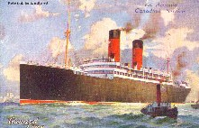

In March 1913, at the age of 22, Olof Petro came to the United States, landing at Portland, Maine.[2]2 His emigration – and that of hundreds of thousands of others – would not have been possible without the Swedish railroads and commercial passenger ships over the Atlantic. At the time, no Swedish commercial line carried passengers directly to New York; the Swedes had to use British or German ships. Olof Peter traveled on the Ascania, a 466-foot British-owned ship that traveled at a speed of 13 knots from Southampton, England. The Ascania had room for 200 second-class and 1,500 third-class passengers. She was owned by the Cunard Steamship Co. and was launched on 6 Mar 1911. In 1918 she was wrecked off the coast of Newfoundland.[3]3

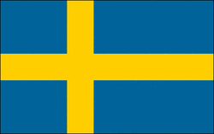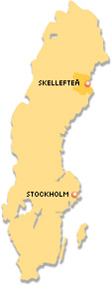

This map of Sweden shows Skelleftea, the main residence of Peter Stenlund’s family.

Olof Petro was 22 when he arrived in America. He came directly to the Upper Peninsula of Michigan and worked on the ore docks in Marquette and also as a woodsman. He settled in the Rapid River area and bought a small farm. He often sent money back to his family in Sweden. His brother, Herman, arrived in the United States a few years later. His United States citizenship papers changed his name from Olof Petro to Peter. He was called “Pete.”

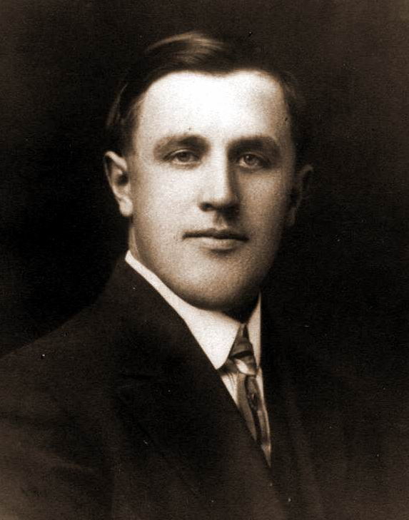

Peter Stenlund was a young man when he was photographed in Michigan.

Pete was naturalized as an American citizen on 27 Jun 1928. In his 6 Apr 1924 application for naturalization, on file in Escanaba, he was described as being 5 feet 8 inches tall, weighing 175 pounds, with dark hair and gray eyes. Witnesses to the naturalization ceremony were John Lundberg, a farmer, and Andrew Magnusson, a storekeeper. Both were from Ensign.

Peter Stenlund was among a group of loggers enrolled in the Civilian Conservation Corps in the 1930s.

On 9 Jun 1933, Pete was enrolled in the Civilian Conservation Corps (CC6-38375) at Camp Custer. He was discharged to accept employment on 29 Nov 1933. He was 42 years old. He was described as a woodsman who had blue eyes, gray hair, fair complexion, and was 5 feet 8 inches tall. He did reconditioning work from 9 Jun 1933 to 23 Jun 1933 at Camp Custer and earned a satisfactory rating from Capt. Edwin R. Morine, commanding officer. From 24 Jun to 23 Nov he did general forestry work at Camp Rapid River and earned an excellent rating. From 24 Nov to 29 Nov he did general forestry work at Camp Wyman in Munising and earned an excellent rating from Capt. Morine. On 1 Mar 1934, the U.S. Army paid him $29.

Peter Stenlund’s signature, taken from his citizenship papers.

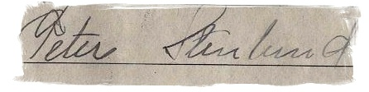

Pete was a relatively young man – probably in his late 40s – when he developed tremors in his limbs. He went to local physicians for a diagnosis – Parkinson’s disease – and they sent him to the Mayo Clinic in Rochester, Minn. for treatment. Married and with a young family, Ellen and her children stayed at the farm in Ensign to care for her siblings while Pete and Helga traveled to Minnesota.

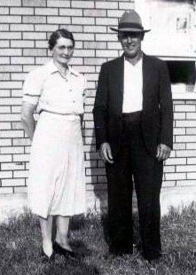

**Helga and Pete Stenlund, c. 1930s.**

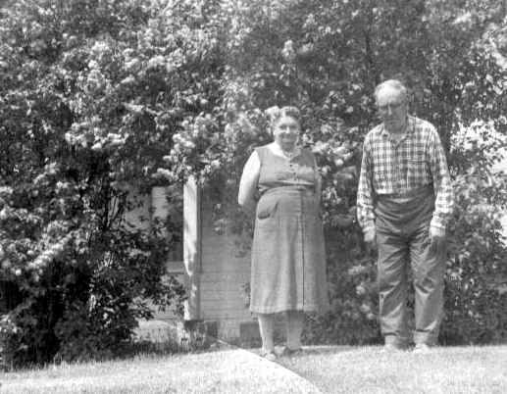

Pete and Helga Stenlund in a photo taken in the early 1960s near the lilac trees along the side of their home in Ensign Township.

“He had started shaking when I was still in school,” Ellen said in 2005. She graduated from Rapid River High School in 1942. “That arm was shaking then.”

**Grandfather Had Parkinson’s**

By Donald Bannister

Grandfather was a broken man.

His hands and head shook with constant motion.

His arms useless

as he shuffled from chair,

to porch,

to outhouse and back,

yelling for Grandmother’s help.

Until she would emerge from the kitchen,

with her apron in place,

smelling of bread

speaking to him in Swedish,

and the crisis would pass.

Long strings of drool hung from his chin,

too strong to break, resisting

his feeble attempts at wiping,

until he stopped in defeat – another

part of life

to be endured.

Strong families accept each member,

and I was allowed to learn, watching from a distance —

except for those times when like a captured bird,

I was placed upon his lap,

trembling with fear,

straining to fly away.

And Grandfather would weep.

Pete died of a stroke at 11:15 p.m. Friday, 12 Mar 1965 at St. Francis Hospital in Escanaba. He was 73 years old. Parkinson’s, which still has no cure, had wracked his body and his mind.

Here is what Peter Stenlund’s obituary in the Daily Press (Escanaba, Mich.) said:

“Peter Stenlund Dies Friday

“Peter Stenlund, 73, long-time resident of Ensign, died at 11:15 p.m. Friday in St. Francis Hospital after a long illness. He had been hospitalized ten days.

“Mr. Stenlund was born in Sweden Oct. 1, 1891, and he came to the United States to the Rapid River area in 1913. He was engaged in farming during his active years and also was a woods and ore dock worker.

“He married the former Helga Mae Albertsen in 1919. He was a member of Calvary Lutheran Church, Rapid River.

“Surviving are his wife, three daughters, Mrs. Berger (Linda) Erickson, Chicago Heights, Mrs. Arnold (Katherine) Siitar, Detroit, and Mrs. Andrew (Ellen) Bannister, Perkins, three sons, Jerry at home, John of Kincheloe AFB and Theodore of Chicago Heights, four brothers and four sisters in Sweden and one brother, Herman, Rapid River.

“The body was taken to the Kelley Funeral Home.

“Friends may call at the funeral home beginning Monday afternoon. Services will be held Tuesday at 11 a.m. at Calvary Lutheran Church, Rapid River, with Pastor George Olson officiating. Burial will be in Rapid River Cemetery.”

Helga said Pete was not in military service. He worked on the ore docks in Marquette during World War II.

Helga, top right, is shown with her mother, Dorothea Albertsen, at bottom right. At left, top, is Helga’s sister, Martha, and at left bottom is her sister, Jennie.

**Helga Stenlund** was born 25 Oct 1897 at home in Fish Creek. Her birth was registered in Ephraim, Gibraltar Township, Wis. She was the ninth and last child of Soren Albertsen and Dorthea Jensen. She was baptized 5 Dec 1897 at Bethany Lutheran Church in Ephraim by the Rev. Gudmund Kluxdal. She was confirmed 6 July 1913.

Helga grew up in Fish Creek, Wis., which was a few miles south of Ephraim, on Lake Michigan’s Door County shoreline. “There were 11 of us on a little 40-acre farm in Fish Creek. When each child was born, my father planted a cherry and an apple tree. For my oldest brothers, he planted two crab apple trees,” she told a Daily Press (Escanaba, Mich.) interviewer for a Senior Spotlight story in 1974. When she returned to the family homestead, “I saw those two crab apple trees with little blooms at the top of each. It looked so comical.”

Helga Albertsen, as a young woman in her 20s.

Helga told the interviewer she was born in a log cabin on her father’s farm. “My father started a new house at that time but it was never finished because it burned down.”

She said her father was a man of several trades. Besides farming, he worked as a bricklayer and as a tailor. “He must have plastered all the houses in Fish Creek,” Helga said.

Helga went to school in a one-room building in Ephraim until her sister Martha quit school. Her father would not allow her to walk across the ice alone after that.

Helga moved to Rapid River, Mich. in 1918, to live with her oldest sister, Jenny. By then, Jenny was married to Fred Roggendorf. Helga met her future husband, Pete, through Jenny.

“He used to haul wood cuttings from the forest to the Whitefish River. And he would pass me in the meadow where I worked on his way,” Helga said. “Upon seeing him I told my sister that fellow would look more handsome if he shaved off his moustache.” The next time she saw him he had no moustache. They were married two years later, on 22 Mar 1919.

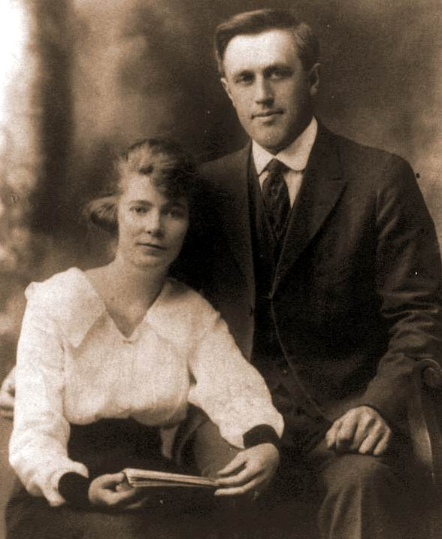

Helga Albertsen was 22 years old and Peter Stenlund was 28 when they were married in 1919.

They were married by Pastor Dahlager at Jenny’s home.

In July, Helga and Pete moved to 120 acres of farmland he had bought between Ensign and Rapid River. Pete built a house that later would be graced by fragrant lilac trees, a “summer kitchen” that was used for cooking in the warm months (most likely her delicious “pult,” the potato dumplings she made for several generations of her family), a dairy barn and a chicken coop. Helga lived on the farm until Pete died in 1965. She sold the farm and bought a small house in Rapid River, within walking distance to downtown.

Helga and Pete’s first child, Catherine, known as “Katie,” was born on 10 Oct 1919 in Menominee, Mich. Hjalmer Eugene was born 21 July 1922 and died 13 Aug 1922. Ellen Mae was born 3 Sept 1924 at home.

Years later, Ellen recalled the births of several siblings.

“I was 4 years old when my brother Olof Peter was born on Dec. 24, 1928. He died the following day,” Ellen wrote in 2005. “My brother Samuel Peter was born (in) 1930. I was 6 years old. It was nice to have a brother to be playing with. In the fall of 1936, having just started school, Sammy was hospitalized with peritonitis from a burst appendix. Sammy died Oct. 5, 1936.”

Helga Albertsen poses with the deer she shot in about 1918, when she was living with her sister, Jenny Roggendorf, in Rapid River.

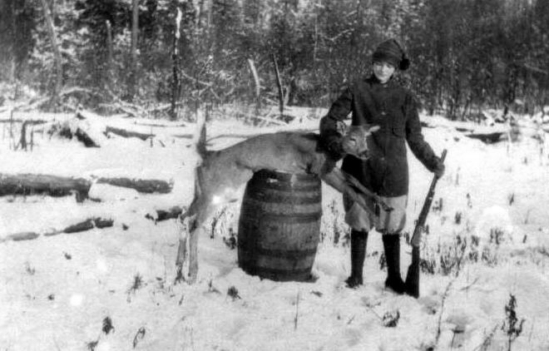

Ellen described her youth as a comfortable family life. In 2005, she wrote:

“Cold weather nights were spent gathered around the kitchen stove, Mom in a rocking chair with Sammy on her lap, Catherine and I sitting close by listening to her read, one chapter each night from a book brought home from the school library. My favorite was ‘Little Women,’ by Louisa M. Alcott. I still enjoy reading through talking books, courtesy of the Library for the Blind.” Ellen is legally blind because of macular degeneration.

“My sister Linda was born Oct. 12, 1935,” she wrote. “I was 11 years old. Now we had someone to sew for and fuss over. I was in the sixth grade and in the second year of 4-H.. Our 4-H leader was Esther Branstrom. I was in high school when my three brothers were born, Jack on Oct. 25, 1938, on Mom’s birthday; Ted, Dec. 7, 1939, and Jerry on Oct. 1, 1941, on Dad’s birthday. Now when I got home from school it wasn’t just the great smell of Mom’s homemade bread that greeted me but three little brothers that wanted me to play with them, which I gladly did.”

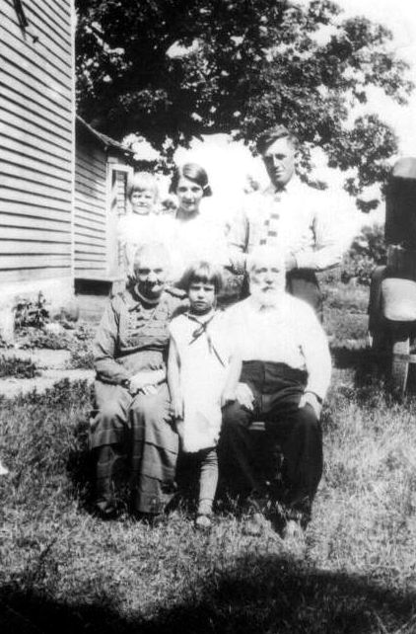

The Albertsen family and the Stenlund family. In front from left are Dorothea Jensen Albertsen, Catherine Stenlund, and Soren Albertsen. In back, from left, are Ellen Stenlund, being held by her mother Helga Albertsen Stenlund and Ellen’s father, Peter Stenlund. The photo was likely taken in the mid 1920s; Ellen was born in 1924 and Soren died in 1926.

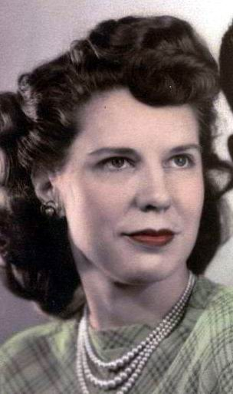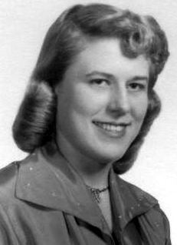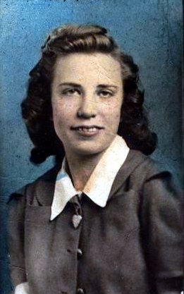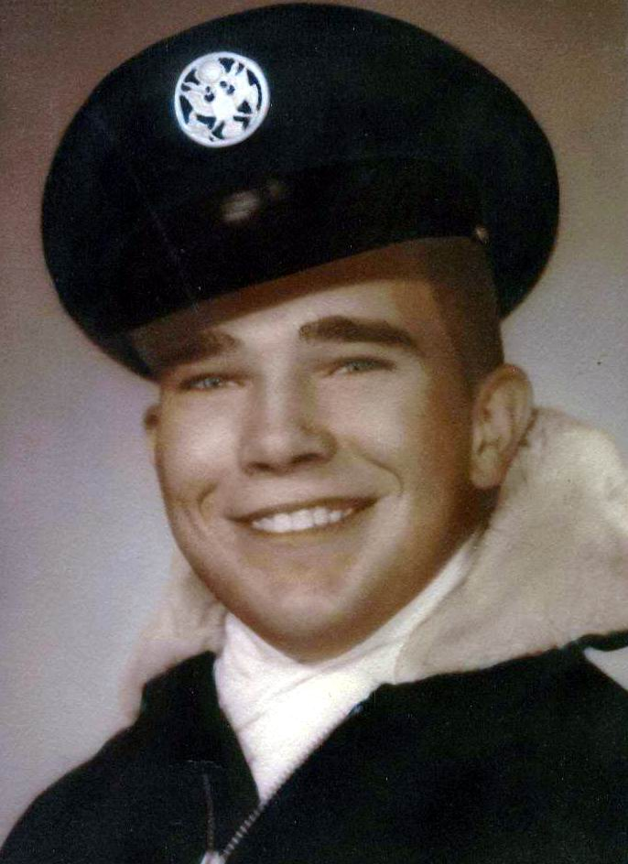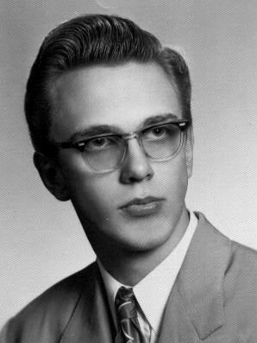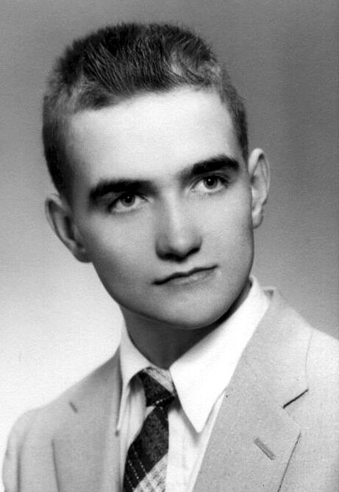

The six children of Helga and Peter Stenlund who reached adulthood: From left are Catherine, Ellen, Linda, John, Theodore, and Jerry.

Although born in Wisconsin, Helga became a Swedish subject when she married Pete, according to her naturalization papers. In 1928, Helga became a naturalized citizen of the United States. Naturalization laws then called for any person who was formerly a citizen of the U.S. to lose her citizenship if she married an alien. Helga’s naturalization petition is No. 2157240, Volume 23, Number 1767. The papers describe her as being 30 years old, 5 feet 2 inches tall, of medium complexion with blue eyes and brown hair. The document was dated 27 Jun 1928.

Helga’s granddaughter, Barbara Bannister, writing in 2005, had these remembrances of her grandmother:

“Grandma was loved by everyone who knew her, likely because *she* was so full of love. She was good-natured, kind and jolly, quick to laugh. Her home was warm and inviting, always full of good smells and good food.

“I loved going into Grandma’s pantry, which smelled of spices and flour. The room was small, just wide enough to hold a metal cupboard with a shelf she could work on. To the left were hanging things, like the broom and dustpan and mops, and a low window, which let in a nice light. To the right were shelves to hold packaged food. In the middle of the room, which was curtained off from the kitchen, was a bare light bulb, with a string attached.

“The farm in Ensign was powered with electricity but it had no running water. Water for the kitchen was carried into the house bucket by bucket from a well with a hand pump out by the milkhouse, where milk from the cows was stored. In the kitchen, the bucket sat on a tall stool near the pantry door; a long-handled water dipper hung on a nail nearby. Grandma cooked on a wood-burning cast-iron kitchen range. The footed stove, which was enameled, was pale green and off-white. She cleaned the cooking surface with a polishing compound called ‘stove black,’ which made it gleam. The range had a water reservoir, an oven and two large bun warmers. On Thanksgiving or Christmas, when the oven was on for hours roasting a 20-pound turkey, the temperature in Grandma’s kitchen crept into the 80s, and we opened the outside door for relief.

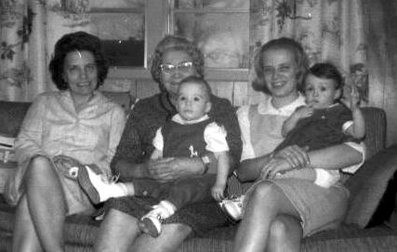

From left, Ellen, Helga holding Barb’s son Larry, and Barb holding her daughter Laurie, in their first four-generation photo.

“Grandma was always plump. When I was a child, her girth was part of a game we played. We marked my physical growth by how close I could come to reaching around her middle when I hugged her. I still remember the first time my fingertips touched.

“Grandma loved tatting. She had special teacups. She loved cheese and crackers and pickled herring, which she bought in wooden kegs filled with brine. She had beautiful, healthy fingernails and tried to teach me to care for my own. She had a Christmas cactus that she kept for decades that is now in her daughter Ellen’s possession; I have a slip. She loved Reader’s Digest books. When Grandpa was still alive, she had long gray hair that she braided and wrapped around her head. I didn’t realize her hair was long until I stayed over and slept with her one night. Before she went to bed, she took her hair down. In later years, after Grandpa had died, she cut her hair short. She was hard of hearing in her later years. Grandma read her Bible every day and devotions every night before she went to sleep. She snored. After menopause, her neck and upper chest remained flushed; she has passed this condition on to me. She wore an apron and a dress every day and never wore pants until she was elderly. She had a yard full of fireflies. If she was poor, I never guessed.”

Helga Albertsen and her fellow students pose in front of the one-room schoolhouse she attended in Ephraim, Wis. The school is now a national historic site.

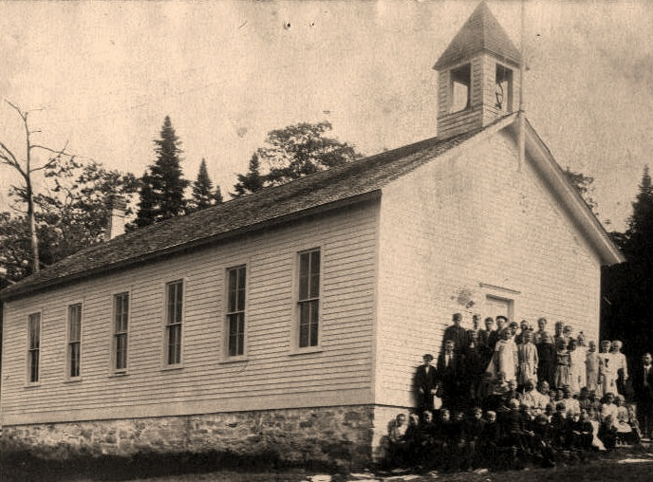

After living in Rapid River for nearly 20 years, Helga broke her hip in 1985. She moved into the Northwoods nursing home in Escanaba. She slipped into a coma 16 months before she died on 20 Jan 1988. Her funeral was on Sunday, 24 Jan at Calvary Lutheran Church in Rapid River, where she had been a member for so long. The Anderson Funeral Home of Gladstone made arrangements. The congregation sang “What a Friend We Have in Jesus” and “Amazing Grace,” and recited Psalm 23, “The Lord is my Shepherd.” The pastor was the Rev. Daniel B. Kangas; Sylvia Dye was the organist. Congregants and the family had lunch and coffee in the parish hall following the funeral. Helga was buried in the Rapid River Cemetery, next to Pete.

**SOREN ALBERTSEN/DOROTHEA JENSEN**

**Parents of Helga Mae Albertsen**

**Soren Albertsen** was born 4 Sept 1848 in Hollensted, parish of Hallund, Dronninglund, Denmark, according to his birth record in Norrejylland, Denmark. The record said his parents were Albrecht Philip Jensen, a tailor, and Mette Marie Sorensdatter. The village of Hollensted is in the county of Hjorring, which is near the town of Aalborg in the north.



The Hallund church records state that Soren was baptized at home 12 Nov 1848. He became a member of the church on 25 Dec 1848. Jerry Stenlund hired Arne Jensen Knudby of Copenhagen, Denmark, to do research for the family in 2002. Here is what the Hallund church records say about Soren’s baptism, based on Mr. Knudby’s research:

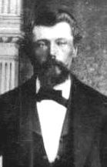

Soren Albertsen, as he appeared in a photo that was likely taken on the occasion of his wedding in 1877. He was 29 years old.

"Soren Albrechtsen, born 4 Sept. 1848, bapt. 25 Dec. 1848. Parents: the unmarried Mette Marie Sorensdatter with her father Soren Poulsen in Hollensted. Witnesses: the teacher Thomas Sorensen's wife Inger Jensdatter; the lodger Peder Christensen's wife Kirstine Marie Jensdatter; farmer and parish officer Jens Rasmussen; the mentioned Peder Christensen; the bachelor Christen Frandsen with his parents; farmer Frands Jensen, all from Hollensted. - Remarks: an illegitimate child. The alleged father is the bachelor and tailor Albrecht Philip Jensen. The mother was with her father, when she got pregnant."

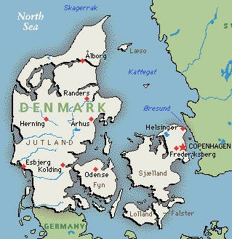

This map shows the country of Denmark, and Aalborg in the north. Soren Albertsen was born in the village of Hollensted, which is near Aalborg, the county seat of Nordjyllands (North Jutland County).

Soren and his mother, Mette Marie, lived with her parents. Census returns in 1850 and 1855 find them living in Hallund parish in the village of Hollensted with Soren Poulsen and Maren Oldsdatter, her parents. He was still living with his grandparents in 1860, when he was 12 years old, but his mother was not living with them.

Soren was confirmed in the Hallund parish on 5 Oct 1862, when he was 14 years old. The church record reads:

“Soren Albrechtsen, with his parents. Parents: the unmarried Mette Marie Sorensdatter and the alledged (sic) father, the bachelor and tailor Albrecht Philip Jensen. Born in Hallund 4 Sept. 1848, baptized in the home 12 Nov. 1848, his baptism made public in the church 23 Dec. 1848. Notes: knowledge: good. Behaviour: very good.”

Denmark was a mostly agricultural country whose modern system of public education was started in the early 19th Century. When King Edward VII (reigned 1843-63) tried to introduce a liberal centralized constitution, Denmark became involved in a war with Prussia over the status of Schleswig-Holstein, the region in the south of Denmark. Denmark was defeated, and agreed to set up a special status for the two regions. Meanwhile, a new constitution was introduced in 1849, ending the absolute monarchy and establishing wide suffrage.

When Denmark attempted to incorporate Schleswig into the constitutional system, war broke out again, in 1864, this time with Prussia and Austria. Denmark was defeated badly and in 1866 lost Schleswig-Holstein, about one-third of the Danish territory.[4]4

Soren met before the military levying commission in 1864, registering to be listed among the future drafted soldiers. He was 16 years old. In 1871 he met once more with the commission. This was the entry: “In 1871 he appeared before us, and he demonstrated on the left side of his neck a scar after scrofulous ulcer (probably the lymph nodes in his neck). He also stutters, which was tested. Unable to serve.”

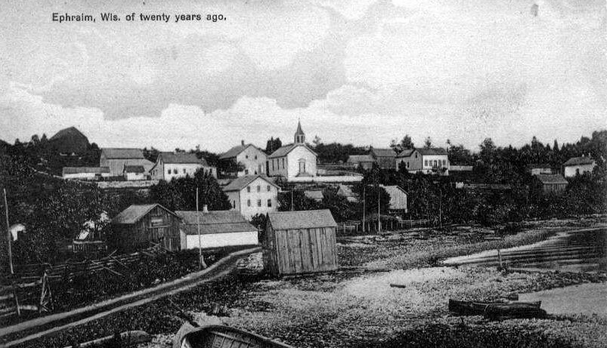

**An Aug. 13, 1914 postcard from Helga Albertsen to her parents shows the village of Ephraim, Wis., “of twenty years ago.”**

All emigration was to be registered by the police in Copenhagen. The next year, in 1872, Soren went there, where he bought his ticket from one of the agencies. With ticket in hand, he went to the police, where he was registered in the passport books, according to Mr. Knudby’s research. Soren was 23 years old and worked as a farmhand in the town of Hjorring. He listed his destination as Chicago, Ill. His ticket was dated 21 Mar 1872. Mr. Knudby’s research pointed out Soren did not leave from Copenhagen; he most likely went to Hamburg in Germany and from there to Southampton in England. Soren’s port of arrival in the United States was Hoboken, N.J., according to his daughter, Helga. He made his way to Wisconsin, where he worked as a mason, a farmer and a tailor.

When he was 29 years old, he married Dorothea Jensen, 20, on 6 Oct 1877 in Ephraim, Gibraltar Township, Door County, Wisconsin. They were married in a Moravian (a Christian denomination) ceremony by John J. Broenfeldt.[5]5 One of the church’s most simple ceremonies is the wedding ritual, where the bridal couple together lights one large candle. The flame is passed to each guest, each of whom has been given a handmade candle. Each guest lights the candle of the one beside until the whole church is aglow.

Witnesses at the wedding were H.P. Jacobs and N. Gordelsen. On the marriage records, Soren’s parents were listed as Albert G. Jensen and Mettemanie Sorensen, apparently an Americanized version of their Scandinavian names. At the time of the marriage, Soren was working as a farmer in Bailey’s Harbor.[6]6

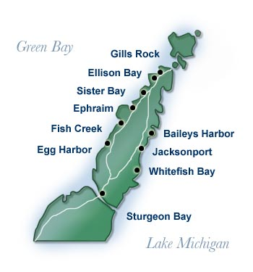

The marriage produced 10 children (dates are from Helga’s memory and IdaKay Orsted’s research):

1. Samuel Martin, b. 12 Dec 1878, Ephraim, Wis.; d. 2 Feb 1879 of bronchitis, Ephraim.
2. Jeny Anna Martin (Helga wrote it as Jenny Martina), b. 2 a.m. Monday, 26 Jan 1880, Ephraim, Wis.; bapt. 3 Feb 1880 at Ephraim Moravian Church; m. Friedrick C. Roggendorf on 18 Oct 1900 in Ephraim Lutheran Church; d. Sept 1937, Ensign, Mich. In the 1920 census, the Stenlunds were renting from the Roggendorfs and living in the same house in Masonville Township, Mich. Fred was a lumberman. Jennie and Fred were buried in Rapid River Cemetery.
3. Anna Jakobine (Helga wrote it as Anna Jacobina), b. 3 Mar 1882, Ephraim, Wis.; m. Oscar Hilton Norton on 23 Dec 1902 in Lutheran Church, Ephraim, Wis.; d. 29 Aug 1953, Omro, Wis. They had 12 children: Wilford, William, Dorothy Luella, Ward Hilton, Lydia Lucille, Waneta Albertine, Mabel Wilford, Eldon Everet, Oscar Harding, Hazel Margaret, Helen Janet and Ruby Ann.

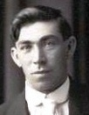

1. Soren Alexander (Helga wrote his name as AlexSander); b. 8 a.m. Monday, 18 Feb 1884, Ephraim, Wis.; d. 17 Apr 1955, Sturgeon Bay, Wis.; m. Ida Hanson 21 Sept 1909. She was born 30 May 1893 in Blossomburg, near Fish Creek, Wis. and d. 11 Sept 1956 in Sturgeon Bay, Wis. of pulmonary edema. She had had diabetes mellitus for five years and arteriosclerosis disease for 10 years. Their children were: Dorothea Alberthas, Philip Samuel Albertson, Florence Odelia, Myrtle Celia, Leona Lorraine, Lavern Helen and Gordon Homer.
2. Peder Franklin; b. 7 a.m. Thursday 11 Mar 1886, Ephraim, Wis.; bap. 25 Apr 1886 at Bethany Lutheran Church, Ephraim; a single man; d. July 1945 (according to Helga); buried Bethany Lutheran cemetery.
3. Walter George; b. 26 Jan 1888, Ephraim, Wis.; d. 7 Mar 1955, Chicago, Ill. of a cerebral hemorrhage. He married Olga Andrina Jacobson in 1914. She was born 3 Oct 1893 in North Bay, Wis., and d. 02 Dec 1969 in Green Bay, Wis. They were divorced in 1944. In 1917 he was a laborer in Hermansville, Mich.; he had gray eyes and black hair. Their children were: Harvey Philips, b. 20 Jan 1916 in Hermansville, d. 29 Jun 2005 in Sturgeon Bay; Wallace Emery, b. 7 Nov 1917 in Hermansville, d. 05 Aug 1991 in Chicago; Marian Jane, b. 26 Aug 1919 in Menominee. Mich.; and Arnold George, b. 13 Sept 1921 in Menominee, Mich.

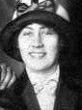

1. Emma Dorothea, b. 23 Aug 1890, Ephraim, Wis.; d. 1 Apr 1979, Hammond, Ind. She married Arthur William Schuyler, Sr. on 23 Mar 1913 in Hammond, Ind. He was born 27 Oct 1884 in Sevastopol, Door County, Wis. and died 15 Dec. 1972 in Gary, Ind. Emma is buried at Ridge Lawn Cemetery, Highland, Ind. Their children were: Elouise Lorraine, b. 15 Feb 1918 in Hammond, Ind.; Arthur William (Buddy), b. 21 Jun 1921, d. 19 Mar 1979, Florida; and John Frederick (Jack), b. 26 Jan 1924, Gary, Ind.
2. Andrew Philip, b. 27 Nov 1892, Fish Creek, Wis.; m. Anne Elizabeth Manney, 11 May 1921, Duluth, Minn.; d. 4 Feb 1977, Sturgeon Bay, Wis. Anne died 26 Feb 1985 in Sister Bay, Wis. They were married aboard the 560-ton ore carrier Hugh Kennedy, in the private dining room with the Rev. A.T. Juvland officiating. Witnesses were Jennie Johnson of Duluth and Wilfred Goodlet of Ephraim. Andrew was second mate aboard the Kennedy at the time. They lived on ship for several months. Later Andrew worked at Peninsula State Park as grounds keeper, where he retired after 32 years. They had gorgeous rose bushes in their yard. Andrew was baptized in 1893 at Ephraim Moravian Church. Sponsors were Andrew, Marie, Peter and Anna Johnson. They are buried at Bethany Lutheran cemetery in Ephraim. Anne’s parents were Major and Alice (Toseland) Manney.

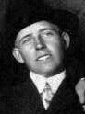

1. Martha Pauline, b. 1 Apr 1894 or 1895, Ephraim, Wis.; m. Edward Frank Zak 28 Jun 1922 in Racine, Wis.; d. 20 Feb 1953, Milwaukee, Wis. Edward Zak was born 11 Aug 1898 in Baileys Harbor, Wis. and died 14 Feb 1989 in Milwaukee, Wis. Martha is buried at Holy Cross Cemetery, Milwaukee, Wis. Their children were: Patricia; Betty, b. 23 Feb 1923; Donald Edward, b. 15 Oct 1928, Milwaukee, Wis., d. 28 Aug 2003, Sturgeon Bay, Wis.; Ralph, b. 30 Nov 1932; and Joan, b. 1 Feb 1934.
2. **HELGA MAY**; b. at 5 p.m. Monday, 25 Oct 1897, Ephraim, Wis.; bap. 5 Dec 1897 at Bethany Lutheran Church, Ephraim, Wis.; m. Peter (Olof Petro) Stenlund, 22 Mar 1919; d. 20 Jan 1988, Escanaba, Mich. Pete was born 1 Oct 1891 in Kankberg, Jorn, Sweden; he died 12 Mar 1965.

In 1891, Soren purchased forty acres of land from Peter Peterson and K. Marie Peterson of Tvedestrand, Norway for $75. The warranty deed, dated 10 Feb 1891, was witnessed on 13 Mar 1891 and recorded at 8 a.m. 17 Apr 1891 by the register of deeds, Jacob DeHos. It was notarized by Gotfred Milberg, notary public, and witnessed by Theodore Spielberg and E. Anderson.[7]7 The deed is on file at the Door County Courthouse register of deeds office in Sturgeon Bay, Wis. In 2008, Gary A. Glojek owned the portion of the forty on which Soren had built his farm.[8]8

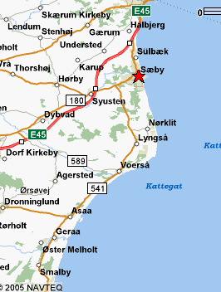

Soren died 5 Dec 1926 in Fish Creek, Wis. He was 78 years old. He is buried in the Bethany Lutheran Church Cemetery near the Ephraim entrance to Peninsula State Park. Dr. W.A. Sneeberger signed the death certificate.

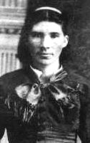

Dorothea Jensen, as shown in what was likely her wedding photo.

**Dorothea Jensen** was born 23 Nov 1856 in Voersaa, Albaek parish, Dronninglund district, Hjorring county, Denmark, according to her birth certificate (although her obituary stated she was born in Saabe). The town of Voersaa is on Aalborg Bay. Her parents were Jens Larsen, a smallholder (which means he owned a small farm), and his wife, Ane Marie Andersdatter.

Dorothea was christened 1 Jan 1857 in Albaek Kirke. Witnessess were Maren Kirstine Christensdatter of Voersaa; Maren Christensdatter of Skovgaard; Niels Christensen of Voersaa; Peder Christensen of Idskov and Niels Andersen of Nordost.[9]9

Dorothea Jensen Albertsen poses with Elouise Schuyler, right, a granddaughter, and her brother. They are the children of Dorothea’s daughter, Emma. They lived in Indiana.

Dorothea was confirmed 16 Apr 1871. An obituary lists the burial place as Bethany Lutheran Church cemetery in Ephraim.

On Dorothea’s wedding certificate, her name was spelled Dorthea and her father’s name was listed as Jens Jensen. Her mother was listed as Anna Andersen. Helga always spelled her mother’s name as Dorothea.

Dorothea died on 14 Feb 1934 in Fish Creek. The cause of death was heart disease; she had angina pectoris, or chest pain from coronary heart disease, for two years.[10]10 Here is what her obituary said in the local paper:

“EARLY SETTLER OF COUNTY DIES AT FISH CREEK

“Another of Door county’s pioneers, Mrs. Dorothea Jensen Albertson (sic), who settled in the town of Gibraltar in the early part of 1876, passed away at the home of her son Andrew at Fish Creek last Wednesday, Feb.14 (1934). Death was attributed to complications incident to old age.

“Deceased was born at Saabe (Saeby), Denmark, Nov. 23, 1856, where she grew to young womanhood. At the age of 19 she immigrated to the United States and on Oct. 5, 1877, was united in marriage to Soren Albertsen of Fish Creek. Mr. Albertsen preceded his wife in death, having passed away seven years ago, and since that time Mrs. Albertsen made her home with her children, nine of whom survive her as follows: Mrs. Fred Roggendorf, Rapid River, Mich.; Mrs. Oscar Norton, Oshkosh; Alexander, Ellison Bay; Peter, Ladysmith; Walter, Hermansville, Mich.; Mrs. Arthur Schuyler, East Chicago, Ind.; Andrew, Fish Creek; Mrs. Edward Zak, Milwaukee; and Mrs. Peter Stenlund, Ensign, Mich. She is also survived by 32 grand children, and one brother, Christian Johnson of Baileys Harbor.

“Funeral services were held from the Andrew Albertsen home at one o’clock Saturday afternoon, and from the Bethania Lutheran church at Ephraim at two o’clock. The deceased had been a member and active worker in the church from which burial took place from the time it was organized in 1882. Services were conducted by Candidate of Theology Walter M. Abramson and the Rev. C. O. Anderson of Ellison Bay and interment was made in the Ephraim church cemetery. Pall bearers were Lincoln and Orrin Malmor, Edgar and Elmer Goodlet, Sander and Christian Christenson. A trio consisting of S.M. and Herman Hogenson and Everett Valentine sang two numbers at the services.”

ALBRECHT PHILIP JENSEN/METTE MARIE SORENSDATTER

**Paternal grandparents of Helga Mae Albertsen**

**Parents of Soren Albertsen**

**Albrecht Philip Jensen** was a tailor, according to his son Soren’s birth certificate. He was born 3 Jun 1826 in Hellevad, Hjorring, Denmark.*[11]11* He was christened the same day. Albrecht married three times.

By 1845, when Albrecht Fellig Jensen was 19, he was living in Hjorring, Borglum, Vester Bronderslev, Vesterbronderslev By, House 93. According to the 1845 census, he was an unmarried tailor living with Christen Thomsen, 27, also an unmarried tailor; Inger Christensdatter, 57, a widow from Aftaegtskone; Jacob Thomsen, 21, an unmarried tailor; Inger Marie Thomsdatter, 13, and Anders Pedersen, 24, an unmarried servant.

Albrecht’s first wife was Kirsten Marie Madsdaughter. With Kirsten, he had a son, Mads Christian Albrechtsen, who was christened in Jeslev or Bester Broenderslev church 10 Nov 1845.

His second wife was **Mette Marie Sorensdatter,** who was born 1827 in Hammer, in Aalborg, according to the 1850 census of the Hallund parish, county of Hjorring, the genealogical researcher Arne Jensen Knudby reported. Soren, the son of Albrecht and Mette Marie, was born 4 Sept 1848, and was baptized at home 12 Nov 1848. His baptism was made public in the church records of Hallund parish on 23 Dec 1848.

When Mette Marie was born, the parish of Hammer, in the county of Aalborg, made this record:

“Mette Marie, born 30 March 1827, bapt. 9 July 1827. Parents: smallholder Soren Poulsen and his wife Maren Oldsdatter in Hammerdamshus. Witnesses: smallholder Laurs Nielsen and wife Marie Oldsdatter in Lindholm; chambermaid Anne Kirstine Hansdatter in the vicarage of Hammer; farmer Peder Stephensen in Broen; bachelor Rasmus Poulsen in Hammerdamshus.” Researcher Knudby noted that the witnesses of the names Olsdatter and Poulsen are most probably relatives of the parents.

According to the 1850 and 1855 census returns of the parish of Hallund, Mette Marie and her son, Soren, were living with her parents, Soren Poulsen and Maren Oldsdatter, a married couple. By 1850, Albrecht was single and living in Hjorring, Borglum, Oster Bronderslev, Osterbenderslev By, House 86 with Ane Kirstine Pedersen, 49, an unmarried housemother; and Niels Peter Nielsen, 17, a servant.

By 18 Mar 1853, Albrecht had married again, this time to Else Maria Hansdatter, in Oester Broenderslev. With Else Maria, he had five children: Inger Marie Albrechtsdatter, b. 1855; Anders Albertin Albrechtsen, b. 1857; Anton Christian Albrechtsen, b. 1862; Lars Johan Albrechtsen, b. 1864; and Johanne Andrea Albrechtsdatter, b. 1867.

In the 1870 census, however, Albrecht was a divorced Lutheran and living in the same house in Vester Hassing as Frederik Johansen, 39, who was married. In 1879, he was working as an independent tailor and living with his assistant, a single mother of two small children while his ex-wife Else Maria Hansdatter was living at a different location in the same town, Vester Hassing, with the children who were still at home.[12]12

**JENS MICHAELSEN/ANE KIRSTINE PEDERSDAUGHTER**

**Paternal great-grandparents of Helga Mae Albertsen**

**Parents of Albrecht Philip Jensen**

**Jens Michaelsen** married **Ane Kirstine Pedersdaughter**. She was born in Hallund, Denmark.

It’s possible Jens Michaelsen died before 1845, when Albrecht Philip was 19. In that year, 1845, Ane Kirstine was living in Oster Bronderslev with a daughter, Albrecht’s half-sister, whose last name was Andersdatter, while Albrecht was studying to be a tailor in Vester Bronderslev. In 1850, Albrecht was back in Oster Bronderslev, still single, and living with his mother.

**SOREN POULSEN/MAREN OLSDATTER**

**Paternal great-grandparents of Helga Mae Albertsen**

**Parents of Mette Marie Sorensdatter**

**Soren Poulsen** was born in Vrensted, according to the 1850 census returns of the parish records of Hallund, county of Hjorring, village of Hollensted. He was a farmer. He was 56 years old in 1850, so he was likely born c. 1794. In the 1855 census for Hollensted, Soren was listed as a smallholder who lived off his land. Living with him, in addition to his wife, were his daughter **Mette Marie Sorensdatter**, her son Soren Albrechtsen, and a foster child named Kirstine Marie Larsen. In 1860, he was listed as a pensioner.

**Maren Oldsdatter** was Soren’s wife, according to the 1850 census. She was 59 at the time of the census, which would put her birth date c. 1791. She was born in Oster Hasing, which is northeast of Aalborg. In 1855, the census listed Maren’s last name as Olsdatter, but in the 1860 census for Hallund, the village of Hollensted, Maren’s last name was listed as Olesen. In Denmark, the wife retains her surname throughout her life, usually.

In the 1834 census for the parish of Hammer in a locality called Hammerdam, Maren Olsdatter’s age was recorded at 34, which would make her year of birth 1800. That census also recorded a son, Poul Sorensen, who was 5 at the time. Mette Marie was listed as 7 years old.

The family moved from Hammer to Hallund some time between 1834 and 1850. Mette Marie was not confirmed in Hammer, so they may have moved before the year in which she was confirmed, usually in a child’s 14th year.

Research done by IdaKay Orsted of Baileys Harbor, Wis., a great-granddaughter of Soren and Dorothea Albertsen, shows that Soren Poulsen was born in 1795 and his wife, Maren Oldsdatter, in 1792. Mrs. Orsted’s research also shows Poul Sorensen was born in 1829 in Hammer, Aalborg, Denmark.

**OLE SORENSEN/METTE CHRISTERDATTER**

**Paternal great-great grandparents of Helga Mae Albertsen**

**Parents of Maren Olesdatter**

**Ole Sorensen** was born about 1739 in Denmark**.**

**Mette Christerdatter** was born about 1752 in Denmark.

The year of their marriage is unknown; however their first child, Johanne Olesdatter, was born in 1775. In the years 1787 and 1801, they were living in Oster Hassing Sogn, Aalborg county, Denmark.[13]13

The marriage produced 10 children.

1. Johanne Olesdatter, born 1775, Denmark; married Peiter Olesen, who was born 1765 in Denmark. One child, Hansine Christiane Peitersdatter, b. 1810.
2. Kirstine Olesdatter, b. 1777, Denmark.
3. Ane Olesdatter, b. 1780, Denmark.
4. Christiane Olesdatter, b. 1782, Denmark.
5. Lars Olesen, b. 1784, Denmark.
6. Christian Olesen, b. 1785.
7. Lars Olesen, b. 1788.
8. Sara Olesdatter, b. 1790.
9. **MAREN OLESDATTER**, b. 1792, Oster Hassing, Aalborg, Denmark; married Soren Poulsen, who was born 1795 in Vrensted, Hjorring, Denmark; two children, Meta Marie Sorensdatter, b. 1827, Hammer, Aalborg, Denmark, and Poul Sorensen, b. 1829, Hammer, Aalborg, Denmark.
10. Maren Olesdatter, b. 1795.

**JENS LARSEN/ANA MARIE ANDERSDATTER**

**Maternal grandparents of Helga Mae Albertsen**

**Parents of Dorothea Jensen**

**Jens Larsen** was born c. 1800. He died 4 June 1870 and is buried in Albaek.

**Ana Marie Andersdatter** was born c. 1812.

Jens and Ana Marie were married 29 Dec 1844 in the Albaek Kirke. She was 32 years old; he was 44. Both were from Voersa.

The Folkeregistret (regional archives) for the Albaek kommune (municipality) identified the children born to this marriage as:

1. Jens Jacob Jensen, b. 25 Mar 1836.
2. Peder Christian Jensen, b. 1 Mar 1849, confirmed 12 Apr 1863.
3. Carl Christian Anton Jensen, b. 11 Jun 1853, confirmed 6 Oct 1867.
4. **DORTHE JENSEN**; b. 23 Nov 1856, confirmed 16 Apr 1871.

Albaek is in Dronninglund, Hjorring, Denmark.

It is unusual that Dorthe’s family name was listed as Jensen rather than Jensdatter, which went against Danish tradition. When the sons came to America, however, their family name was changed to Johnsen, all except Jens Jacob, according to Dorthe’s (Dorothea) daughter, Helga. Dorothea came to America when she was 19, in 1875.

Jens died 4 June 1870, according to the regional archives, which are in Viborg.

**ANDERS ANDERSEN/KAREN JENSDATTER**

**Maternal great-grandparents of Helga Mae Albertsen**

**Parents of Ane Andersdatter**

**Anders Andersen** was born about 1778 in Horby, Denmark.

**Karen Jensdatter** was born about 1777.

It’s not known when they were married.

They had two children:

1. **ANE ANDERSDATTER**, b. about 1812 in Denmark; m. Jens Larsen, b. about 1799 in Denmark.
2. Kirsten Andersdatter, b. about 1816.

1. Web Page “The American West: A CELEBRATION OF THE HUMAN SPIRIT”
2. Olof Peter Stenlund’s naturalization papers held in the Delta County Courthouse in Escanaba. He applied for naturalization 6 Apr 1924; naturalization was approved 8 Nov 1927; the ceremony was 27 Jun 1928.
3. Web Page The Ship’s List: www.theshipslist.com
4. Web site of Information Please, which is part of Pearson Education, an educational publisher that owns Prentice Hall and other imprints.
5. M. R. Kiehnau, Deputy Register of Deeds, Door County, Wis., 1964.
6. Ibid.
7. Warranty deed, Door County, Sturgeon Bay.
8. Door County Real Property office, Sturgeon Bay, Wis
9. Research done by IdaKay Orsted, Baileys Harbor, Wis, transferred to Barbara Bannister in 2008. IdaKay is also a great-granddaughter of Soren Albertsen.
10. Ibid.
11. Ibid.
12. Ibid.
13. IdaKay Orsted, Baileys Harbor, Wis., research of the Oster Hassing Sogn, Aalborg county, Denmark census from 1787 and 1801.