Chapter 15

SWEDISH CONNECTION

Herman Stenlund/Ida Carolina Holmqvist

**Parents of Olof Peter Stenlund**

**Herman Stenlund** and **Ida Carolina Holmqvist** wereborn into an era of unimaginable hardships.

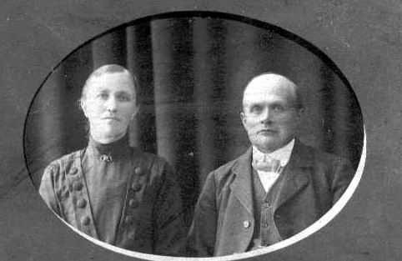

Ida Carolina Holmqvist married Herman Stenlund, a farmer, on 4 Dec 1888 at State Church in Skelleftea, Sweden. They raised nine children, including two who traveled to America.

A mainly agricultural society, Sweden depended upon its farmers to feed its poor but growing population. But in 1867, the summer Ida turned 2 years old and Herman was born, a famine of huge proportions took hold. It was a cold and wet summer in which the potato crops the Swedes, like the Irish, had come to rely on rotted in the fields.

The failed crops produced a severe food shortage that affected the whole country. Religious leaders advised Swedes to mix tree bark into their flour for bread and to eat heather and roots.[1]1 Riots were reported nearby in Skelleftea.

The next year, 1868, was so hot and dry that crops burned in the fields. By 1869, the country suffered not only famine but also rampaging diseases.[2]2 Cholera struck Norrland, the northernmost part of Sweden. Famine and disease combined to produce a period of mass migration that would claim two of Herman’s sons, who left their homeland to seek a new life in the United States of America.

**HERMAN STENLUND3; (OLOF NILSSON2** andMARTA LENA NILSDOTTER)b. 18 (Some say 17) Aug 1867 in the parish of Norsjo; m. 4 Dec 1888 to Ida Carolina Holmqvist at State Church in Skelleftea; worked as a small farmer; d. 1 Apr 1956 in Medle; buried in Skelleftea Country Parish Cemetery at Skelleftea. Gravestone reads: “Family Grave of Herman Stenlund.”[3]3

**IDA CAROLINA HOLMQVIST**; (JOHAN OLOFSSON HOLMQVIST and Greta Cajsa (or Katharina) Nilsdotter) b. 4 July 1865 in Kankberg, Sweden; Baptized in Swedish State church; m. Herman Stenlund; d. 10 July 1939.[4]4

Children of this marriage, according to the regional archives at Kankberg, (with additional information from Ellen Bannister) are:

1. Jenny; b. 29 Nov 1889 in Kankberg, Jorn; married Valfrid Borjesson. Children Lisette Johansson, b. 1911; May, 9 Mar 1927; and Hans-Olaf, 3 Sept 1928.
2. **OLOF PETRO4**, became known as “Pete” in America; b. 1 Oct 1891 in Kankberg; married Helga Mae Albertsen.
3. Elin Serafia; b. 20 Jan 1894 in Kankberg, Jorn; m. Gottfrid Andersson; no children.
4. Herman Gideon; b. 3 Sept 1896 at Kankberg, Jorn; m. Mandy Gustafson. Children: Lloyd, Ethel, Harold, Doris, Dorothy, Ralph.
5. John Irenes; b. 5 Apr 1898 at Kankberg, Jorn; m. Ida. Children: Vanja Aslrom, Sonja Lundqvist (husband Arne), Lars Stenlund, Karl-Gunnar Forsland (wife Katrina) and Ingemar Stenlund.
6. Gunnar Heribet; b. 16 Mar 1900 at Kankberg, Jorn; d. 9 Jun 1979.
7. Bror; b. 16 Mar 1900 at Kankberg, Jorn; m. Elsa. Children: Elsy Norberg, Birgitta Stenlund, Britt-Marie Lindahl (children Mats Lindahl, Nichlas Lindahl, Ove Lindahl), Hakan Stenlund, Asta Verlinder-Stenlund (husband Bruno), and Astrid Stenlund.
8. Elsa Viola; b. 31 Jan 1903; in Kankberg, Jorn; married an Andersson. Children: Gun Norstrom (daughter Anika Norstrom), Anne-Catherine Johannsson.
9. Svea Serudia; b. 28 Aug 1905 in Medle, Skelleftea; married Rudolph Lundberg. Children Rune, Solbrit Soderstrom (husband Henry).

Herman was born in the village of Missentrask, county of Jorn, Sweden on 17 Aug 1867, the son of the settler Olof Nilsson and his wife Marta Lena Nilsdotter. Jorn is in Vasterbotten, one of Sweden’s historical provinces (*landskap*) and is considered part of what Swedes call Norrland. It is an area rich in mountains and lakes, but its subarctic climate brings long winters and short summers.

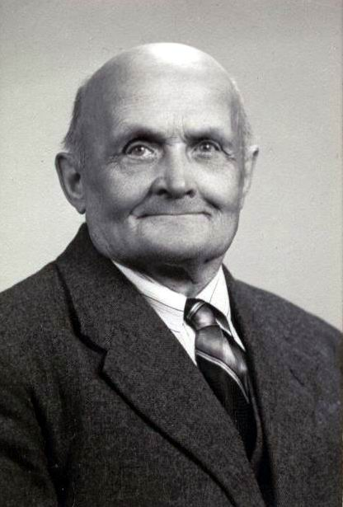

Herman Stenlund

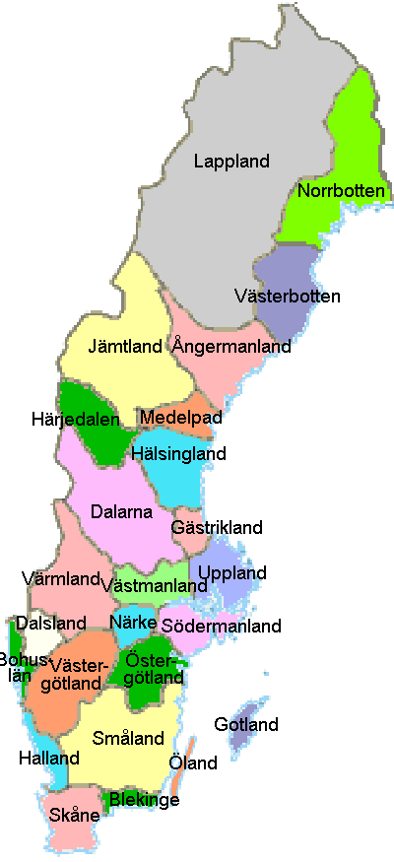

Herman was baptized in the State Church of Skelleftea, his daughter Elsa wrote in 1969. He was 21 years old when he married Ida Carolina Holmqvist on 4 Dec 1888. Ida was 23 years old. They were married at State Church in Skelleftea. Herman worked a small farm.

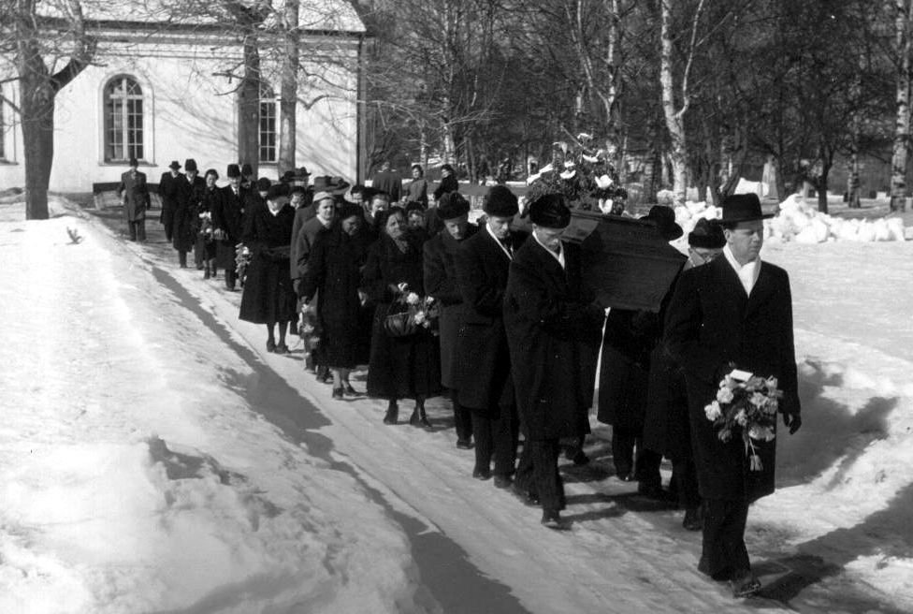

Mourners leave the State Church of Skelleftea after the funeral service for Herman Stenlund in 1956. He is buried in the Skelleftea Country Parish.

Ida Carolina Holmqvist was born 4 July 1865 in the village of Kankberg, in Jorn, Sweden. She was a daughter of Johan Olofsson and his wife Greta Katharina Nilsdotter.

Together Herman and Ida had nine children, two of whom – Olof Petro and Herman Gideon – traveled to America. They both settled in Delta County, Mich.

Herman and Ida and their family moved to Medle, Skelleftea on 10 Oct 1903, according to the registry for Jorn.

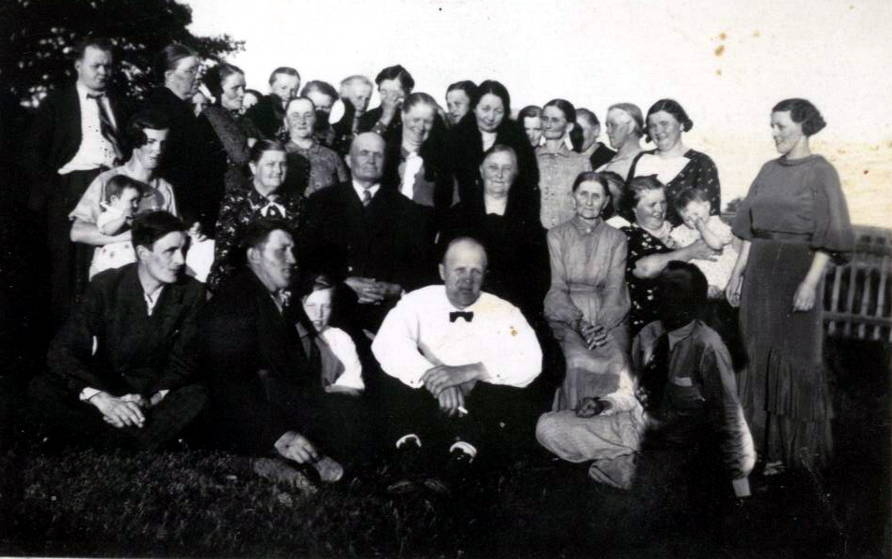

The family of Herman and Ida Stenlund gathered probably on her 70th birthday in July 1935. Lars Stenlund has identified some of the family. In front row, from left, are: Rudolf Lundberg, husband of Svea, Herman and Ida’s daughter; son John Stenlund, Lars’ father; unknown; son Gunnar Stenlund, in whiter shirt; son Bror Stenlund, in shadow. Second row: Elsa, Bror’s wife; Elsy, seated on her mother’s lap; unknown; Herman; Ida; unknown; daughter Svea Lundberg, wife of Rudolf; Sol-Britt, held by her mother, Svea; and daughter Elsa Andersson, standing. Third row, from left: Eugen, Elsa’s husband; unknown; Linda, Rudolf’s mother and a neighbor; and unknown from then on.

A grandson, Lars Stenlund, writing in 1999, described his grandfather as a good storyteller and well versed in the Bible.

“He was skillful and produced a lot of tools for his farmyard,” Lars wrote. “He liked children very much and with his knife he splitted many curious toys.”

The newspaper in Skelleftea, Norra Vasterbotten, described Ida Carolina as dying at age 74 in 1939. The paper said she was born in Kankberg, Jorn, and married Herman Stenlund in 1889 [the household index for Jorn said 1888], in Kankberg. Later the family moved to Medle, where she was called “Madam Stenlund.”

“She was a very popular and clever person,” the newspaper said. “(With) her long experience she kindly informed young people. It was very pleasant to talk with Mrs. Stenlund. Her decease has brought deep mourning but the memory of her will be cherished in happy remembrance.”

Some records kept in Sweden spell Ida’s middle name with a “K,” others with a “C.”

**JOHAN OLOVSSON HOLMKVIST/GRETA KAJSA NILSDOTTER**

**Parents of Ida Carolina Holmqvist**

**Johan Olovsson Holmkvist** was born 24 Dec 1839 in Kankberg, according to the Household Examination roll of Jorn. He married **Greta Kajsa Nilsdotter** on 26 Mar 1862 in Jorn. She was born 30 Aug 1838.

Johann died at the age of 39, on 8 Sept 1879, according to Hakan Stenlund, his great-grandson.

Greta moved to Skelleftea on 23 May 1896, the pastor’s office in Jorn said. She died 5 Nov 1906, at the age of 68.

**OLOV MAGNUSSON/BRITA KAJSA CHRISTIANSDOTTER**

**Parents of Johan Olovsson Holmkvist**

**Paternal grandparents of Ida Carolina Holmqvist**

**Olov Magnusson** was born 23 Sept 1809, according to Hakan Stenlund. He married **Brita Kajsa Christiansdotter**, but the date is unknown. She was born 21 July 1812, according to the Household Examination roll of Jorn.

Olov died 13 Feb 1828, at the age of 18. Brita died 10 Mar 1890, at the age of 77.

**MAGNUS (MAUS) OLOVSSON/SARA ANDERSDOTTER**

**Parents of Olov Magnusson**

**Paternal great-grandparents of Ida Carolina Holmqvist**

**Magnus (Maus) Olovsson** was born in 1778, according to Hakan Stenlund. He married **Sara Andersdotter**. Sara was born in 1786.

Magnus died 17 Nov 1821. He was 43. Sara died in 1815, at the age of 29.

**OLOV MAUSSON (MAGNUSSON)/BRITA MIKAELSDOTTER**

**Parents of Magnus Olovsson**

**Paternal great-great grandparents of Ida Carolina Holmqvist**

**Olov Mausson (Magnusson)** was born in 1747. He married **Brita Mikaelsdotter**. She was born in 1742.

Olov died 3 Nov date unknown. Brita died 6 Feb 1815, at the age of 73. This information is from Hakan Stenlund.

1. Mrs. Susan Biltucci’s Classrooms Around the World project, Remington Elementary School, Ilion, N.Y. Website.
2. Linda Magnusson, Causes of the Swedish emigration, ThinkQuest Web site.
3. Elsa Andersson, Herman’s daughter, in a 1969 questionnaire.
4. Hakon Stenlund, Herman’s grandson, son of Bror, in notes translated by Lars Stenlund.