Chapter 16

A 19th CENTURY SWEDE

Olof Nilsson/Marta Lena Nilsdotter

**Parents of Herman Stenlund**

**Olof Nilsson** was born 21 Nov 1841 in Granliden. His birth is registered with the Norsjo parish office.[1]1

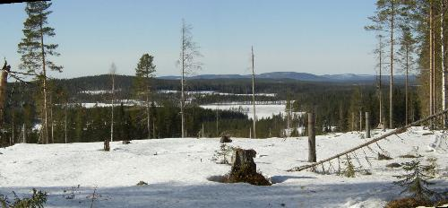

A panoramic photo shows the countryside around the village of Granliden, Norsjo, Vasterbotten, Sweden. The photo was taken from the village’s Web page in 2008.

Little else is known about Olof or his wife**, Marta Lena Nilsdotter,** except that she was born in the village of Elgliden and resided in the same municipality of Norsjo, in the province of Vasterbotten.

**OLOF NILSSON2; (NILS OLOFSSON1** andBRITA CAJSA MATSDOTTER); b. 21 Nov 1841 in Granliden; m. 7 Nov 1863 to Marta Lena Nilsdotter; d. 22 July 1915 in Norsjo.

**MARTA LENA NILSDOTTER**; (Nils Nilsson and Martha Lena Andersdotter) b. 28 June 1839 in Norsjo-Elgliden; d. 30 July 1915 in Norsjo.

Children of this marriage were:

1. Ludvig.
2. Olaf.
3. August Stenlund.
4. Johan Stenlund.
5. **HERMAN STENLUND**; b. 18 Aug 1867; m. Ida Carolina Holmqvist 4 Dec 1888 at Skelleftea, Vasterbotten; d. 1 Apr 1956 in Medle; buried in Skelleftea.
6. Vendla.
7. Erika.
8. Elina.

**NELS NILSSON/MARTHA LENA ANDERSDOTTER**

**Parents of Martha Lena Nilsdotter**

**Maternal grandparents of Herman Stenlund**

**Nils Nilsson** was born 23 Mar 1813.[2]2

Nils married **Martha Lena Andersdotter**, who was born 24 Nov 1815.

1. A.J. Sjolen, Registrar’s Landsarkivet office, by letter, 1968.
2. Household Examination roll, Jorn.